UNITED STATES

SECURITIES AND EXCHANGE COMMISSION

Washington, D.C. 20549

SCHEDULE 14A

Proxy Statement Pursuant to Section 14(a) of

the Securities Exchange Act of 1934 (Amendment No. )

Filed by the Registrant ☒

Filed by a party other than the Registrant ☐

Check the appropriate box:

- Preliminary Proxy Statement

- Confidential, for Use of the Commission Only (as permitted by Rule 14a-6(e)(2))

- Definitive Proxy Statement

- Definitive Additional Materials

- Soliciting Material under §240.14a-12


Micron Technology, Inc.

(Name of Registrant as Specified in Its Charter)

(Name of Person(s) Filing Proxy Statement, if other than the Registrant)

Payment of Filing Fee (Check all boxes that apply):

- No fee required

- Fee paid previously with preliminary materials.

- Fee computed on table in exhibit required by Item 25(b) per Exchange Act Rules 14a-6(i)(1) and 0-11

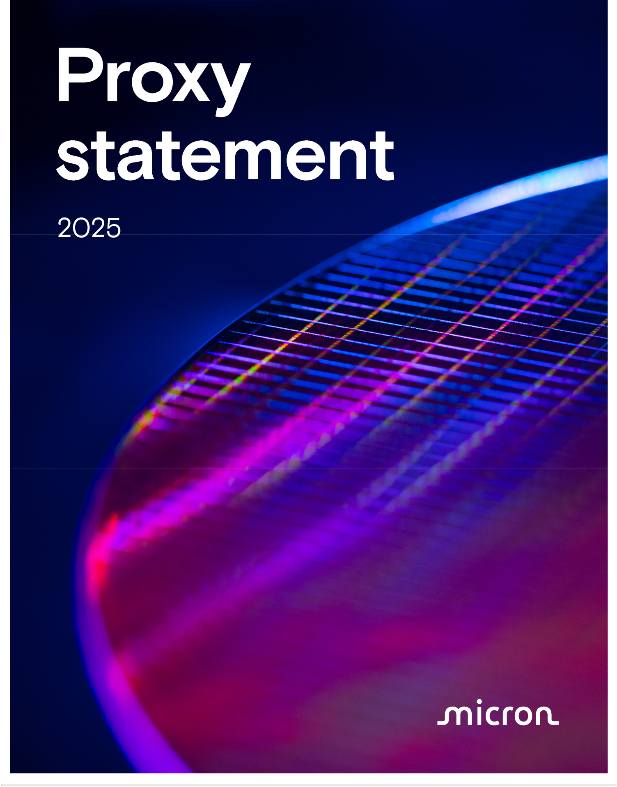



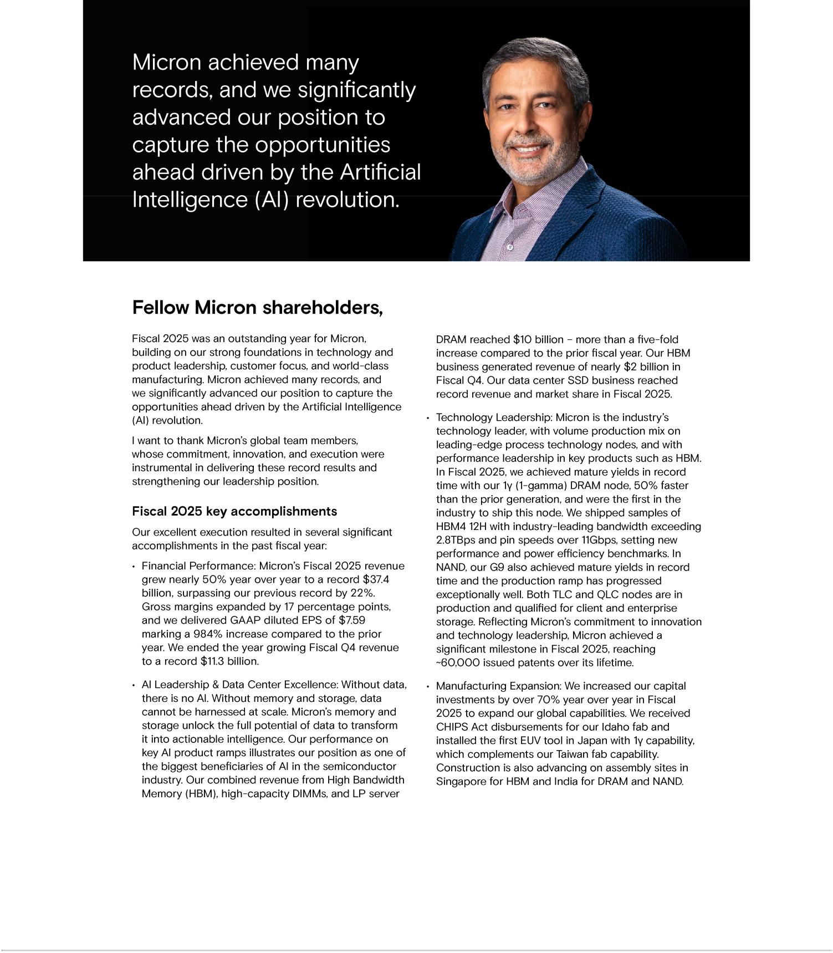

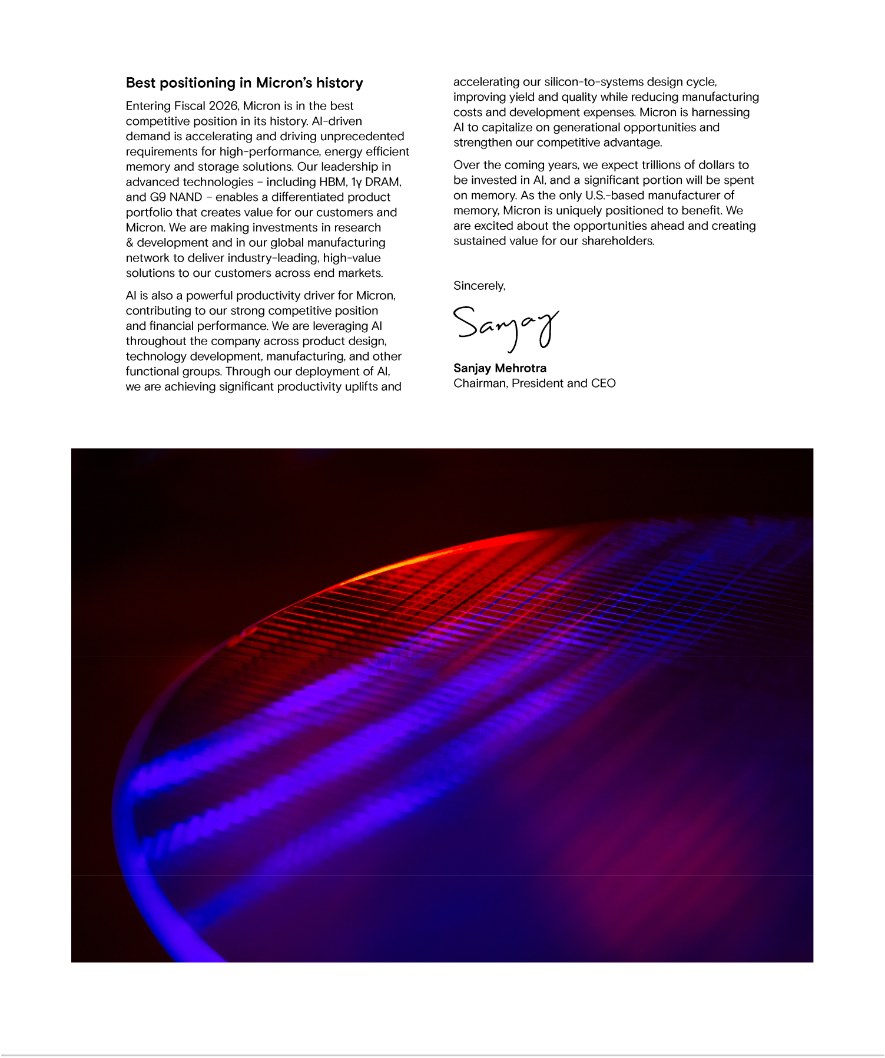

Notice of Fiscal 2025 Annual Meeting of Shareholders January 15, 2026
To the Shareholders of Micron Technology, Inc.:

NOTICE IS HEREBY GIVEN that the Annual Meeting of Shareholders (the “Annual Meeting”) of Micron Technology, Inc., a Delaware corporation, for the fiscal year ended August 28, 2025 (“Fiscal 2025”), will be held virtually on January 15, 2026, at 10:00 a.m., Mountain Standard Time, for the purposes listed below. As used herein, “we,” “our,” “us,” “Micron,” the “Company,” and similar terms refer to Micron Technology, Inc., unless the context indicates otherwise.

- To elect eight (8) directors to our Board of Directors to serve for the ensuing year and until their successors are elected and qualified;

2 To approve, on a non-binding basis, the compensation of our named executive officers;


- To approve an amendment to the Company’s Restated Certificate of Incorporation adding a provision regarding exculpation of officers in accordance with Delaware law;

- To ratify the appointment of PricewaterhouseCoopers LLP as our independent registered public accounting firm for the fiscal year ending September 3, 2026;

- To vote on a shareholder proposal included in the accompanying proxy statement, if properly presented at the Annual Meeting; and

6 To transact such other business as may properly come before the Annual Meeting or any adjournment thereof.

The foregoing items of business are more fully described in the proxy statement (the “Proxy Statement”) accompanying this notice.

Shareholders of record at the close of business on November 17, 2025 are entitled to receive notice of and to vote at the meeting and any postponements or adjournments of the meeting. A complete list of shareholders entitled to vote at the meeting will be available for inspection by any shareholder, for any purpose related to the meeting, for ten days prior to the meeting at our principal business offices during ordinary business hours. Please contact our Corporate Secretary at corporatesecretary@micron.com to schedule an appointment to review the list.

The Securities and Exchange Commission permits proxy materials to be furnished over the Internet rather than in paper form. Accordingly, unless otherwise requested, we are sending our shareholders a notice (the “Notice”) regarding the availability of the Proxy Statement, our annual report on Form 10-K for Fiscal 2025 (the “Annual Report”), and other proxy materials (together, the “proxy materials”) via the Internet. This electronic process gives you fast, convenient access to the proxy materials, reduces the impact on the environment, and reduces our printing and mailing costs. If you received the Notice by mail, you will not receive a printed copy of the proxy materials in the mail. The Notice instructs you on how to access and review the proxy materials. The Notice also instructs you on how you may submit your vote over the Internet. If you received a Notice by mail and would like to receive a copy of our proxy materials by electronic mail or mail, you should follow the instructions for requesting such proxy materials included in the Notice.

We are pleased to provide shareholders with the opportunity to participate in the Annual Meeting online via the Internet in a virtual-only meeting format to facilitate shareholder attendance and provide a consistent experience to all shareholders regardless of location. We will provide a live webcast of the Annual Meeting at www.virtualshareholdermeeting.com/MU2025, where you will also be able to submit questions and vote online. You will not be able to attend the Annual Meeting at a physical location.

To ensure your representation at the meeting, you are urged to vote, whether or not you attend the Annual Meeting. You may vote by telephone or electronically via the Internet by following the instructions on the Notice. Alternatively, if you received a paper copy of the proxy card, you may sign, date, and return the proxy card in the postage-prepaid envelope enclosed for that purpose. Please refer to the instructions included with the proxy card for additional details. Shareholders attending the Annual Meeting may vote using the virtual meeting platform even if they have already submitted their proxy, and any previous votes that were submitted by the shareholder, whether by Internet, telephone, or mail, will be superseded by the vote that such shareholder casts at the Annual Meeting.

We began distributing a Notice of Internet Availability of proxy materials, the Proxy Statement, the Annual Report, and proxy card, as applicable, to shareholders on November 25, 2025.

Boise, Idaho
November 25, 2025

By Order of the Board of Directors

Michael Ray
Senior Vice President, Chief Legal Officer and Corporate Secretary

YOUR VOTE IS IMPORTANT. PLEASE SUBMIT YOUR PROXY PROMPTLY.

 1

PROXY ROADMAP

Proposal |  | ☑ | The Board recommends that you
Proposal |  | ☑ | vote “FOR” each director
1 | To elect eight (8) directors to our Board of Directors | ☑ | vote “FOR” each director
1 | To elect eight (8) directors to our Board of Directors | ☑ | nominee.
To elect eight (8) directors to serve for the ensuing year and until their successors are elected and qualified. Upon the recommendation of our Governance and Sustainability Committee, our Board of Directors has nominated eight (8) current directors as nominees for election. See “Corporate Governance—Proposal 1 - Election of Directors” on page 6.

OUR BOARD NOMINEES


Lynn A. Dugle |  | Sanjay Mehrotra
Micron’s Lead Independent Director; |  | Micron’s Chairman, President and Chief
Former Chairman, Chief Executive |  | Executive Officer
Officer, and President of Engility
Holdings Inc.
Steven J. Gomo |  | A. Christine Simons
Former Executive Vice President, |  | Former Audit & Assurance partner of
Finance and Chief Financial Officer of |  | Deloitte & Touche LLP
NetApp, Inc.
Linnie M. Haynesworth |  | Robert H. Swan
Former Sector Vice President, Cyber |  | Operating Partner at Andreessen
and Intelligence of Mission Solutions |  | Horowitz; Former Chief Executive
Division at Northrop Grumman |  | Officer and Chief Financial Officer of
 |  | Intel Corporation
T. Mark Liu |  | MaryAnn Wright
Founder and Chairman of J&M Copper |  | Former Group Vice President
Beech Ventures and Former Chairman |  | of Engineering and Product
of Taiwan Semiconductor Manufacturing |  | Development of Johnson Controls
Company Limited |  | International



2 | 2025 Proxy Statement

Proposal | To approve, on a non-binding basis, the compensation of
2 | our named executive officers

- The Board recommends that you vote “FOR” Proposal 2.

For additional details on compensation of our named executive officers (the “Named Executive Officers” or the “NEOs” listed in the section “Executive Compensation and Related Information—Compensation Discussion and Analysis—Named Executive Officers”), see “Executive

Compensation and Related Information—Proposal 2—Say-on-Pay” on page 35.

EXECUTIVE COMPENSATION HIGHLIGHTS
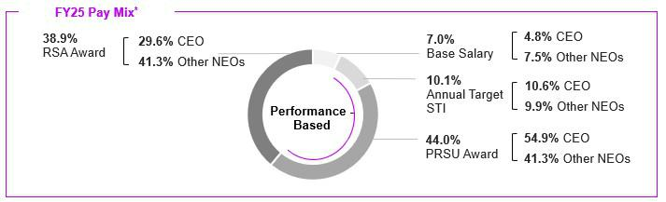

*Percentages may not total 100% due to rounding.
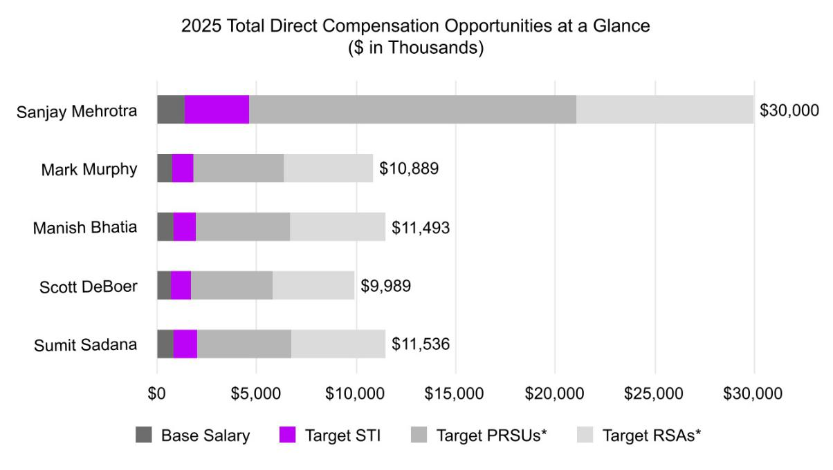

*PRSUs = Performance-Based Restricted Stock Units; RSAs = Restricted Stock Awards

3

Proposal | To approve the amendment of our Restated Certificate of
Proposal | Incorporation to reflect Delaware law provisions regarding
3 | exculpation of officers

- The Board recommends that you vote “FOR” Proposal 3.

To approve an amendment to our Restated Certificate of Incorporation adding a provision regarding exculpation of officers in accordance with Delaware law. Please see page 85 for additional information.

Proposal | To ratify the appointment of our independent registered
4 | public accounting firm

- The Board recommends that you vote “FOR” Proposal 4.

The Board recommends ratifying the appointment of PricewaterhouseCoopers LLP (“PwC”) as our independent registered public accounting firm for the fiscal year ending September 3, 2026 (“Fiscal 2026”). Please see page 87 for additional information.
Proposal |  | ☒ | The Board recommends that you
5 | Shareholder proposal | ☒ | The Board recommends that you
5 | Shareholder proposal | ☒ | vote “AGAINST” Proposal 5.
Shareholder proposal requesting that the Board take steps to give the owners of 10% of our outstanding common stock the power to call a special shareholder meeting. Please see page 90 for additional information.


Important Notice Regarding the Availability of Proxy Materials for the Annual Meeting

to be held on January 15, 2026:

The proxy statement and annual report on Form 10-K for Fiscal 2025 are available at www.proxyvote.com.

We began distributing a Notice of Internet Availability of proxy materials, the proxy statement, the annual report
on Form 10-K for Fiscal 2025, and proxy card, as applicable, to shareholders on November 25, 2025.

4 | 2025 Proxy Statement

TABLE OF CONTENTS

Proxy Section | Page | Frequently Requested Information | Page
Notice of Annual Meeting | 1 | Artificial Intelligence | 26
Proxy Roadmap | 2 | Auditor Fees | 87
Corporate Governance | 6 | Beneficial Ownership Table | 94
Proposal 1 - Election of Directors | 6 | Board Leadership Structure | 19
Board of Directors | 7 | Board Refreshment and Continuing Education | 16
Nominees for Election | 7 | Chief Executive Officer Pay Ratio | 73
Director Nominees’ Skills and Experience | 13 | Code of Business Conduct and Ethics | 28
Director Nominations and Board Refreshment | 16 | Components of our Executive Compensation Program | 46
Board Structure | 19 | Compensation Consultant | 44
The Board’s Roles and Responsibilities | 24 | Cybersecurity Oversight | 25
Shareholder Outreach | 29 | Director Independence | 19
Certain Relationships and Related Person Transactions | 31 | Director Nominees’ Skills and Experience Matrix | 13
Director Compensation | 32 | Director Stock Ownership Guidelines | 34
Executive Compensation and Related Information | 35 | Director Tenure | 15
Proposal 2 - Say-on-Pay | 35 | Director Time Commitment Policy | 18
Compensation Discussion and Analysis | 36 | Enterprise Risk Management Oversight | 24
Compensation Committee Report | 64 | Executive Compensation Highlights | 38
Compensation Tables | 65 | Executive Compensation Practices | 41
Fiscal 2025 Summary Compensation Table | 65 | Financial and Business Highlights | 37
Grants of Plan-Based Awards | 67 | Fiscal 2025 Director Compensation | 32
Outstanding Equity Awards | 69 | Human Capital and Culture | 26
Stock Vested in Fiscal 2025 | 72 | Named Executive Officers | 36
Nonqualified Deferred Compensation | 73 | Nominees for Director and Director Biographies | 7
Chief Executive Officer Pay Ratio | 73 | Executive Officer Stock Ownership Guidelines | 59
Potential Payments Upon Termination or Change in Control | 74 | Pay-for-Performance | 80
Equity Compensation Plan Information | 78 | Peer Group | 45
Pay Versus Performance | 80 | Potential Payments Upon Termination or a Change in | 74
Pay Versus Performance | 80 | Control | 74
Proposal 3 - Approval of Amendment to our Restated
Certificate of Incorporation to Provide Exculpatory Protection | 85 | Report of the Audit Committee | 88
to Certain Company Officers | 85 | Report of the Audit Committee | 88
Proposal 4 - Ratification of Appointment of | 87 | Severance and Change in Control Arrangements | 60
PricewaterhouseCoopers LLP | 87 | Severance and Change in Control Arrangements | 60
Principal Shareholders | 94 | Sustainability | 26
Information Concerning Solicitation and Voting | 96
Incorporation by Reference of Certain Financial Information | 100
Householding of Proxy Statements and Annual Reports | 100
Cautionary Note on Forward-Looking Statements | 101
Deadline for Receipt of Shareholder Proposals for Fiscal | 102
2026 Annual Meeting | 102
Annex A - Amendment to Restated Certificate of | 103
Incorporation | 103

5

Table of Contents

CORPORATE GOVERNANCE

PROPOSAL 1 - ELECTION OF DIRECTORS

PROPOSAL DETAILS

- All directors elected annually by a simple majority of votes cast

- Lead Independent Director

- Seven of eight director nominees are independent

Our Board has nominated eight (8) individuals for election as directors at our Annual Meeting of Shareholders for Fiscal 2025 (the “Annual Meeting”). Each of the nominees is currently a member of our Board and each nominee was elected to our Board at the Annual Meeting of Shareholders for the fiscal year ended August 29, 2024 (“Fiscal 2024”), except for Mr. Liu and Ms. Simons, who were appointed to the Board in March 2025. Ms. Simons was recommended to the Governance and Sustainability Committee by a non-management director and Mr. Liu was recommended to the Governance and Sustainability Committee by our Chief Executive Officer.

In October 2025, Mr. Beyer and Ms. McCarthy provided notice that they would retire from the Board and would not seek re-election at the Annual Meeting. Mr. Beyer and Ms. McCarthy will continue to serve as directors through the end of their terms at the Annual Meeting.

Each director elected at the Annual Meeting will serve until our Annual Meeting of Shareholders for Fiscal 2026 and until a successor is duly elected and qualified, or until such director’s earlier death, resignation, or removal. Each of the nominees has consented to be named in this proxy statement (the “Proxy Statement”) and to serve as a director if elected. If any nominee is unable or unwilling to stand for election or serve as a director if elected, the persons named as proxies may vote for a substitute nominee designated by our existing Board, or our Board may choose to reduce its size.

BOARD RECOMMENDATION

The Board recommends voting “FOR” the election of each of the nominees.

VOTE REQUIRED FOR APPROVAL

Each nominee will be elected as a director if such nominee receives the affirmative vote of a majority of the votes cast with respect to his or her election (in other words, the number of shares voted “FOR” a director must exceed the number of votes cast “AGAINST” that director). Shareholders are not permitted to cumulate votes with respect to the election of directors.

If a nominee who is serving as a director is not elected at the Annual Meeting by the requisite majority of votes cast, Delaware law provides that the director would continue to serve on our Board as a holdover director. However, under our Corporate Governance Guidelines, each incumbent nominee is required to submit a contingent resignation to the Chair of the Governance and Sustainability Committee prior to the Annual Meeting. If the incumbent nominee fails to receive a majority of the votes cast in an election that is not a “contested election” (as defined in our Amended and Restated Bylaws (as currently in effect, the “bylaws”)), the Governance and Sustainability Committee will make a recommendation to the Board on whether to accept or reject the resignation, or whether other action should be taken. The Board will act on the resignation, taking into account the Governance and Sustainability Committee’s recommendation, and publicly disclose its decision and the rationale behind it within 90 days from the date the election results are certified.

6 | 2025 Proxy Statement

Table of Contents

BOARD OF DIRECTORS

NOMINEES FOR ELECTION

Lynn A. Dugle


Lead Independent Director

Age | 66
Director Since | 2020

Professional Experience

- Chairman, Chief Executive Officer, and President of Engility Holdings Inc., an NYSE-listed engineering services firm, from March 2016 to January 2019.

- Prior to Engility, Ms. Dugle was Corporate Vice President, President of Intelligence and Information Systems of Raytheon Company, a U.S. defense contractor and industrial corporation, from January 2009 to March 2015.

- Within the past five years, Ms. Dugle served on the Board of Directors of State Street Corporation.

Other Current Public Company Directorships

- EOG Resources, Inc.

- KBR, Inc.

- TE Connectivity Ltd.

Board Skills, Qualifications, and Expertise

Ms. Dugle’s experience as chairman and chief executive officer of a public engineering services firm and senior officer of a leading public technology company provides our Board expertise in information, technology, cybersecurity, corporate strategy, operations, and research and development, all of which are

Committees | critical to achieving our strategic objectives. We believe these experiences, qualifications, attributes, and
Governance and Sustainability, | skills qualify Ms. Dugle to serve as a member of our Board.
Compensation

Steven J.

Gomo

Independent

Age | 73
Director Since | 2018

Committees
Audit, Finance (Chair)

Professional Experience

- Executive Vice President, Finance and Chief Financial Officer from October 2004 until his retirement in December 2011, and Senior Vice President, Finance and Chief Financial Officer from August 2002 to September 2004 at NetApp, Inc., a storage and data management company.

Other Current Public Company Directorships

- Nutanix, Inc.

- Enphase Energy, Inc.

Board Skills, Qualifications, and Expertise

Mr. Gomo’s experience as the chief financial officer of a public technology company provides our Board expertise in the technology industry, particularly in the areas of finance, accounting, treasury, investor relations, and securities, which contribute valuable insights and perspectives to our business and operations. We believe these experiences, qualifications, attributes, and skills qualify Mr. Gomo to serve as a member of our Board.

7

Table of Contents

Linnie M. Haynesworth

Independent

Age | 68
Director Since | 2021

Committees
Audit, Security (Chair)

Professional Experience

- Sector Vice President, Cyber and Intelligence Mission Solutions Division from January 2016 to 2019, and Sector Vice President and General Manager from December 2013 to 2019 at Northrop Grumman, a defense and space company.

Other Current Public Company Directorships

- Truist Financial Corporation

- Automatic Data Processing, Inc.

- Eastman Chemical Company

Board Skills, Qualifications, and Expertise

Ms. Haynesworth’s experience as the sector vice president and general manager of a public defense and space company provides our Board expertise in technology integration, cybersecurity (including a Certificate in Cybersecurity Oversight), enterprise strategy, risk management, and large complex system development, delivery, and deployment, and contributes valuable insights and perspectives to our business and operations. Additionally, Ms. Haynesworth was a Member of the Defense Business Board of the United States Department of Defense from November 2021 to April 2025. We believe these experiences, qualifications, attributes, and skills qualify Ms. Haynesworth to serve as a member of our Board.

T. Mark Liu
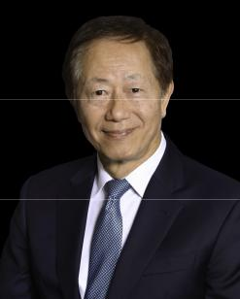

Independent

Age | 71
Director Since | 2025

Committees
Governance and Sustainability, Finance

Professional Experience

- Founder_{2024.} and Chairman of J&M Copper Beech Ventures, a multi-strategy investment fund since April

- Executive Chairman of Taiwan Semiconductor Manufacturing Company Limited, a multinational semiconductor contract manufacturer, from June 2018 to June 2024.

Other Current Public Company Directorships

- None

Board Skills, Qualifications, and Expertise

Mr. Liu’s experience holding operations leadership positions, including Executive Chairman, in Taiwan Semiconductor Manufacturing Company Limited, a public multinational semiconductor contract manufacturer, provides our Board expertise in our industry and technology, as well as finance, business development, manufacturing, international operations, corporate governance and information security expertise. We believe these experiences, qualifications, attributes, and skills qualify Mr. Liu to serve as a member of our Board.

8 | 2025 Proxy Statement

Table of Contents


Sanjay Mehrotra

Chairman, Chief Executive Officer

Age | 67
Director Since | 2017

Professional Experience

- Mr. Mehrotra has served as Micron’s President, Chief Executive Officer, and Director since May 2017 and has served as Micron’s Chairman since January 2025.

- Prior to that, Mr. Mehrotra co-founded and led SanDisk Corporation as a start-up in 1988 until its eventual sale in May 2016, serving as its President and Chief Executive Officer from January 2011 to May 2016 and as a member of its Board of Directors from July 2010 to May 2016.

Other Current Public Company Directorships
- CDW Corporation

Board Skills, Qualifications, and Expertise

Mr. Mehrotra has 45 years of experience in the semiconductor memory industry, and as a co-founder of SanDisk, he offers a unique perspective on the industry and has significant senior leadership and technological expertise. In addition, Mr. Mehrotra’s experience provides our Board expertise in finance, corporate development, corporate governance, and business strategy, all of which are critical to achieving our strategic objectives. We believe these experiences, qualifications, attributes, and skills qualify Mr. Mehrotra to serve as a member of our Board.

- Christine Simons

Independent

Age | 63
Director Since | 2025

Committees
Audit, Security

Professional Experience

- Partner at Deloitte & Touche LLP, the U.S. member firm of the global audit, tax, and advisory services firm, from August 2004 to May 2025, serving global technology clients in various leadership roles, including leading the firm’s Global Semiconductor Center of Excellence and leading the U.S. Technology, Media & Telecommunications (TMT) Audit & Assurance practice.

Other Current Public Company Directorships

- Autodesk, Inc.

Board Skills, Qualifications, and Expertise

Ms. Simon’s experience advising numerous global technology clients on financial and accounting matters as a partner at Deloitte & Touche LLP provides our Board deep technical expertise in financial and accounting matters, and contributes valuable insights and perspectives to our business and operations. We believe these experiences, qualifications, attributes, and skills qualify Ms. Simons to serve as a member of our Board.

9

Table of Contents

Robert H. Swan


Independent

Age | 65
Director Since | 2024

Committees
Audit, Finance

Professional Experience

- Operating Partner at Andreessen Horowitz, a venture capital firm, since July 2021. Prior to that, Mr. Swan served at Intel Corporation, a semiconductor manufacturing company, as Chief Executive Officer from February 2019 to February 2021, as Interim Chief Executive Officer and Executive Vice President, Chief Financial Officer from June 2018 to January 2019 and as Executive Vice President, Chief Financial Officer from October 2016 to June 2018. Prior to joining Intel, Mr. Swan held several senior management roles at other companies, including Chief Financial Officer at eBay Inc., Electronic Data Systems Corp., TRW Inc., and Webvan Group, Inc., where he additionally served as Chief Operating Officer and Chief Executive Officer.

- Within the past five years, Mr. Swan served on the Board of Directors of eBay and Intel and served on the Board of Commissioners of GoTo Group.

Other Current Public Company Directorships

- Nike, Inc.

- Automatic Data Processing, Inc.

Board Skills, Qualifications, and Expertise

Mr. Swan’s experience as a former Chief Executive Officer and Chief Financial Officer of public technology companies in the semiconductor memory industry, including Intel, provides our Board

expertise in our industry and technology as well as finance, business development, manufacturing, operations, corporate governance and information security expertise. We believe these experiences, qualifications, attributes, and skills qualify Mr. Swan to serve as a member of our Board.

Professional Experience

•


•

•

•

Group Vice President of Engineering and Product Development of Johnson Controls International from 2013 to 2017. Ms. Wright also served as Vice President and General Manager for Johnson Controls’ Hybrid Systems business and as Chief Executive Officer of Johnson Controls-Saft from 2007 to 2009.

Prior to joining Johnson Controls, Ms. Wright served in the Office of the Chair and was Executive Vice President Engineering, Sales and Program Management at Collins & Aikman Corporation from 2006 to 2007.

Prior to that, Ms. Wright held several executive positions at Ford Motor Company, including Chief Engineer, from 2003 to 2005, and Director of Sustainable Mobility Technologies and Hybrid and Fuel Cell Vehicle Programs from 2004 to 2005.

Within the past five years, Ms. Wright served on the Board of Directors of Maxim Integrated Products, Inc.

MaryAnn Wright

Independent

Age | 63
Director Since | 2019

Committees
Compensation, Governance and Sustainability (Chair)

Other Current Public Company Directorships

- Group 1 Automotive, Inc.

- Brunswick Corporation

- Solid Power, Inc.

Board Skills, Qualifications, and Expertise

Ms. Wright’s extensive experience in, and knowledge of, the automotive industry (OEM and Tier 1 supplier), public board experience and her expertise in vehicle, advance powertrain, and energy storage system technologies, provide our Board expertise in the technology industry as well as business

operations, finance, corporate development, corporate governance, and management, all of which are critical to achieving our strategic objectives. We believe these experiences, qualifications, attributes, and skills qualify Ms. Wright to serve as a member of our Board.

10 | 2025 Proxy Statement

Table of Contents

RETIRING DIRECTORS


Richard M.
Beyer

Independent

Age | 77
Director Since | 2013

Committees
Compensation (Chair), Security

Professional Experience

- Chairman and Chief Executive Officer of Freescale Semiconductor, Inc., a semiconductor manufacturer, from 2008 through June 2012; director from 2008 to 2013.

- Prior to Freescale, Mr. Beyer was President, Chief Executive Officer and a director of Intersil Corporation, a semiconductor company, from 2002 to 2008.

- Mr. Beyer previously served as Chief Executive Officer of Elantec Semiconductor Inc. and in executive management roles at FVC.com, VLSI Technology, and National Semiconductor Corporation, and served three years as an officer in the United States Marine Corps.

- Within the past five years, Mr. Beyer served on the Board of Directors of Dialog Semiconductor.

Other Current Public Company Directorships

- None

Board Skills, Qualifications, and Expertise

Mr. Beyer’s experience as the chief executive officer and a director at leading technology companies provides our Board expertise in the technology industry and also in corporate strategy, financial management, operations, marketing, and research and development, all of which are critical to achieving our strategic objectives.

Mary Pat McCarthy

Independent

Age | 70
Director Since | 2018

Committees
Audit (Chair), Finance

Professional Experience

- Vice Chair of KPMG LLP, the U.S. member firm of the global audit, tax, and advisory services firm, from July 1998 until her retirement in December 2011. Ms. McCarthy joined KPMG in 1977, became a partner in 1987, and held numerous senior leadership positions with the firm during her tenure.

Other Current Public Company Directorships

- Palo Alto Networks, Inc.

Board Skills, Qualifications, and Expertise

Ms. McCarthy’s experience advising numerous companies on financial and accounting matters as a Certified Public Accountant (ret.) provides our Board deep technical expertise in financial and accounting matters, and contributes valuable insights and perspectives to our business and operations.

There are no family relationships between any of our directors or executive officers.

11

Table of Contents

BOARD SNAPSHOT:
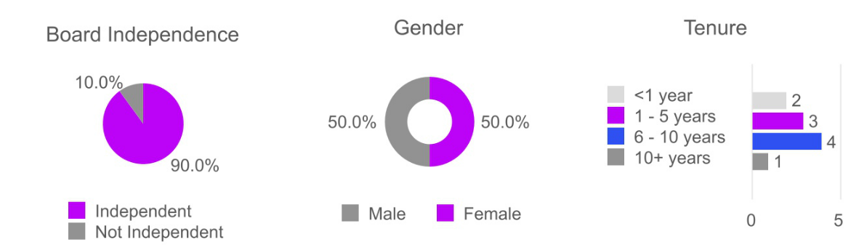

12 | 2025 Proxy Statement

Table of Contents

DIRECTOR SKILLS AND EXPERIENCE

The skills that we value for our Board align with our vision to be a global leader in memory and storage solutions, to transform how the world uses information to enrich life for all. The below table provides an overview of the collective skills of our nominees and why each is essential to the oversight and successful execution of our strategy and values.

Skills and Experience Alignment to Micron’s Strategy and Values

Multinational Experience


Experience with businesses with significant global operations


Executive Leadership (public or private)

Experience in a senior leadership role

Micron is a global leader in memory with over 53,000 employees spanning multiple countries. Our directors provide valuable business and cultural perspectives aligned to our core vision and mission.

The scale and complexity of our industry requires leadership with strategic clarity and an understanding of how to execute our biggest goals.

Operations/Manufacturing


Experience with global, large-scale complex operations or manufacturing


Strategy/Marketing

Experience with sales or marketing strategy

Cybersecurity


Experience managing cybersecurity, information, and data security risks

Governance/Public Company Board Service Experience on a public company’s board of directors overseeing corporate governance programs and policies



Finance

Experience overseeing financial reporting

Our business model involves a complex distribution and supply chain network. Our directors oversee and guide operational efficiencies in various facets of our operations.

We win by knowing our customers and our Board provides guidance in marketing and sales strategy.

Protecting our data and assets requires constant vigilance and awareness of cybersecurity threats. Having directors with a background in cyber oversight allows our Board to assist management in identifying and mitigating these threats.

Our Board emphasizes good board and governance practices and provides valuable oversight in our evolving regulatory environment.

We are a large-scale technology company in a capital-intensive industry, which requires complex financial management. Our Board is an integral part of this function.

13

Table of Contents

Auditing/Accounting


Experience overseeing auditing and accounting

Strategy/Innovation

Experience setting and executing corporate strategies geared towards long-term success


Risk Management

Experience assessing and responding to enterprise risks

Human Capital Management

Experience in human capital management in large global organizations

Technology/Semiconductor


Experience in the semiconductor industry or other relevant technology industries

Public Policy/Political Affairs

Experience obtained through substantive engagements with policymakers or government agencies

Experience with accounting or auditing allows our Board to provide key oversight of our financial reporting processes and internal controls.

Innovation is at the heart of Micron and our Board’s experience with emerging technologies and strategic planning gives us valuable perspective as we assess and execute on our strategic objectives.

Risk management oversight experience promotes our ability to detect, evaluate, and respond to enterprise risks.

Our people are integral to our success, and we care about their successes as well. Our Board’s experiences with management, talent retention and development, and corporate culture provides key insights for our continued investment in our people globally.

We benefit from our Board’s experience and knowledge of the business, technology, products, operations and challenges that impact semiconductor companies or other companies in the technology sector.

Experience working with policymakers or government agencies provides the necessary insight into the political and regulatory matters that impact our Company and its stakeholders. Our Board helps to guide our engagement with regulators and policymakers.

14 | 2025 Proxy Statement

Table of Contents

SUMMARY OF SKILLS AND EXPERIENCE OF NOMINEES

The Governance and Sustainability Committee oversees the Board’s composition and identifies and continually refines the list of skills, attributes, and experiences that it believes will result in an effective, dynamic, and diverse Board. The Governance and Sustainability
Committee uses the insights this matrix provides to recommend committee assignments and inform searches for new director candidates or opportunities to refresh Board composition. From time to time the Governance and Sustainability Committee will undertake a comprehensive review and refresh of the skills matrix. In their most recent annual update in Fiscal 2024, the Governance and Sustainability Committee refreshed the skills matrix to ensure its alignment with our business, including defining the skills and adding a statement on the importance of each skill.

The following table highlights the specific skills, experience, qualifications and attributes that each of our nominees brings to the Board. A particular nominee may possess other skills, experience, qualifications or attributes even though they are not indicated below.

 | Skills and Experience | Lynn A. Dugle | Steven J. | Linnie M. | T. Mark Liu | Sanjay | A. Christine | Robert Swan | MaryAnn
 | Skills and Experience | Lynn A. Dugle | Gomo | Haynesworth | T. Mark Liu | Mehrotra | Simons | Robert Swan | Wright
 | Multinational experience | • | • | • | • | • | • | • | •
Executive leadership (public |  | • | • | • | • | • | • | • | •
 | or private)
 | Operations/Manufacturing | • | • | • | • | • |  | • | •
 | Strategy/Marketing |  |  | • | • | • | • | • | •
 | Cybersecurity | • | • | • | • |  |  | •
Governance/Public Company |  | • | • | • | • | • | • | • | •
 | Board Service
 | Finance | • | • | • | • | • | • | • | •
 | Auditing/Accounting |  | • |  | • |  | • | •
 | Strategy/Innovation | • | • | • | • | • | • | • | •
 | Risk Management | • | • | • | • | • | • | • | •
Human Capital Management |  | • | • |  | • | • |  | • | •
 | Technology/Semiconductor |  | • | • | • | • | • | • | •
Public Policy/Political Affairs |  | • |  |  | • | • |  | • | •
 | Age | 66 | 73 | 68 | 71 | 67 | 63 | 65 | 63
 | Director Since | 2020 | 2018 | 2021 | 2025 | 2017 | 2025 | 2024 | 2019
 | Tenure (Years) | 5 | 7 | 4 | 0 | 8 | 0 | 1 | 6
 |  |  |  | Female,
 | Demographics | Female, |  | African |  |  | Female, |  | Female,
 | Demographics | Female, |  | American or |  |  | Female,
 |  | Female, | Male, White | American or | Male, Asian | Male, Asian | Female, | Male, White
 |  | White | Male, White | Black | Male, Asian | Male, Asian | White | Male, White | White
 |  |  |  |  |  |  |  |  | 15

Table of Contents

DIRECTOR NOMINATIONS AND BOARD REFRESHMENT

NOMINATION PROCESS

The Governance and Sustainability Committee is responsible for identifying and evaluating potential director candidates, reviewing Board and Committee composition, and making recommendations to the full Board.

1 |  |  | 2 |  |  | 3
Director Succession Planning |  |  | Board and Committee Self- |  |  | Tenure, Skills & Background
 |  |  | Evaluations
 | The Governance and |  |  | Annual Board and |  |  | To ensure the Board has an
 | Sustainability Committee |  |  | Committee evaluations help |  |  | appropriate balance of
 | conducts regular reviews |  |  | identify director skills that |  |  | experience, continuity and
 | of the size and |  |  | would enhance Board |  |  | fresh perspective, the
• | composition of the Board, |  | • | effectiveness, and areas for |  | • | Board considers length of
• | including anticipating |  | • | improvement. |  | • | tenure when reviewing
 | vacancies and required |  |  |  |  |  | nominees.
 | expertise for the effective
 | oversight of the
 | Company.
 | The Governance and |  |  | The Governance and |  |  | The Governance and
 | Sustainability Committee |  |  | Sustainability Committee |  |  | Sustainability Committee
 | engages in an ongoing |  |  | reviews the results of the |  |  | considers, among other
 | process to identify and |  |  | self-evaluations for |  |  | things, the knowledge,
 | evaluate, as appropriate, |  |  | potential action and |  |  | experience, integrity, and
 | potential new director |  |  | recommendations, with the |  |  | judgment of the existing
• | candidates with the help |  | • | final results and |  | • | Board and any candidates,
• | of management and an |  | • | recommendations reviewed |  | • | their contribution to the
 | outside consultant, to |  |  | with the full Board. |  |  | diversity of backgrounds,
 | whom it may pay a fee. |  |  |  |  |  | experience and skills* on
the Board, and their ability
to devote sufficient time
and effort to their duties as
directors and provide
appropriate oversight.

4 |  |  | 5
Board Committee Rotation |  |  | Director Onboarding
 | The Governance and |  |  | All new directors participate
 | Sustainability Committee |  |  | in an extensive onboarding
 | considers the periodic |  |  | program, enabling new
 | rotation of Committee |  |  | directors to quickly
 | members and Chairs to |  |  | enhance their strategic
• | introduce fresh |  | • | value to our Board. See
• | perspectives and |  | • | ”Director Onboarding and
 | broaden and diversify the |  |  | Continuing Education”
 | views and experience |  |  | below for additional
 | represented on the |  |  | information regarding
 | Board’s standing |  |  | director onboarding.
 | Committees.

6

Results

Our process has resulted in three new directors in the

last two years, each of whom contributes a variety
of skills, attributes and
- experiences to enhance our Board. See ”Board Refreshment” below.

*The Governance and Sustainability Committee considers the following skills and experience particularly relevant for the Board: experience in the semiconductor industry or related industries; strong business acumen and judgment; excellent interpersonal skills; business relationships with key individuals in industry, government, and education that may be of assistance to us and our operations; familiarity with accounting rules and practices; and “independence” as defined and required by the Listing Rules of the Nasdaq and relevant rules and regulations of the Securities and Exchange Commission (the “SEC”).

16 | 2025 Proxy Statement

Table of Contents

BOARD REFRESHMENT

Our Board believes that periodic director refreshment can provide new experiences and fresh perspectives to the Board and is most effective if it is sufficiently balanced with continuity among Board members that will allow for the sharing of historical perspectives and experiences relevant to the Company. Our Board seeks to achieve this balance through its director succession planning process, as well as in response to the annual Board and individual director assessment process discussed below.

Five of our eight continuing directors have been appointed since 2020. With the recent appointments of Mr. Swan in 2024 and Mr. Liu

and Ms. Simons in 2025, our Board refreshed its composition while maintaining institutional knowledge with directors of varying lengths of tenure.
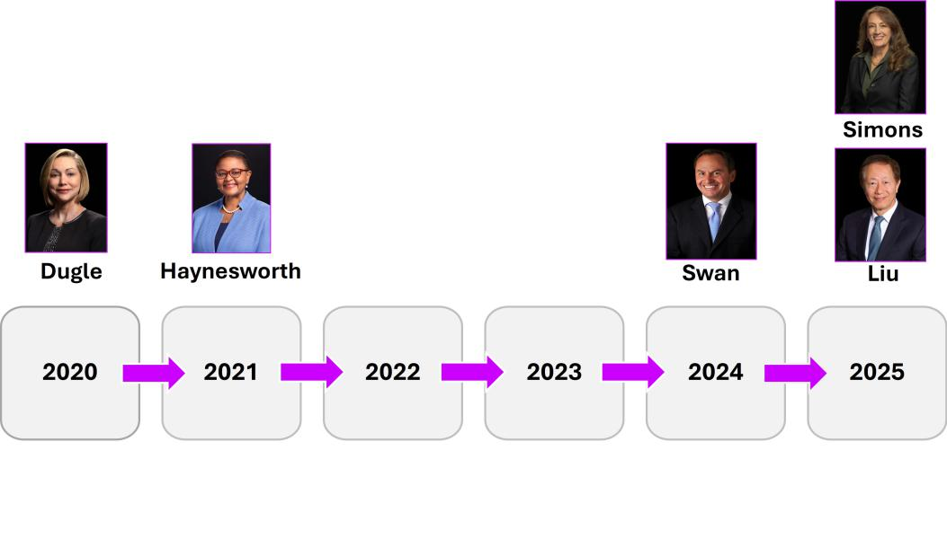

DIRECTOR ONBOARDING AND CONTINUING EDUCATION

We maintain a comprehensive director onboarding program, which is regularly updated, focused on introducing new directors to our business and facilitating director integration on our Board. Our program is designed to familiarize new directors with our business, organization, strategies and policies, and assists new directors in developing company and industry knowledge to optimize their service on the Board. Our process is individualized for each director, taking into account their existing skills and background. The orientation program includes one-on-one meetings with several members of our senior management team, to familiarize new

directors with Micron’s financial position and strategic plans, compliance programs and policies, risk management policies, and operations of the Board.

Regular continuing education programs enhance the skills and knowledge directors use to perform their responsibilities. These programs may include internally developed materials and presentations, programs presented by third parties and financial and administrative support to attend academic or other independent programs.

BOARD SELF-EVALUATION

The Governance and Sustainability Committee oversees the Board’s ongoing and annual assessments of its effectiveness, including the effectiveness of its committees and directors. All directors complete an evaluation form for the Board and for each committee on which they serve. These forms include ratings for certain key metrics, as well as the opportunity for written comments. The comments provide key insights into the areas in which directors believe the Board can improve or in which its performance is strong. Evaluation topics include number and length of meetings, topics covered, and materials provided, committee structure, and activities, Board composition and expertise, succession planning, director participation and interaction with management, and promotion of ethical behavior. Our Board considers the results when making decisions on the composition,

17

Table of Contents

structure and responsibilities of our Board and its committees, agendas and meeting schedules for our Board and its committees, and changes in the performance or functioning of our Board. Such evaluations are also taken into account by the Board in making decisions regarding nominations of directors.

DIRECTOR TIME COMMITMENT POLICY

Our Corporate Governance Guidelines contain the following limits on the number of public company board commitments a director may have.

Director Category | Director Time Service Limits
Non-Employee Directors | No More than 4 Other Public Company Boards
Employee Directors | No More than 2 Other Public Company Boards

This limitation will not apply if the Board determines that simultaneous service does not impair the ability of the member to effectively serve on the Board. A director’s time commitment is considered as part of the director nomination process and is reviewed annually.

18 | 2025 Proxy Statement

Table of Contents

BOARD STRUCTURE

DIRECTOR INDEPENDENCE

The Board has determined that directors Beyer, Dugle, Gomo, Haynesworth, Liu, McCarthy, Simons, Swan, and Wright qualify as independent directors as defined in the Listing Rules of Nasdaq. None of these directors have a relationship which, in the opinion of the Board, would interfere with the exercise of independent judgment in carrying out the responsibilities of a director.

BOARD LEADERSHIP STRUCTURE

Our Board is currently led by Sanjay Mehrotra, as our Chairman, President and Chief Executive Officer, and Lynn A. Dugle, as our Lead Independent Director. Mr. Mehrotra and Ms. Dugle each assumed their role in January 2025.

We do not have a fixed policy on whether the roles of Chairman of the Board and Chief Executive Officer should be separate or combined. Our Governance and Sustainability Committee conducts regular assessments of the Board’s leadership structure and, when appropriate, recommends changes to the Board’s leadership structure to the Board for approval, taking into consideration the needs of the Board and the Company at such time. In the fall of 2024, in connection with the retirement of our former longstanding independent Chairman of the Board, the Board reviewed the Board leadership structure and considered the benefits and risks of a combined Chairman and Chief Executive Officer leadership structure, taking into account the Company’s practices for ensuring independent Board oversight of management. After consideration, our Board determined that combining the roles of Chairman and Chief Executive Officer (in combination with a Lead Independent Director) is the most effective leadership structure for the Company at this time, and unanimously appointed Mr. Mehrotra as Chairman.

Mr. Mehrotra has transformed the Company into a technology, product, and manufacturing leader and has been widely recognized for his leadership and contributions to the memory and storage industry. This Board leadership structure clearly allocates primary responsibility for the operational leadership and strategic direction of the Company to our Chairman and Chief Executive Officer, while enabling the Lead Independent Director to facilitate our Board’s independent oversight of management, promote communication between management and our Board, and support our Board’s consideration of key governance matters.

Our Corporate Governance Guidelines provide that when the role of the Chairman is combined with that of the Chief Executive Officer, the independent directors are required to appoint a lead independent director. Accordingly, in connection with Mr. Mehrotra’s appointment as Chairman, the Board unanimously elected Lynn Dugle as our Lead Independent Director. Ms. Dugle is an experienced public company Board member and former executive. Her background and experience not only provides our Board with strong, experienced and independent leadership, it also provides our Board expertise in information, technology, cybersecurity, corporate strategy, operations, and research and development, all of which are critical to achieving our strategic objectives. In addition, her five-year tenure on the Micron Board is balanced in that it is long enough for her to have gained a deep understanding of the Company, yet short enough to ensure there is no entrenchment and that she is fully independent of management. Ms. Dugle provides strong independent leadership, which is essential for our Board to effectively perform its primary oversight functions, and provide the Board with the opportunity to constructively challenge management, while leveraging Mr. Mehrotra’s deep understanding of the business, the semiconductor industry and technology to elevate the right strategic opportunities and key risks and mitigation approaches to the Board’s attention.

In her role as Lead Independent Director, Ms. Dugle oversees our Board and facilitates the flow of information between it and management. This fosters open dialogue and constructive feedback among our independent Board members and management. In particular, our Lead Independent Director has the duties as set forth in our Corporate Governance Guidelines as follows, as well as such other duties and responsibilities as requested by the Board:

- serve as a liaison between the Chief Executive Officer and the independent directors;

- lead executive sessions of the Board;

19

Table of Contents

- have authority to call Board meetings, special meetings of shareholders, and meetings of the independent directors;

- lead the Board in discussions concerning the Chief Executive Officer’s performance and Chief Executive Officer succession;

- approve meeting agendas and meeting schedules for the Board;

- approve information sent to the Board; and

- if requested by major shareholders, be available for consultation and direct communication.

We believe it is essential that the Board maintain the flexibility to determine its leadership structure based on the particular composition of the Board and continuity of leadership, the individuals serving in leadership positions, and the evolving needs and opportunities of the Company. The Board believes its programs for overseeing risk, as described under “The Board’s Roles and Responsibilities—The Board’s Role in Risk Oversight—Risk Oversight, Assessment, and Mitigation” below, would be effective under a variety of leadership frameworks and therefore do not materially affect its choice of structure.

Accordingly, the Board will continue to consider its leadership structure from time to time.

BOARD MEETINGS AND COMMITTEES

Our Board held seven formal meetings during Fiscal 2025. The Board met in Executive Session (meetings in which only independent directors are present) six times during Fiscal 2025. In Fiscal 2025, the Board had a standing Audit Committee, Compensation Committee, Finance Committee, Governance and Sustainability Committee, and Security Committee. During Fiscal 2025, the Audit Committee met nine times, the Compensation Committee met six times, the Finance Committee met four times, the Governance and Sustainability Committee met five times, and the Security Committee met four times. In addition to formal committee meetings, the chair of each committee engaged in regular discussions with management regarding various issues relevant to their respective committees. All incumbent directors attended 75% or more of the total number of meetings of the Board and the committees on which they served during Fiscal 2025. We expect director attendance at the Annual Meeting, and all then-serving members of our Board were present at our Fiscal 2024 Annual Meeting of Shareholders.

The Audit, Compensation, Finance, Governance and Sustainability, and Security Committees each have written charters that comply with the rules of the SEC and the Listing Rules of Nasdaq rules relating to corporate governance matters. The complete duties and responsibilities of each of the committees are set forth in their written charters. Copies of the committee charters as well as our Corporate Governance Guidelines are available on the corporate governance portion of our website at www.micron.com and are also available in print without charge upon request to corporatesecretary@micron.com.

Audit Committee

Mses. McCarthy, Haynesworth and Simons and Messrs. Gomo and Swan currently serve on the Audit Committee. Ms. Simons joined the committee in June 2025. Ms. McCarthy has served as Chair of the Audit Committee since January 2023 and will continue to serve until her term as a director ends at the Annual Meeting. The Board has determined that all Audit Committee members are independent under the rules applicable to audit committee members promulgated by the SEC and the Listing Rules of Nasdaq and that each of these members is sufficiently proficient in reading and understanding our financial statements to serve on the Audit Committee. The Board has determined that each of Mses. McCarthy and Simons and Messrs. Gomo and Swan qualifies as an “audit committee financial expert” for purposes of the rules and regulations of the SEC.

20 | 2025 Proxy Statement

Table of Contents


Audit Committee | Primary Responsibilities

- Assist the Board in overseeing and monitoring:

Meetings in Fiscal 2025• the integrity of our financial statements;

5 | • | the adequacy of our internal controls and procedures;
Members | • | the performance of our internal audit function and of our independent registered
 | • | public accounting firm;

Mary Pat McCarthy, Chair

Steven J. Gomo

Linnie M. Haynesworth

A. Christine Simons Robert H. Swan

- any related party transactions;

- the qualifications and independence of our independent registered public accounting firm; and

- our compliance with legal and regulatory requirements.

Prepare the Audit Committee Report that is included in our proxy statement.

Compensation Committee

Mses. Wright and Dugle and Mr. Beyer currently serve on the Compensation Committee. Ms. Dugle joined the committee in January 2025.

Mr. Beyer has served as Chair of the Compensation Committee since April 2021 and will continue to serve until his term as a director ends at the Annual Meeting. The Board has determined that all Compensation Committee members are independent under the applicable Listing

Rules of Nasdaq and each qualifies as a “non-employee director” as defined under Rule 16b-3 of the Securities Exchange Act of 1934, as amended (the “Exchange Act”). The Compensation Committee is responsible for reviewing and approving the compensation of our executive officers. See “Executive Compensation and Related Information—Compensation Discussion and Analysis” and “Executive Compensation and Related Information—Compensation Committee Report” for information regarding how the Compensation Committee sets executive compensation levels. The Compensation Committee has authority to delegate any of its responsibilities to a subcommittee as it may deem appropriate in its judgment.

Compensation Committee |  | Primary Responsibilities
6 |  |  | Review and approve salaries, bonuses, equity awards, other compensation, and the
6 |  | • | performance measures and goals for our Chief Executive Officer and other executive
Meetings in Fiscal 2025 |  |  | officers;
3 |  | • | Review and approve amendments to or terminations of any compensatory contracts
Members |  | • | with the Chief Executive Officer or other executive officers;
 |  | • | Establish and review, and oversee the development and implementation of, the
 |  | • | Company’s employee compensation plans, including the Short-Term Incentive Plan
 |  |  | (the “STI Plan”);
 |  | • | Administer the Company’s equity-based plans;
 |  | • | Assess risks arising from the Company’s compensation plans, programs, policies
 |  | • | and practices;
Richard M. Beyer, Chair |  | • | Administer the Company’s clawback and recoupment policy; and
Lynn A. Dugle |  | • | Oversee matters relating to shareholder approval of executive compensation,
MaryAnn Wright |  | • | including related shareholder proposals.

Finance Committee

Ms. McCarthy and Messrs. Gomo, Liu, and Swan currently serve on the Finance Committee. Mr. Liu joined the Finance Committee in March 2025. Mr. Gomo has served as Chair of the Finance Committee since January 2023. Ms. McCarthy will continue to serve on the Finance Committee until her term as a director ends at the Annual Meeting. The Board has determined that all Finance Committee members are independent under the Listing Rules of Nasdaq.

21

Table of Contents


Finance Committee | Primary Responsibilities

- Assist the Board in overseeing and monitoring:

Meetings in Fiscal 2025• financial policies and strategies;

4 | • | capital structure;
Members | • | debt and equity offerings;
 | • | capital return program;
Steven J. Gomo, Chair | • | cash management and investments; and
T. Mark Liu | • | risk management related to hedge and derivative instruments and insurance.
Mary Pat McCarthy
Robert H. Swan

Governance and Sustainability Committee

Mses. Dugle and Wright and Mr. Liu currently serve on the Governance and Sustainability Committee. Mr. Liu joined the committee in March 2025. Ms. Wright has served as Chair of the Governance and Sustainability Committee since April 2021. The Board has determined that all Governance and Sustainability Committee members are independent under the Listing Rules of Nasdaq.


Governance and | Primary Responsibilities
Sustainability Committee | Primary Responsibilities
- Assist the Board in overseeing and monitoring:

Meetings in Fiscal 2025• identification and selection of nominees to our Board;

3 | • | director compensation;
Members | • | development and integration of material sustainability strategies;
 | • | our human capital management efforts, including talent development and retention,
 | • | and culture programs and initiatives;
 | • | development of our Corporate Governance Guidelines;
 | • | evaluation of the Board and management;
MaryAnn Wright, Chair | • | monitoring our lobbying and political activity, including policies and guidelines
Lynn A. Dugle | • | regarding the Company’s political contributions and activities; and
Lynn A. Dugle | • | shareholder engagement and shareholder proposals.
T. Mark Liu | • | shareholder engagement and shareholder proposals.

Security Committee

Mses. Haynesworth and Simons and Mr. Beyer currently serve on the Security Committee. Ms. Simons joined the committee in March 2025. Ms. Haynesworth has served as Chair of the Security Committee since January 2024. Mr. Beyer will continue to serve on the Security Committee until his term as a director ends at the Annual Meeting. The Board has determined that all Security Committee members are independent under the Listing Rules of Nasdaq.

22 | 2025 Proxy Statement

Table of Contents


Security Committee | Primary Responsibilities
- Assist the Board in overseeing and monitoring:

Meetings in Fiscal 2025 |  | • | physical security of our facilities and employees as well as enterprise cybersecurity
3 |  | • | and data protection risks associated with our security-related infrastructure and
3 |  |  | related operations, including outside partners;
Members |  | • | cyber crisis preparedness and security breach and incident response plans;
 |  | • | compliance with applicable information security and data protection laws and
 |  | • | industry standards;
 |  | • | our physical and cybersecurity strategy, crisis or incident management, as security-
Linnie M. Haynesworth, |  | • | related information technology and planning processes;
Chair |  | • | public disclosure relating to security of our employees, facilities, and information
Richard M. Beyer |  | • | technology systems, including privacy, network security and data security; and
A. Christine Simons |  | • | oversight of cybersecurity and data protection risks associated with our products.

Executive Sessions

Ms. Dugle has been the Lead Independent Director of our Board since January 2025. During Fiscal 2025, as part of her duties as Lead Independent Director, Ms. Dugle chaired Executive Session meetings of our Board. The Board meets in Executive Session regularly and held six such Executive Session meetings in Fiscal 2025.

23

Table of Contents

THE BOARD’S ROLES AND RESPONSIBILITIES

THE BOARD’S ROLE IN RISK OVERSIGHT

Risk Oversight, Assessment and Mitigation

We operate in a dynamic economic, social, and political landscape, making structured and conscientious risk management more important than ever. Our Board reviews and oversees our enterprise risk management program, which uses an integrated approach to manage risks that helps us achieve a shared understanding of risks and opportunities and make informed business decisions. This approach enhances our capability to identify potential events, trends, and operating conditions that could create uncertainty for our business, enabling us to better prepare and respond to the risks in an efficient and effective manner.

The Board has delegated primary oversight of our enterprise risk management process to the Audit Committee, which conducts reviews of our risk assessment and enterprise risk management policies as described below, including overseeing the management of risks related to financial reporting and compliance. Other Board committees provide additional insights into our enterprise risk management program in the areas of their core competencies, and report to the Board regularly on matters relating to the following specific areas of risk the committees oversee:

- The Compensation Committee oversees management of risks relating to our compensation plans and programs.

- The Finance Committee oversees the Company’s strategies for management of significant financial risks.

- The Governance and Sustainability Committee oversees risks associated with the Board’s governance, director independence, the Company’s human capital programs and sustainability initiatives, and public policy and government affairs activities.

- The Security Committee oversees risks associated with physical security and cybersecurity.

In performing their oversight responsibilities, the Board and each committee has full access to management, as well as the ability to engage independent advisors. In addition, the Lead Independent Director of the Board leads regular executive sessions of the independent directors, facilitates cross-committee feedback, and fosters open dialogue and constructive feedback among the independent directors, which further supports the Board’s ability to fulfill its risk oversight duties. See “Proposal 1 - Election of Directors—Board’s Roles and Responsibilities— Board Leadership Structure.”

Enterprise Risk Management Process

We designed our enterprise risk management program to clearly identify risk management roles and responsibilities, bring together senior management to discuss risk, promote visibility and constructive dialogue, and facilitate risk response and mitigation strategies. The Audit Committee plays a key role in this process, and the full Board conducts periodic reviews.

Our Vice President of Risk Advisory Services coordinates two enterprise risk management workstreams:

- Quarterly Assessment by Risk Council: This workstream consists of a quarterly meeting of the Risk Council, which is composed of representatives from all our major functions. The Risk Council evaluates our operations and surrounding circumstances, identifying potential events, trends, or operational conditions that could result in a risk exposure, referred to as Risk Triggers. Once the most significant Risk Triggers are identified, Risk Advisory Services performs an evaluation of their potential impacts on us, assesses if the existing business processes and controls are sufficient to manage the risk and identifies if additional risk mitigating actions are needed. Where additional actions are deemed necessary, the Risk

24 | 2025 Proxy Statement

Table of Contents

Council representative of the relevant function coordinates the implementation of such actions. The results of Risk Council quarterly assessments are presented to the Company’s senior leadership and the Audit Committee for review and discussion, and feedback from these parties is taken into consideration in the implementation of such actions.

- Annual Process Owner Risk Self-Assessment: Annually, Risk Advisory Services facilitates a process where key process owners across the enterprise evaluate their processes’ ability to mitigate related risks and identify necessary improvements. This assessment is presented to each functional head, where process owners and their senior functional leaders discuss the results and determine if any actions, process changes or improvements are necessary. The overall results of the annual self-assessment are presented to the Audit Committee and the Board.

The combination of these two workstreams embeds risk management in our fabric, regularly engaging leaders across the enterprise and focusing the entire organization on the identification of and mitigation of risks.

These workstreams also provide timely information to our Chief Executive Officer’s staff and the Audit Committee that is used as input in the development of the Company’s strategy and direction.

Compensation Risks

The Compensation Committee reviews our compensation programs annually to determine whether risks arising from our compensation policies and practices are reasonably likely to have a material adverse effect on us. In making this assessment, we, with guidance from outside compensation consultants, reviewed our compensation programs to determine if the programs’ provisions and operations create undesired or unintentional risk of a material nature. The Compensation Committee then reviewed the results of our findings with our outside compensation consultant. This risk assessment process included a review of program policies and practices; program analysis to identify risk and risk control related to the programs; and determinations as to the sufficiency of risk identification, the balance of potential risk to potential reward, and risk control. In most cases, our compensation policies and practices are centrally designed and administered and are substantially the same across the Company. Certain internal groups have different or supplemental compensation programs tailored to their specific operations and goals, and programs may differ by country due to variations in local laws and customs. Although the Compensation Committee’s review included all compensation programs, the committee focused on the programs with variability of payout, with the ability of a participant to directly affect payout, and the controls on participant action and payout. Following the review, the Compensation Committee concluded that our compensation policies and practices are not reasonably likely to create situations that would have a material adverse effect on us.

Cybersecurity Risks

Our Board administers its cybersecurity risk oversight function directly as a whole, as well as through the Security Committee, which is comprised of independent directors. Our Chief Security Officer and our Chief Information Officer report to our Security Committee, which oversees monitoring and incident response, risk mitigation, supply chain security, physical security, product security, insider trust, and other security-related items, and are primarily responsible to assess and manage our material risks from cybersecurity threats. Our Chief Security Officer and Chief Information Officer provide quarterly briefings to the Security Committee regarding our cybersecurity risks and activities, including any recent cybersecurity incidents and related responses, cybersecurity systems testing, and activities of third parties. Our Security Committee provides regular updates to the Board on such reports. In addition, our Chief Security Officer and our Chief Information Officer provide annual briefings to the Board on cybersecurity risks and activities.

25

Table of Contents

Our cybersecurity policies and practices follow the cybersecurity framework of the National Institute of Standards and Technology (NIST). We periodically engage assessors, consultants, auditors, or other third parties in connection with our risk assessment processes. The results of those assessments are reported to the Security Committee, and we make adjustments to our cybersecurity policies and practices as necessary in light of the assessments. Like any other technology company operating in today’s environment, we have experienced incidents in the past and may experience them in the future. However, we have not experienced any cybersecurity incidents that have been determined to be material. We maintain an information security (cybersecurity) risk insurance policy as a matter of good practice.

ARTIFICIAL INTELLIGENCE

Our artificial intelligence (“AI”) governance framework is intended to be flexible enough to keep pace with emerging opportunities, challenges and risks, as well as the evolving international regulatory environment. In the fall of 2023, with Board support, we launched a generative AI governance initiative. Our governance structure provides for technical and AI risk assessment and executive leadership oversight on the innovative and responsible use of emerging generative AI-enabled solutions. All Micron team members are required to adhere to our AI Governance Policy in the development or deployment of AI systems.

Our information technology and security teams, led by our Chief Information Officer, are responsible for the AI governance process, with close support from the Compliance, Legal, and People teams. We have established an Executive Committee, comprised of senior management, which provides strategic guidance and meets periodically to review key cases escalated by the Operating Committee. The cross-functional Operating Committee drives compliance with AI ethical principles and regulatory requirements in the development and usage of generative AI tools and implements Executive Committee Guidance. Our Operating Committee, which meets regularly, reports to our Chief Information Officer and provides regular updates. The Security Committee of the Board also receives regular updates on our AI governance process and procedures.

HUMAN CAPITAL AND CULTURE

Micron is committed to fostering a culture of innovation and excellence by attracting and retaining top talent. In alignment with this commitment, the Company mandates comprehensive training for all employees to promote a respectful and inclusive workplace, free from harassment and discrimination. Leaders receive additional training focused on psychological safety to enhance trust, collaboration, and organizational performance. To further support employee wellbeing, Micron provides a global Employee Assistance Program accessible to all team members. The Company’s 10 Employee Resource Groups (“ERGs”) play a critical role in cultivating inclusive environments, with membership now representing more than half of the workforce. Micron also facilitates opportunities for team members to engage in community service and build social connections through onsite experiences.

The Board has directed management to proactively develop the future semiconductor workforce and regularly evaluates improvement efforts. We are investing in upskilling employees for an AI-driven workplace by assessing current AI proficiency, launching foundational learning pathways, and creating cohort-based, hands-on training to address skills gaps and enhance AI capabilities throughout the organization.

Beyond these internal initiatives, the Board has directed the Company to strengthen its support for global communities. The Micron Foundation, established by the Company, advances this goal by providing grants that expand access to STEM education, careers in the semiconductor industry, and resources addressing basic living needs. The Company has increased its annual donation match cap to $10,000 per employee and enhanced corporate governance by implementing a new company-wide policy governing financial and in-kind contributions to nonprofits, academic institutions, and governments. Micron employs outcomes-based, data-driven grant making and encourages skills-based volunteering to further employee development and community impact.

SUSTAINABILITY

Our commitment to understanding and addressing sustainability impacts and opportunities relevant to our business, along our value chain and in our communities is a critical part of our business practice and our vision to transform how the world uses information to enrich life for all. Our Board considers sustainability to be an integral

26 | 2025 Proxy Statement

Table of Contents

part of its business oversight and our corporate strategy and has encouraged a proactive approach toward mitigating our impact on the environment, establishing energy and climate strategy, supporting our team members and the communities in which they live, respecting human rights, driving transparency and accountability in our supply chain, and developing innovative products that support our customers and a sustainable future. We have developed and are executing a sustainability strategy addressing these areas that leverages our leading products, responsible sourcing and operations, and engaged team members.

The Board, supported by the Governance and Sustainability Committee and other Board committees as needed, oversees and monitors the development and integration of this strategy and regularly reviews sustainability performance. Board oversight includes, but is not limited to, monitoring material sustainability trends and related long- and short-term impacts of the Company’s operations, supply chains, and products, as well as the Company’s activities and annual public reporting on these topics directed by the Company’s Sustainability Council, which is made up of senior leaders who represent a range of functions, sustainability staff, and various teams implementing the Company’s sustainability efforts.

The Governance and Sustainability Committee reviews and discusses sustainability issues at each quarterly committee meeting. Discussions and reports to the committee include information about significant sustainability issues, such as observations from consultations with team members, customers, investors, and other stakeholders about their interests and expectations for us; our sustainability impacts and benefits; and the risks and opportunities that these subjects may pose to our business. The Governance and Sustainability Committee regularly reviews the establishment and implementation of our long-term environmental goals and aspirations. As our programs continue to evolve, we revisit these goals to drive greater performance and address the expectations of our stakeholders. In 2020, we set ambitious long-term goals for emissions, energy, water, and waste. In 2022, we expanded our ambitions, setting new goals for our climate initiatives. We expect to allocate about $1 billion of capital expenditures between 2021 and 2028 to support these goals, though we cannot guarantee that our environmental goals and aspirations set forth below will be realized. These goals and initiatives have been developed based in part on feedback from investors, customers, and team members, and are a critical component of our management of evolving physical, regulatory, market, supply chain, and other risks and opportunities related to climate change, water availability, and other sustainability issues.

Our Environmental Goals and Aspirations

 | Goals | Aspirations
Emissions: | 42% absolute reduction in scope 1 emissions by | Net zero scope 1 and 2 emissions by
 | calendar year 2030 from the calendar year 2020 | calendar year 2050
 | baseline
Energy: | 100% renewable electricity in U.S. operations by | 100% carbon-free electricity globally, where available
 | the end of calendar year 2025
 | 100% renewable electricity in Malaysia and China
 | (ongoing)
Water: | 75% water conservation through reuse, recycling, and | 100% water conservation through reuse,
 | restoration in calendar year 2030 | recycling, and restoration
Waste: | 95% reuse, recycle, and recovery and zero hazardous | Zero waste to landfill through waste minimization,
 | waste to landfill in calendar year 2030* | reuse, recycling, and recovery

- Subject to vendor availability

In Fiscal 2025, the Board also reviewed:

- our annual sustainability report content and processes, which includes indexes and information aligning with the Sustainability Accounting Standards Board (“SASB”) semiconductor industry standard, and Taskforce on Climate-related Financial Disclosures (“TCFD”);

- our responsible sourcing and human rights efforts, including our annual modern slavery and human trafficking statement;

27

Table of Contents

- our human capital initiatives, including our talent acquisition, retention, and development policies and practices; and

- findings from team member, customer, investor and other stakeholder engagement exercises.

We plan to continue regular consultation with stakeholders regarding sustainability, reviewing and enhancing our performance in support of our business, and reporting annually on our progress. Our 2025 Sustainability Report, available at micron.com/sustainability, includes more details about our sustainability programs.

COMMUNICATIONS WITH THE BOARD OF DIRECTORS

Shareholders and interested parties wishing to communicate with our Board, or our non-employee directors as a group, may contact our Corporate Secretary at corporatesecretary@micron.com. Communications are reviewed by our Legal and Investor Relations teams and directed to the appropriate member of the Board. Certain items that are unrelated to the duties and responsibilities of the Board will not be forwarded, such as: business solicitation or advertisements; product- or service-related inquiries, junk mail or mass mailings; resumes or other job-related inquiries; spam; and overly hostile, threatening, potentially illegal, or similarly unsuitable communications.

BOARD PROCESSES AND POLICIES

Code of Business Conduct and Ethics

Acting ethically is a critical part of our culture and our vision to transform how the world uses information to enrich life for all. The Board has adopted a Code of Business Conduct and Ethics that is applicable to all our directors, officers, and team members. The Code of Business Conduct and Ethics sets out our expectations regarding the treatment of our team members, customers, and the communities in which we operate, as well as our commitment to high product quality, ethical and legal sourcing of our materials, and acting with integrity for our investors. A copy of our Code of Business Conduct and Ethics is available at www.micron.com and is also available in print without charge upon request to corporatesecretary@micron.com. Any amendments or waivers of the Code of Business Conduct and Ethics will also be posted on our website as required by applicable rules and regulations of the SEC and the Listing Rules of Nasdaq.

Corporate Governance Guidelines

The Board has adopted Corporate Governance Guidelines that address items such as the qualifications and responsibilities of our directors and director candidates, board leadership, certain governance policies and practices, and the Board’s communications with our stakeholders. A copy of our Corporate Governance Guidelines is available at www.micron.com and is also available in print without charge upon request to corporatesecretary@micron.com.

28 | 2025 Proxy Statement

Table of Contents

SHAREHOLDER OUTREACH

Our relationship with our shareholders plays an important part in our long-term success. Our shareholders have regularly shared their insights and perspectives with us over the years through our investor relations program, which involves one-on-one meetings, conferences and roadshows, among other engagements. In 2025, we continued our expanded, integrated shareholder engagement effort that included outreach to our shareholders’ investor stewardship and governance teams to continue to solicit feedback on areas of interest from shareholders, including governance, compensation and sustainability matters.

Who We Met With

58%

Of Shares Outstanding Contacted

Including Contacting

100%

Of Our 40 Largest Shareholders

40%

Of Shares Outstanding Met with Us

Across

13
Meetings

Micron’s |  | Primary Topics
Outreach Team |  | Covered
Lead Independent |  | Sustainability, Human
Director of Board |  | Capital and Artificial
 |  | Intelligence
People Team
Environmental, Health &
Safety |  | Corporate Governance
Corporate Secretary
Office
Investor Relations |  | Executive Compensation
 |  | Program


Our discussions with shareholders included senior members of our Legal, People, Sustainability and Investor Relations teams. In addition, our Lead Independent Director was involved in meetings with holders of 39% of our outstanding shares. The feedback we received during these meetings was shared with our full Board and relevant committees.

29

Table of Contents

Over the years, these conversations with our shareholders covered corporate governance, executive compensation, sustainability and human capital, business, strategy and global operations, and our governance and political practices, including AI governance and the impact of AI on these matters. Such conversations informed enhancements to our practices and disclosures in these areas. Specifically, feedback related to executive compensation was carefully considered in making changes to our compensation program.

Topic | What We Heard and Our Perspective
Compensation
Executive Compensation Program and | • Shareholders appreciated the program enhancements and increased proxy
Disclosures | statement disclosure in recent years.
 | • In response to shareholder questions, we discussed, and investors generally
 | understood, that we are limited in our ability to disclose more details about our
 | strategic goals because disclosure of these details could cause irreparable harm to
 | us due to our unique competitive environment.
 | • Shareholders asked for details about, and we discussed, how sustainability is
 | integrated into our executive compensation program and details about our targets.
Corporate Governance
Board Experience, Composition, and | • We engaged with shareholders to familiarize them with the backgrounds and skills
Refreshment | that Mr. Liu and Ms. Simons, two directors we added in March 2025, bring to the
 | Board.
 | • We engaged with shareholders regarding our board leadership structure, including
 | the rationale for the combined Chief Executive Officer/Chairman with a Lead
 | Independent Director structure we implemented in January 2025, and why it is the
 | best structure for the Board at this time.
 | • We engaged with shareholders on our Board’s composition, including tenure, skills
 | and experience, as well as our evaluation process.
Board Oversight of Risk | • We engaged in discussions regarding our Board’s approach to oversight of risk,
 | including geopolitical, cybersecurity and AI risks, and our enterprise risk
 | management program.
Human Capital and Culture
Succession Planning, Employee Retention, | • We engaged with our shareholders regarding succession planning, employee
and Competition for Talent | retention, including the impact of AI on our workforce, and where we may face
 | competition for talent.
 | • We provided our perspective on how we equip our team members with the latest AI
 | tools and training to unlock human potential and labor productivity.
Sustainability
Goals and Investments | • We engaged in discussions regarding our commitments on water, energy, waste and
 | greenhouse gas emissions and maintaining our goals as we grow our manufacturing
 | operations and business. Shareholders provided favorable feedback on our
 | sustainability disclosures, and progress on our goals.
 | • We discussed our commitment to invest $1 billion by 2028 to advance our
 | environmental goals, and the focus of our spend on opportunities relevant to
 | Micron’s business.
Energy Efficiency | • We discussed our global renewable energy strategy, including how we are
 | managing the energy demand of AI, and our efforts to build energy efficiency into
 | our products. Shareholders appreciated our energy strategy and energy efficient
 | products.
Supply Chain | • We discussed our active engagement with all stakeholders to continue to advance a
 | resilient and sustainable semiconductor supply chain.

30 | 2025 Proxy Statement

Table of Contents

CERTAIN RELATIONSHIPS AND RELATED PERSON TRANSACTIONS

Our Related Person Transactions Policy delegates authority to the Audit Committee to review and approve related person transactions. Pursuant to the policy, related person transactions are reviewed and approved or ratified at least quarterly by our Audit Committee in accordance with the terms of the policy. Related persons include our directors and officers, their affiliates, nominees for election as director, certain beneficial owners of 5% or more of any class of our capital stock, and any member of the immediate family of any of the foregoing persons. If a conflict of interest exists between us and the related person, the conflicted director will recuse himself or herself from any discussion or vote of the Audit Committee on the transaction creating the conflict. In reviewing a proposed related person transaction, the Audit Committee considers all the relevant facts and circumstances of the transaction, such as (i) whether the terms of the transaction are fair to the Company and on terms that are no less favorable than terms available to an unaffiliated party in similar circumstances, (ii) the extent of the related person’s in interest in the transaction, (iii) the business reasons for the transaction, (v) whether the transaction would result in an improper conflict of interest, and (vi) whether the transaction would impair the ability of any director to serve on the Company’s Board or committees. There were no actual or proposed related person transactions in which a related person had a direct or indirect material interest since the beginning of Fiscal 2025.

31

Table of Contents

DIRECTOR COMPENSATION

The Governance and Sustainability Committee oversees the setting of compensation for our non-employee members of the Board and recommends changes, if any, to the full Board for consideration. Each year, the Governance and Sustainability Committee works with our compensation consultant to review and evaluate director compensation for the ensuing fiscal year, in light of prevailing market conditions and to attract, retain, and reward qualified non-employee directors. The compensation consultant gathers and reviews market data for non-employee directors from the same compensation peer group used to evaluate executive officer compensation. For a discussion concerning the companies that comprised our compensation peer group, please see “Executive Compensation and Related Information—Compensation Discussion and Analysis—Determination of the Compensation Peer Group.”

Non-employee directors are compensated pursuant to the terms of the 2025 Director Compensation Plan (the “DCP”), which operates as a sub-plan of the 2025 Equity Incentive Plan (the “2025 Plan”) and provides for cash and equity compensation. Employee directors receive no additional or special remuneration for their service as directors.

ELEMENTS OF DIRECTOR COMPENSATION

Annual Retainer and Committee Chair Remuneration

In Fiscal 2025, non-employee directors were entitled to receive an annual cash retainer of $125,000. Non-employee directors may elect to take some or all of their annual cash retainer in shares of common stock, $0.10 par value per share (the “Common Stock”), payable on the
dates on which the retainer is normally paid, or in deferred rights to receive Common Stock upon termination as a director (in either case, having an initial value equal to the cash amount forgone). The amounts earned by the non-employee directors in respect of their service during Fiscal 2025 are set forth below under “—Fiscal 2025 Director Compensation.”

In addition to the annual cash retainer, non-employee directors are entitled to receive cash for their service as a committee chair or Lead Independent Director. Set forth below are the standard cash amounts non-employee directors were and are entitled to receive for their service as committee chair or Lead Independent Director for Fiscal 2025 and 2026 (assuming in each case service for the entire year):

Audit Committee Chair | $ | 37,500
Compensation Committee Chair |  | 30,000
Finance Committee Chair |  | 20,000
Governance and Sustainability Committee Chair |  | 20,000
Security Committee Chair |  | 20,000
Lead Independent Director(1) |  | 55,000
Chair of the Board(2) |  | 150,000

- The cash amount for the Lead Independent Director was established during Fiscal 2025, following input from our compensation consultant, in connection with the appointment of Ms. Dugle to such role in January 2025.

- Mr. Mehrotra does not receive compensation for his role as Chairman of the Board.

Except for the foregoing, directors do not receive any additional or special cash remuneration for their service on any of the committees established by the Board. We reimburse directors for travel and lodging expenses, if any, incurred in connection with attendance at Board or committee meetings, Company events, and for continuing education.

32 | 2025 Proxy Statement

Table of Contents

Equity Award

Non-employee directors receive an equity award each fiscal year, which may be in the form of restricted stock, restricted stock units, stock options, or other awards. In Fiscal 2025, non-employee directors received restricted stock with a targeted value of $250,000 unless they elected to defer receipt of their equity awards as described in the paragraph below. The “targeted value” for the annual non-employee director equity award is established each year by the Board following discussions with our compensation consultant and has been $ 250,000 since Fiscal 2015. The number of shares of restricted stock awarded to each non-employee director is determined by dividing the applicable targeted value by the Fair Market Value of a share of our Common Stock, as defined under our equity plans. For purposes of our equity plans, “Fair Market Value” is the closing price of our Common Stock on the last trading day prior to the date of grant. 100% of such restricted stock vest and are released from our repurchase right on the first anniversary of the date of grant (the “Vesting Period”), generally assuming continued service on the Board through that date. Notwithstanding the foregoing, 100% of such restricted stock vest and are released from our repurchase right upon a director’s qualified retirement from the Board during the Vesting Period if the director has achieved a minimum of three years of service with the Board prior to the effective date of their retirement, or upon a director’s departure from the Board due to death or disability. The restricted stock includes the potential to receive dividends (at the same rate as dividends are distributed for Common Stock generally). Any such dividends will accumulate and be released from escrow only if and when the underlying shares are released.

The DCP allows non-employee directors to defer receipt of their equity awards granted in Fiscal 2025 and later years. If a director makes a deferral election, the director will receive a deferred restricted stock unit award in lieu of a restricted stock award, with targeted value and vesting terms consistent with the corresponding terms of the restricted stock as described in the preceding paragraph, and shares subject to the director’s deferred restricted stock unit awards will be delivered (to the extent vested) upon termination of service as a director.

FISCAL 2025 DIRECTOR COMPENSATION

The following table details the total compensation earned by our non-employee directors in Fiscal 2025. Mr. Mehrotra does not receive separate compensation for his services on the Board. For information on compensation earned by Mr. Mehrotra for Fiscal 2025, please see “Executive Compensation and Related Information Compensation—Compensation Tables—Summary Compensation Table” below.

Name | Fees Earned or Paid |  |  | Stock Awards(2) |  | Total
Name |  | in Cash(1) |  | Stock Awards(2) |  | Total
Richard M. Beyer | $ | 155,000 | $ | 249,979 | $ | 404,979
Lynn A. Dugle |  | 159,588 |  | 249,979 |  | 409,567
Steven J. Gomo |  | 145,000 |  | 249,979 |  | 394,979
Linnie M. Haynesworth |  | 145,000 |  | 249,979 |  | 394,979
T. Mark Liu(3) |  | 61,330 |  | 121,570 |  | 182,900
Mary Pat McCarthy |  | 161,667 |  | 249,979 |  | 411,646
A. Christine Simons(3) |  | 61,330 |  | 121,570 |  | 182,900
Robert H. Swan |  | 125,000 |  | 249,979 |  | 374,979
Robert Switz |  | 114,583 |  | 249,979 |  | 364,562
MaryAnn Wright |  | 145,000 |  | 249,979 |  | 394,979

- Mr. Liu elected to receive part of his annual retainer from April 1, 2025 in the form of shares of Common Stock. In Fiscal 2025, Mr. Liu received 188 shares of Common Stock with a grant date fair value of $26,042 and $35,288 of cash. Mr. Swan elected to receive his annual retainer for Fiscal 2025 in the form of shares of Common Stock. In Fiscal 2025, Mr. Swan received 1,193 shares of Common Stock with a grant date fair value of $125,000. Mr. Switz concluded his board service on January 16, 2025, and therefore his fees are prorated.

33

Table of Contents

- On October 13, 2024, each of Messrs. Beyer, Gomo, Swan, and Switz, along with Ms. McCarthy was granted 2,338 shares of restricted stock. The grant date fair value of these awards was $249,979, based on a per-share value of $106.92. On the same date, Mses. Dugle, Haynesworth, and Wright were each awarded deferred restricted stock units covering 2,338 shares of Common Stock, also valued at $249,979 ($106.92 per unit). The shares under these deferred restricted stock units will be delivered fifteen days after separation from service, or earlier in the event the Company is subject to a change in control event. On March 5, 2025, Mr. Liu and Ms. Simons were each granted 1,333 shares of restricted stock, with a grant date fair value of $121,570, based on a per-share value of $91.20. For details regarding the terms and restrictions of these awards, refer to the section titled “—Elements of Director Compensation – Equity Award”.

As of August 28, 2025, each of Messrs. Beyer, Gomo and Swan as well as Ms. McCarthy held 2,338 shares of restricted stock, each of Mses. Dugle, Haynesworth and Wright held deferred restricted stock units covering 2,338 shares of Common Stock, and each of Mr. Liu and Ms. Simons held 1,333 unvested shares of restricted stock. For information regarding Mr. Mehrotra’s holding of stock as of August 28, 2025, see “Outstanding Equity Awards at Fiscal 2025 Year-End” below.

- Mr. Liu and Ms. Simons joined the Board on March 5, 2025, and therefore, their “Fees Earned or Paid in Cash” and “Stock Awards” for Fiscal 2025 are prorated.

DIRECTOR STOCK OWNERSHIP GUIDELINES

We have established stock ownership guidelines for our non-employee directors. The minimum ownership guideline for directors is to hold shares with a value equal to five times their annual cash retainer, currently set at $125,000. Directors are given five years to meet the ownership guidelines. The Governance and Sustainability Committee reviews the stock ownership guidelines annually and monitors each person’s progress toward, and continued compliance with, the guidelines. Stock sales restrictions may be imposed upon directors if the stock ownership guidelines are not met. All our directors are in compliance with the guidelines, taking into account the five-year onboarding period.


Please refer to page 59 for information on the stock ownership guidelines for our Chief Executive Officer and other Named Executive Officers.

34 | 2025 Proxy Statement

Table of Contents

EXECUTIVE COMPENSATION AND RELATED INFORMATION

PROPOSAL 2 – ADVISORY VOTE ON THE COMPENSATION OF OUR NAMED EXECUTIVE OFFICERS (“SAY-ON-PAY”)

PROPOSAL DETAILS

This proposal enables our shareholders to vote to approve, on an advisory (non-binding) basis, the compensation of our Named Executive Officers. The say-on-pay vote is required by Section 14A of the Exchange Act. We seek your advisory vote and ask that you indicate your support for the compensation of the Named Executive Officers as disclosed in this Proxy Statement in the “—Compensation Discussion and Analysis” section and the related compensation tables beginning on page 36.

This “say-on-pay” proposal gives our shareholders the opportunity to express their views on the compensation of our Named Executive Officers. This vote is not intended to address any specific item of compensation, but rather the overall compensation of our Named Executive Officers. At our Fiscal 2023 Annual Meeting of Shareholders, our shareholders voted to have an annual advisory vote on say-on-pay and in accordance with the results of this vote, the Board determined to continue to implement an advisory vote on executive compensation every year until the next required vote on the frequency of shareholder votes on the compensation of executives.

At our Fiscal 2024 Annual Meeting of Shareholders held in January 2025, 84% of the votes cast on the say-on-pay proposal were voted in favor of the proposal.

Please read the “—Compensation Discussion and Analysis” section and related compensation tables for information necessary to inform your vote on this proposal.

BOARD RECOMMENDATION

The Board invites you to review carefully the Compensation Discussion and Analysis beginning on page 36 and the tabular and other disclosures on executive compensation beginning on page 65, and cast a vote “FOR” the following resolution:

“Resolved, that shareholders approve, on an advisory basis, the compensation of Micron’s Named Executive Officers, as discussed and disclosed in the Compensation Discussion and Analysis, the executive compensation tables, and any narrative executive compensation disclosure contained in this Proxy Statement.”

VOTE REQUIRED FOR APPROVAL

The “FOR” vote of the holders of a majority of the voting power of the shares of our Common Stock present in person (virtually) or represented by proxy at the Annual Meeting is required to approve the non-binding advisory vote on the compensation of our Named Executive Officers.

The say-on-pay vote is advisory and therefore not binding on us, the Compensation Committee, or the Board, and will not be construed as overruling a decision by our Company or our Board or creating or implying any additional fiduciary duty for our Company or our Board. Furthermore, because this non-binding, advisory resolution primarily relates to the compensation of our Named Executive Officers that has already been paid or contractually committed, there may not be an opportunity for us to revisit these decisions. However, the Board and Compensation Committee value the opinions of our shareholders and will consider the results of the say-on-pay vote and any other feedback from shareholders in their evaluation of our compensation program as they believe to be appropriate.

35

Table of Contents

COMPENSATION DISCUSSION AND ANALYSIS

NAMED EXECUTIVE OFFICERS

This Compensation Discussion and Analysis presents material information necessary to understand the objectives and policies of our compensation program for executive officers and the compensation reported in the tables that follow. This discussion focuses on the compensation awarded to, earned by, and paid to the following individuals:
 | Sanjay | during his 45 years in the semiconductor industry, several of which were foundational to enabling high-
 |  | Mr. Mehrotra, our Chairman, President and Chief Executive Officer, has earned more than 70 patents
 | Mehrotra | capacity flash memory. Mr. Mehrotra co-founded SanDisk in 1988 and led its growth ahead of its sale to
 |  | Western Digital in 2016. In November 2023, the Semiconductor Industry Association honored Mr.
 | Chairman,
 | Chairman, | Mehrotra with the Robert N. Noyce Award, recognizing outstanding achievement and leadership in the
 | President and | one of the profession’s highest distinctions. He was awarded honorary doctorates from Boise State
 |  | semiconductor industry. In 2022, Mr. Mehrotra was inducted into the National Academy of Engineering,
 | Chief | University, the Rochester Institute of Technology and the Birla Institute of Technology and Science, Pilani,
 | Executive | India, in recognition of his industry leadership. In addition, he received the Malaysian Order of Loyal
 | Executive | Defender of the State medal in 2021, and the 2019 Flash Memory Summit Lifetime Achievement Award
 | Officer | for advancing the architecture that enabled the industry and market for flash memory, and for his
 |  | leadership of SanDisk and Micron. He holds positions on the boards of CDW Corporation and the
 |  | Semiconductor Industry Association and chairs the Micron Foundation Board.
 | Mark Murphy | Mr. Murphy, our Executive Vice President and Chief Financial Officer, has served more than 25 years in
 | Mark Murphy | executive finance and general management roles, primarily for businesses in semiconductor materials
 |  | and semiconductor fabrication, with additional experience in the power generation sector. He is
 | Executive Vice
 | Executive Vice | responsible for leading Micron’s finance organization and all financial functions, driving capital allocation
 | President and | organizations through industry cycles, has extensive global operating experience in capital intensive
 |  | to optimize revenue growth, profitability, and shareholder returns. He has led large-scale finance
 | Chief Financial | technology businesses, and has managed IT, procurement, and M&A during his career. Mr. Murphy is a
 | Officer | veteran of the United States Marine Corps, where he served as both an infantry officer and a supply
 | Officer | officer. He serves on the board of an advanced materials sciences company, where he sits on the audit
 |  | and governance committees, and he is a member of the advisory council of the College of Business and
 |  | Economics at Boise State University.
 | Manish Bhatia | Mr. Bhatia, our Executive Vice President of Global Operations, is responsible for Micron’s end-to-end
 | Manish Bhatia | operations, delivering industry-leading technology and products at scale. With over 25 years of
 | Executive Vice | engineering and operations experience, Mr. Bhatia has a proven track record of driving semiconductor
 | President, | manufacturing excellence with best-in-class supply chain and quality performance. His scope includes
 | President, | fab and assembly/test manufacturing, packaging & test development, global quality, global supply chain,
 | Global | global procurement, global government and public affairs, as well as information technology, smart
 | Operations | manufacturing and artificial intelligence. Mr. Bhatia is a board member of the U.S.-Japan Business
 | Operations | Council and Singapore Economic Development Board and was awarded Singapore’s Public Service
 |  | Medal (Friends of Singapore) in 2024 for his contributions to the semiconductor industry.
 | Scott DeBoer | Dr. DeBoer, our Executive Vice President, Chief Technology and Products Officer, has three decades of
 | Scott DeBoer | experience at Micron. He leads the global teams responsible for delivering core semiconductor
 | Executive Vice | customer base. Dr. DeBoer has earned more than 120 patents, many of which are instrumental in today’s
 |  | technology leadership and enabling industry-leading memory product solutions for Micron’s diverse
 | President, | DRAM processes and process integration. Dr. DeBoer currently serves as the Chair of the Industrial
 | Chief | Advisory Committee for the U. S. Department of Commerce. He also serves on the board of directors of
 | Chief | Global Semiconductor Alliance, Semiconductor Research Corp. (SRC), and Idaho Business for
 | Technology | Education, as well as on the governing council of SRC’s JUMP and nCORE long-term research
 | and Products | initiatives.
 | Officer
 | Sumit Sadana | Mr. Sadana, our Executive Vice President and Chief Business Officer, has more than 30 years of
 |  | experience in the technology industry. He is responsible for the Company’s P&L and leads all the
 | Executive Vice
 | Executive Vice | Company’s business units, strategy and corporate business development, global communications and
 | President and | marketing, as well as Micron Ventures—the Company’s venture capital investment arm. Throughout his
 | President and | career, Mr. Sadana has held engineering and business roles spanning chip design, software
 | Chief Business | development, operations management, strategy development and intellectual property licensing. He has
 | Officer | also served in executive positions such as Chief Technology Officer, Chief Financial Officer and General
 |  | Manager. Notably, he has overseen approximately $40 billion of M&A transactions. Additionally, he has
 |  | served on the board of directors of Silicon Labs, an industry leader in IoT, since 2015 and was appointed
 |  | lead independent director in 2022. In 2025, he was recognized as a Distinguished Alumnus by the Indian
 |  | Institute of Technology, Kharagpur.


36 | 2025 Proxy Statement

Table of Contents

Throughout this discussion and elsewhere in this Proxy Statement, the foregoing individuals are referred to as our Named Executive Officers.

Focus on Top Talent

The Compensation Committee places a strong emphasis on developing, motivating, retaining, and attracting top talent. Such talent is key to the execution of our business strategy and the growth of our business.

As highlighted above, our Named Executive Officers have been recognized by business, higher education and community-focused organizations for their exceptional leadership, knowledge and contributions to the semiconductor industry.

EXECUTIVE SUMMARY

FINANCIAL AND BUSINESS HIGHLIGHTS

In Fiscal 2025, the Micron team delivered record revenue, up nearly 50%, and expanded gross margins by 17 percentage points from Fiscal 2024. The Micron team delivered the following financial results in Fiscal 2025:

Fiscal 2025 Highlights


 | Revenue |  | GAAP Net Income
$37.4 billion | Fiscal 2025 |  | $8.5 billion | Fiscal 2025
$25.1 billion | Fiscal 2024 |  | $0.8 billion | Fiscal 2024
GAAP Diluted Earnings Per Share |  |  | GAAP Gross Margins
$7.59 | Fiscal 2025 |  | 39.8% | Fiscal 2025
$0.70 | Fiscal 2024 |  | 22.4% | Fiscal 2024

37

Table of Contents

Micron entered Fiscal 2026 with strong momentum, including the following achievements in Fiscal 2025:


☑

☑

☑

☑

☑

☑

Combined revenue from High Bandwidth Memory (HBM), high-capacity DIMMs, and LP server DRAM reached $10 billion – more than a five-fold increase compared to the prior fiscal year.

Data center SSD business reached record revenue and market share.

First in the industry to ship 1γ (1-gamma) DRAM node.

Shipped samples of HBM4 12H with industry-leading bandwidth exceeding 2.8TBps and pin speeds over 11Gbps.

G9 achieved mature yields in record time and the production ramp has progressed exceptionally well. Both TLC and QLC nodes are in production and qualified for client and enterprise storage.

Expanded global manufacturing capabilities: received CHIPS Act disbursements for our Idaho fab, installed the first EUV tool in Japan with 1γ capability (complimenting our Taiwan fab capability) and advanced on assembly sites in Singapore for HBM

and India for DRAM and NAND.

The following chart shows our one- and three-year relative total shareholder return data through the last trading day of Fiscal 2025 as

compared to the S&P 500 Composite Index, the Philadelphia Semiconductor Index (“SOX”) and the median of our Compensation Peer Group as identified in “—Compensation-Setting Process and the Determination of Compensation Levels—Determination of the Compensation Peer
Group” below.

Total Shareholder Return
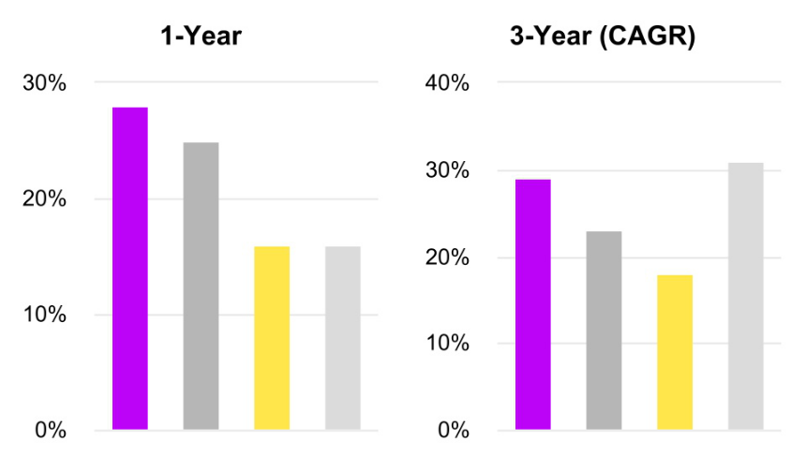

• Micron Technology, Inc. • Exec. Comp. Peer Group Median • S&P 500 • PHLX Semiconductor Sector Index

EXECUTIVE COMPENSATION HIGHLIGHTS

Our compensation program is designed so that executives’ and shareholders’ interests will be strongly aligned. The majority of each Named Executive Officer’s compensation is at risk and a substantial portion vests based on achievement of objective performance goals.

The following graphic illustrates the amount and mix of pay opportunities (at target) for our Named Executive Officers for Fiscal 2025.

38 | 2025 Proxy Statement

Table of Contents
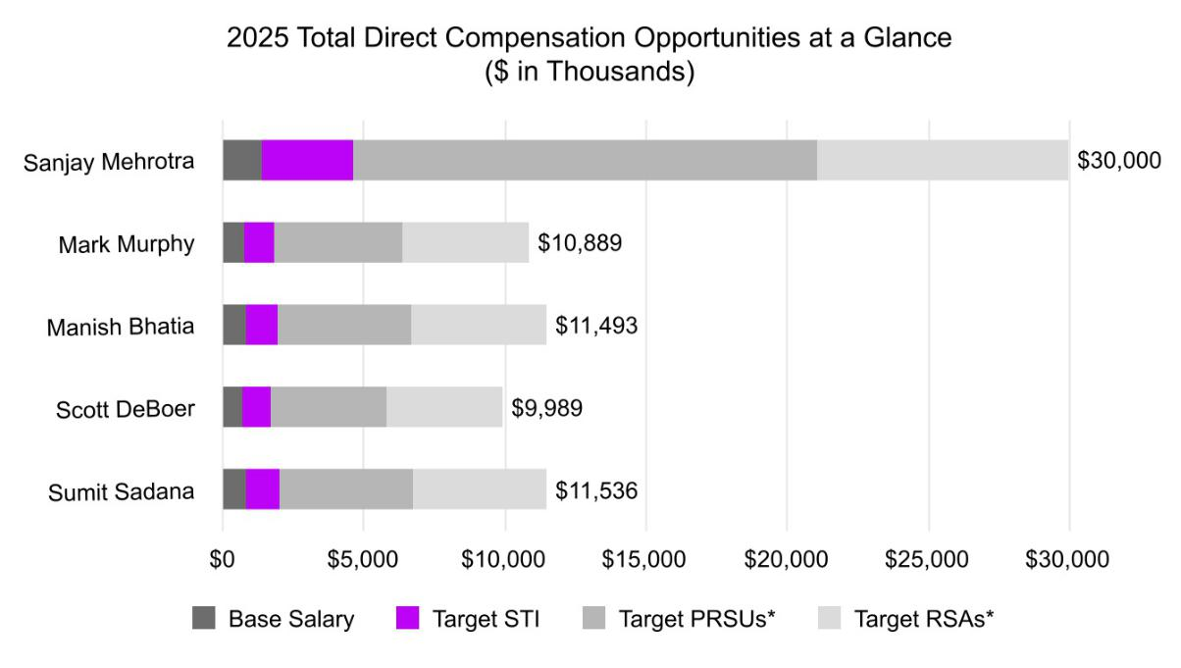

*PRSUs = Performance-Based Restricted Stock Units; RSAs = Restricted Stock Awards

The Fiscal 2025 pay mix, based on target amounts established in October 2024, for our Chief Executive Officer and other Named Executive Officers (on average), as shown below, remained heavily weighted towards variable, at-risk compensation opportunities.
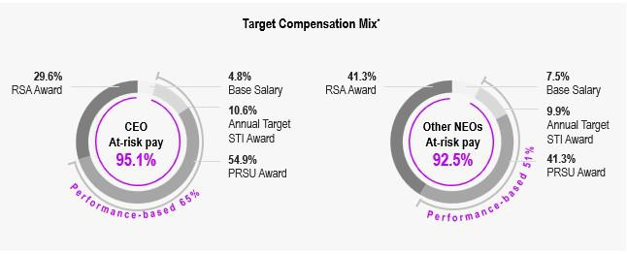

*Percentages may not total 100% due to rounding.

39

Table of Contents

FISCAL 2025 COMPENSATION PROGRAM OVERVIEW

Our executive compensation program for Fiscal 2025 was largely consistent with our program for Fiscal 2024. Our short-term incentive (“STI”) performance metrics in Fiscal 2025 were largely consistent with Fiscal 2024, using a balance of profitability and strategic metrics to incentivize stretching performance. In Fiscal 2025, we did not make any changes to our long-term incentive (“LTI”) awards with respect to the vehicle mix or length of performance periods relative to Fiscal 2024. As previewed in our proxy statement last year and as illustrated below, based on shareholder feedback, beginning with Fiscal 2025 awards we updated our PRSU award vesting schedule to provide for cliff vesting of all shares at the end of year 3 of the performance period. We continued the use of rigorous goals for all performance measures, including outperformance on total shareholder return relative to our comparator group of the SOX index (“rTSR”) at the 55th percentile for the three-year performance period in order to achieve target payout under PRSUs, and adding a payout cap for PRSUs at target levels if absolute total shareholder return (“TSR”) for the three-year performance period is negative. Throughout the Executive Compensation and Related Information section of this Proxy Statement, we refer to total shareholder return as “TSR” and relative TSR as “rTSR.”
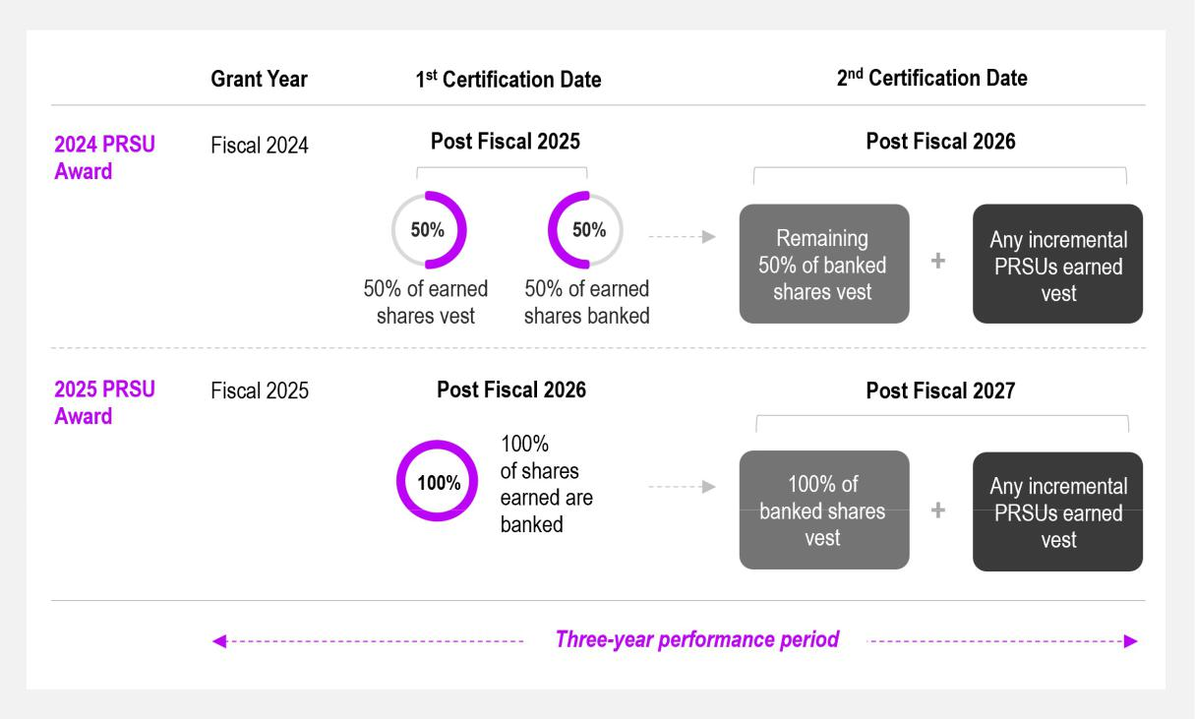

PRSU Compensation Design Best Practices
 | Feature | Micron Design
 | LTI Pay Mix for Chief Executive Officer | 65/35 (PRSU/RSA) Mix
 | PRSU Payout Cap | Maximum combined payout capped at 200% of
 | PRSU Payout Cap | target across PRSUs
 | PRSU rTSR Goal Target | 55th percentile to achieve target payout
 | rTSR Payout Cap | At target if absolute TSR is negative
 | Performance Period | 3-year performance period with cliff vesting
 | rTSR Comparator Group | SOX Index

40 | 2025 Proxy Statement

Table of Contents

EXECUTIVE COMPENSATION PRACTICES

We strive to maintain sound executive compensation practices and policies, which include adherence to the following compensation principles.

OUR COMPENSATION PRINCIPLES


What We Do

- Pay for performance by requiring that a substantial portion of our executive officers’ target total direct compensation be earned based on performance goals

- Link our compensation program to our long-term corporate growth strategy and key drivers of sustainable shareholder value creation

- Use a mix of objective performance measures, cash- and equity-based components, and short- and long-term incentive opportunities that hold our executive officers accountable for executing on our short- and long-term strategies

- Engage an independent compensation consultant to evaluate and advise the Compensation Committee on our executive compensation program design and pay decisions for our executive officers

- Cap maximum payout levels under our incentive plans

- Maintain a compensation recoupment ("clawback”) policy that provides for recoupment of incentive compensation paid to current and former executive officers in the event of an accounting restatement due to material noncompliance

What We Don’t Do

- No special retirement benefits other than participation in our broad-based retirement plans on the same basis as other employees

- No golden parachute tax gross-ups

- No repricing of options or stock appreciation rights without prior shareholder approval

- No “single-trigger” vesting for equity awards upon Change in Control

- No insider pledging or hedging activities involving our stock

- No excessive perquisites

- Maintain executive stock ownership guidelines

■ Incorporate robust shareholder engagement practices

PAY-FOR-PERFORMANCE PHILOSOPHY

Our compensation philosophy for executive officers is based on the belief that the interests of our executives should be closely aligned with our long-term performance and sustainable value creation for our shareholders. To support this philosophy, a significant portion of each executive officer’s target total direct compensation is “at risk” and linked to the accomplishment of specific financial and operational performance goals that we expect will lead to increased long-term value.

41

Table of Contents

Compensation Program Design Aligns with Our Philosophy


Performance-Based Pay |  | Significant Weight on LTI |  | Shareholder Value Creation |  | Variable Pay
 |  | Awards
A substantial majority of the |  |  |  | Incentive awards require |  | Actual, realized compensation
A substantial majority of the |  | Performance-based equity |  | Incentive awards require |  | Actual, realized compensation
compensation available for |  | awards, measured by internal |  | achievement of critical |  | is designed to fluctuate with
executives is performance- |  | and external metrics intended |  | financial and operational goals |  | changes in shareholder value
based and delivered in the |  | to drive shareholder value, |  | and are measured against |  | over time.
form of equity awards in order |  | comprise a significant portion |  | objective metrics that we
to more closely align |  | of our long-term incentive |  | believe result in the creation of
management and shareholder |  | compensation opportunities. |  | sustainable value for our
interests. |  |  |  | shareholders.
Market-Based |  | Annual Review |  | Factors for Individual
 |  |  |  | Assessment

We refer to market data when setting compensation targets,

adjusted based on factors such as the individual’s position and experience,

contributions and technical expertise, importance to our leadership succession plans

and business factors.

The Compensation Committee reviews our pay-for-

performance compensation arrangements annually, with input from our Chief Executive

Officer and advice from the Compensation Committee’s independent compensation

consultant, and takes into account feedback we receive from our shareholders.

Assessment of individual
performance is based on
numerous factors, including:
contribution to business results
and Company performance;
completion of objectives;
behavior consistent with the
highest standard of integrity,
ethics and Company values;
and commitment to
sustainability and human
capital programs and
initiatives.

42 | 2025 Proxy Statement

Table of Contents

COMPENSATION-SETTING PROCESS AND THE DETERMINATION OF COMPENSATION LEVELS

TARGETING “REASONABLE” AND “COMPETITIVE” PAY

We believe that offering a compensation package that is both “reasonable” and “competitive” with what our executives could otherwise obtain in the market—especially from companies within our Compensation Peer Group—enables us to attract, motivate, reward, and retain qualified individuals who can help us meet our overall objective of increasing shareholder value. The Compensation Committee determines what would be reasonable and competitive compensation based upon an analysis of peer market data (as outlined below in “—Use of Compensation Peer Group Data”), the recommendations of its compensation consultant, and our historical experience.

The Compensation Committee generally views the peer market data median as reasonable. However, because the semiconductor industry is highly volatile, the market data (and the median) may change dramatically from year to year, as performance varies, compensation practices change, executives retire, less experienced and lower-paid executives are hired, survey participants change or the quality of available compensation data shifts. As such, the Compensation Committee also considers additional factors in establishing each individual’s target compensation, including:

- the executive’s position, level of responsibility, tenure, and experience—both in absolute terms and as compared to our other officers and the executive’s counterparts within the Compensation Peer Group;

- the executive’s past and anticipated contributions and technical expertise;

- the executive’s importance to our leadership succession plans;

- recent Company performance and projections for future periods;

- applicable business unit performance; and

- our strategic business plan.

The Compensation Committee believes, including based on advice from its compensation consultant, that a reasonable and competitive executive compensation package will address practices with respect to each of the three most common elements of direct compensation: base salary, short-term incentive (cash bonus), and long-term incentive (typically equity). We do not have a rigid formula for dividing target total direct compensation among these three elements, but strongly believe that a significant portion of compensation should be variable and incentive-based, consistent with our pay philosophy.

OVERSIGHT OF THE EXECUTIVE COMPENSATION PROGRAM

Each year, the Compensation Committee, advised by its independent compensation consultant, undertakes a rigorous process to review our executive compensation program and to determine compensation in the context of our pay-for-performance philosophy. The Compensation Committee reviews and approves the goals and objectives used to determine executive compensation, evaluates performance considering such goals and objectives, and determines and approves compensation levels based on that evaluation. The Compensation Committee works closely with our Chief Executive Officer to establish performance goals that further our strategic objectives and to set compensation for the Company’s other officers.

43

Table of Contents

The Compensation Committee sets compensation levels at the beginning of each fiscal year. A more detailed description of the Compensation Committee’s responsibilities is provided in the Compensation Committee’s charter.

ENGAGEMENT OF COMPENSATION CONSULTANT

The Compensation Committee annually engages a compensation consultant to provide a comprehensive review of executive compensation matters and meets with the compensation consultant at least quarterly. The compensation consultant provides the Compensation Committee with information regarding cash and non-cash compensation elements for our executive officers and historical and trend payment data.

The Compensation Committee has established procedures intended to keep its independent compensation consultant’s advice objective and free of influence from our management. These procedures include: a direct reporting relationship to the Compensation Committee; a provision in the engagement letter specifying what information, data, and recommendations can be shared with management; and an annual update to the Compensation Committee on the compensation consultant’s relationship with the Company, including a summary of the work performed during the preceding 12 months. For Fiscal 2025, the specific activities undertaken by the compensation consultant for the Compensation Committee included:

- review the Compensation Peer Group and recommend any changes to its members;

- evaluate target total direct compensation and its components for our executive officers;

- evaluate our historical “pay-for-performance” relationship;

- review the metrics and targets associated with the annual STI and LTI compensation plans;

- review the proposed equity awards to be granted to our executive officers, along with providing vesting recommendations;

- assist with a risk assessment of our compensation policies and practices;

- review Chief Executive Officer benefit and perquisite practices;

- provide periodic updates on compensation trends and regulatory developments;

- review a draft of the Compensation Discussion and Analysis section of our definitive proxy statement; and

- attend the Compensation Committee meetings in which executive compensation matters are discussed.

Compensia, Inc. (“Compensia") was the Compensation Committee’s independent compensation consultant in Fiscal 2025. Compensia did not provide any services for the Company other than consulting work related to executive compensation for the Compensation Committee and non-employee director compensation for the Governance and Sustainability Committee.

The Compensation Committee considered Compensia’s independence in light of SEC rules and Nasdaq Listing Rules. The Compensation Committee received a letter from Compensia addressing its independence, including the following factors: (i) other services provided to the Company by them; (ii) fees paid by the Company as a percentage of their total annual revenue; (iii) policies or procedures maintained by them that are designed to prevent a conflict of interest; (iv) any business or personal relationships between the individual consultants involved in the engagement and any member of the Compensation Committee; (v) whether the individual consultants involved in the engagement owned shares of our Common Stock; and (vi) any business or personal relationships between our executive officers and Compensia or the individual consultants involved in the engagement. The Compensation Committee concluded that there were no conflicts of interest with Compensia.

44 | 2025 Proxy Statement

Table of Contents

DETERMINATION OF THE COMPENSATION PEER GROUP

The Compensation Committee, with the support of Compensia, reviews and approves our Compensation Peer Group annually to ensure that it reflects industry or economic changes and core selection criteria. Our current criteria include comparable revenue and market capitalization size; industry, with a focus on semiconductor companies and other broad technology industry companies that are market leaders in their space; and whether a company competes with Micron for executive talent or has a similar business strategy.

Our Compensation Peer Group for Fiscal 2025 was composed of the following 16 companies. In consultation with Compensia, the Compensation Committee reviewed and approved the Compensation Peer Group for Fiscal 2025, which was unchanged from our Compensation Peer Group for Fiscal 2024. In approving such peer group, the Compensation Committee observed that given the cyclicality and volatility of the industry in which the Company operates, that the Company’s relative positioning can fluctuate significantly year to year. The Compensation Committee considered that it was important for the Company to avoid inadvertently overcorrecting or relying too heavily on relative positioning changes that may be limited to short-term fluctuations and to provide appropriate continued focus on other critical parameters such as companies with similar business strategies and/or that compete with us for executive talent.
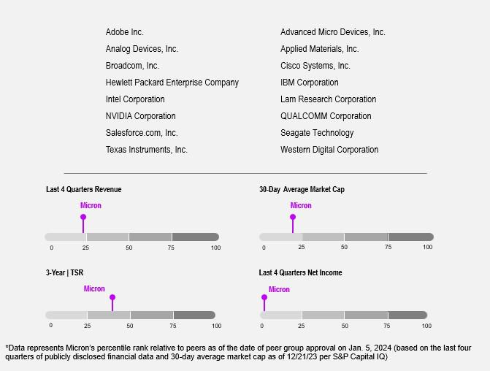

USE OF COMPENSATION PEER GROUP DATA

Compensia gathers data from the proxy statements publicly filed by the members of our Compensation Peer Group and, for certain roles, from published compensation surveys. Compensation survey data may vary from year to year. For Fiscal 2025, Compensia used the Radford Global Technology Survey. The relevant survey and

45

Table of Contents

Compensation Peer Group data for Fiscal 2025 are collectively referred to throughout this Compensation Discussion and Analysis as market data.

Compensia endeavors to collect data based on job descriptions so the Compensation Committee can match positions held by our executives with positions in our Compensation Peer Group. If the Compensation Committee cannot match positions to a reasonable number of companies within the Compensation Peer Group, it will match the rank of the person involved. For example, our third-highest paid executive officer could be compared to the third-highest paid executive officer at each company within the Compensation Peer Group.

COMPENSATION-SETTING PROCESS

Based on its review of the most recent available market data, Compensia identifies the values for the 25th, 50th, and 75th percentile with respect to each position or rank, and then compares our compensation data—both as to the elements and the amounts to be paid or potential value to be delivered—with those findings and reports to the Chief Executive Officer and the Compensation Committee. The Chief Executive Officer works with Compensia by providing our financial data for the most recent fiscal year and reviewing our strategic business plan and projected financial results for the current fiscal year. For all Named Executive Officers other than himself, the Chief Executive Officer makes suggestions as to base salary, recommends a potential set of Company-wide and/or business unit metrics and short-term targets for the current fiscal year, and offers suggestions as to long-term incentive compensation. The Chief Executive Officer makes no recommendations as to his own level of compensation.

The Compensation Committee reviews the market data, discusses it with the Chief Executive Officer and with Compensia, discusses individual executive officer performance based on input from the Chief Executive Officer and, without the Chief Executive Officer present, discusses the Chief Executive Officer’s performance for the recently completed fiscal year, anticipated performance for the current year and the other factors outlined above, as relevant. Following these deliberations, the Compensation Committee approves the compensation for the current fiscal year, including the performance metrics and targets, as well as exercises its business judgment to certify the payment of performance-based compensation.

COMPONENTS OF OUR EXECUTIVE COMPENSATION PROGRAM

In October 2024, the Compensation Committee set compensation levels and performance goals for Fiscal 2025 based on a review of financial results, projections, individual contributions, strategic objectives, market data, and market conditions. The table below reflects target total direct compensation for our Named Executive Officers and illustrates our executive compensation program’s emphasis on longer-term and performance-based variable award opportunities.

46 | 2025 Proxy Statement

Table of Contents

Compensation Component | Characteristics | Purpose |  | Determining Factors
 |  | Compensates executives for |  | Market data informs baseline
 |  | performing day-to-day job |  | Market data informs baseline
Base Salary |  | responsibilities
 | Fixed Compensation | Attracts, develops, and retains
 |  | highly-qualified executive talent |  | Adjusted for executive’s
 |  |  |  | contributions, experience and
 |  |  |  | performance
 |  | Maintains stable management |  | performance
 |  | team


Variable, performance-based

cash compensation

Provides performance-based,
incentive cash awards for
outstanding performance at the Market data informs baseline
individual, business-unit and/or

Company-wide level

Short-Term Incentive Pay

Annual, pre-determined goals set by

Target payout is tied to a percentage of executive’s base salary

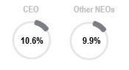

Encourages accountability by rewarding achievement of specific performance goals

Focuses executives on achievement of near-term financial and operational objectives

Promotes long-term Company success and drives shareholder value

the Compensation Committee:
- Profitability targets
- Achievement of certain technology, product, revenue mix and cost and efficiency goals

- Other goals including customer, sustainability and human capital

 | Variable, performance-based
 | equity compensation
 | Three-year performance
 | period; no shares vest and
Performance-Based RSUs | settle before the end of year 3
 | Measured at end of year 2
 | and year 3 for operational
 | goals and each day beginning
 | on first day of year 2 for
 | financial goal
 | All PRSUs earned in year 2
 | are banked at the end of year
 | 2. All PRSUs earned in year 3
 | vest at the end of year 3,
 | along with all shares banked
 | at the end of year 2.

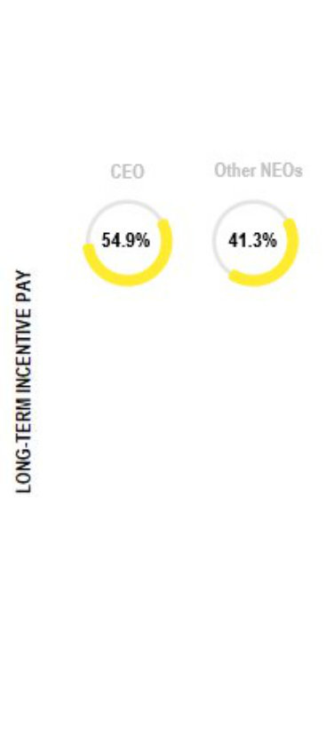

Creates direct, specific alignment with shareholders’ interests by focusing executives on long-term value creation through the achievement of key operational milestones and stock price performance

Market data informs baseline

Goals set by the Compensation Committee:

- HBM3E+ bits shipped or revenue-based market share
- Data center SSD bits shipped or revenue-based market share
- TSR relative to the semiconductor sector
- Additional stretch performance conditions for operational awards, subject to the aggregate 200% limit described below

 | Variable, performance-based |  | Provides alignment with |  | Market data informs baseline
Time-Based RSAs |  |  | shareholders’ interests by |  | Market data informs baseline
Time-Based RSAs | equity compensation |  | focusing executives on long-term
 |  |  | value creation

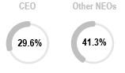

Vests ratably over three years Provides retention value Value based on stock price

The percentages shown for each of the compensation components in the table above are presented based on base salary, target annual STI award, and the annual LTI awards (at the target award values approved by the Compensation Committee) granted to our Chief Executive Officer (on the left) and averaged for all other Named Executive Officers, excluding our Chief Executive Officer (on the right). Percentages may not total 100% due to rounding.

47

Table of Contents

BASE SALARIES

In October 2024, the Compensation Committee reviewed and determined to adjust base salary levels for all Named Executive Officers for Fiscal 2025. Based on the Company’s performance in Fiscal 2024, individual executive performance, and the assessment of compensation levels relative to market, salaries were increased, on average, 5.5% from Fiscal 2024.

 |  | Fiscal 2024 |  | Fiscal 2025 | Base Salary
Executive Officer |  | Fiscal 2024 |  | Fiscal 2025 | % Change From
Executive Officer |  | Base Salary |  | Base Salary | Fiscal 2024
Sanjay Mehrotra | $ | 1,418,000 | $ | 1,450,000 | 2.3 %
Mark Murphy |  | 775,000 |  | 821,500 | 6.0 %
Manish Bhatia |  | 800,000 |  | 848,000 | 6.0 %
Scott DeBoer |  | 700,000 |  | 756,000 | 8.0 %
Sumit Sadana |  | 825,000 |  | 866,250 | 5.0 %

SHORT-TERM INCENTIVES

We use our STI plan to attract, retain, and reward qualified executives who are important to our success by offering the opportunity to earn cash awards for achieving performance goals set by the Compensation Committee. Due to the challenging nature of the goals set by the Compensation Committee, achievement of STI goals has historically required significant leadership and effort.

Fiscal 2025 Short-Term Incentive Awards

In October 2024, the Compensation Committee established Fiscal 2025 performance goals and a short-term incentive compensation opportunity (the “Target Awards”) for each Named Executive Officer. The Compensation Committee selected the Company Performance goals outlined below based on their correlation to the creation of shareholder value and their alignment with our financial and strategic objectives. The STI award payouts were determined following the end of the Fiscal 2025 performance period as follows:
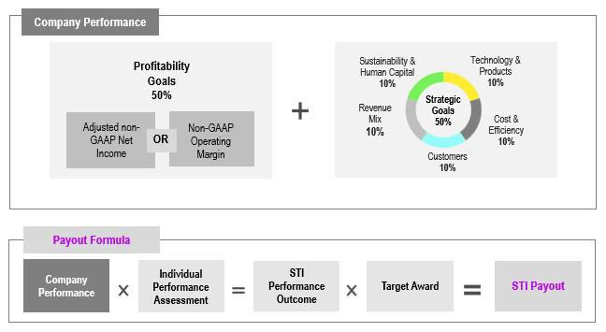

48 | 2025 Proxy Statement

Table of Contents

STI Bonus Targets

In October 2024, the Compensation Committee approved increases in target incentive opportunities for all Named Executive Officers to improve the competitive positioning of target STI opportunities and total cash compensation relative to the market. Fiscal 2025 Target Awards under the STI plan and actual amounts earned for each Named Executive Officer are as follows:

 | Fiscal 2024 Target | Fiscal 2025 Target | % Change in Target | Fiscal 2025 |  | Fiscal 2025
Named Executive Officer | Award (% of Base | Award (% of Base | % Change in Target | Target Award |  | Bonus Paid
Named Executive Officer | Salary) | Salary) | from Fiscal 2024 | ($) |  | ($)
Sanjay Mehrotra | 215 % | 220 % | 2.3 % $ | 3,190,000 | $ | 3,894,990
Mark Murphy | 125 % | 130 % | 4.0 % | 1,067,950 |  | 1,185,425
Manish Bhatia | 125 % | 135 % | 8.0 % | 1,144,800 |  | 1,397,801
Scott DeBoer | 120 % | 130 % | 8.3 % | 982,800 |  | 1,199,999
Sumit Sadana | 125 % | 135 % | 8.0 % | 1,169,438 |  | 1,427,883

Company Profitability and Strategic Performance Goals

The Compensation Committee chose the profitability and strategic goals and weightings outlined above based on the following criteria:

- Criticality in driving the Company’s near- and long-term performance to increase shareholder value

- To motivate stretch financial performance achievement beyond the Company’s annual business plan for Fiscal 2025

- Focus on sustainability and human capital, which delivers business value, is an expectation of our customers and benefits our communities, team members, and other stakeholders

Profitability Goals

The Compensation Committee established profitability goals (50% weighting) consisting of adjusted non-GAAP net income or non-GAAP

operating margin metrics. It viewed these goals to be highly rigorous at the time they were set, with payout targets based on our Fiscal 2025 operating plan. Achieving the threshold under either goal was considered substantially uncertain. Given the volatile nature of our industry, the
intent of this dual goal design was to provide substantial motivation to the Named Executive Officers at the outset of Fiscal 2025, notwithstanding a challenging and uncertain business climate, which had the potential to create unpredictable changes after the goals were set.

Profitability Goals |  |  | Target |  | Maximum | 2025 Actual
 | 0.5x | 0.9x | Target | 1.50x | Maximum | 2025 Actual
 | 0.5x | 0.9x | 1.00x | 1.50x | 2.00x | Performance
Adjusted Non-GAAP Net | $5.90 | $10.30 | $11.70 | $14.30 | $16.80 | $9.00
Income (in billions)(1)
Non-GAAP Operating | Or | Or | Or | Or | Or
Non-GAAP Operating | 18% | 28% | 30% | 32% | 34% | 29%
Margin(2)
(1)
The Company’s adjusted non-GAAP net income is calculated as the Company’s reported Fiscal 2025 non-GAAP net income minus stock compensation expense (including Employee Stock Purchase Plan), plus short-term incentive expense (including taxes and net of inventory impacts). Short-term incentive expense includes expense from all the Company’s STI programs. Any change to U.S. tax law or financing costs necessary to sustain minimum liquidity levels approved by the Finance Committee were not accounted for in the annual business plan and associated profitability goal targets, and would have been removed from adjusted non-GAAP net income as part of the achievement calculation.

- The Company’s non-GAAP operating margin is calculated as the Company’s reported Fiscal 2025 non-GAAP operating income divided by the Company’s reported Fiscal 2025 revenue, expressed as a percentage.

49

Table of Contents

Linear interpolation is applied between each adjusted non-GAAP net income and non-GAAP operating margin target. Profitability goal achievement is based on the higher of adjusted non-GAAP net income or non-GAAP operating margin percent achievement. There is no increase to payout if both of the profitability goals are achieved.

Despite a year of record revenue, the Fiscal 2025 profitability goal achieved below target at 95%, which was based on the non-GAAP operating margin performance.

The Committee approved an individual performance multiplier for Messrs. Mehrotra, Bhatia, DeBoer and Sadana at 1.10 in recognition of their successful efforts in their respective areas. Mr. Mehrotra delivered a record revenue year with gross margins of nearly 40% and played a critical role in strengthening Micron’s strategic relationships with key stakeholders. Mr. Bhatia delivered on critical operational metrics and milestones including HBM3E yield and output, product qualification and leading node yields. Dr. DeBoer delivered on our technology roadmap, including HBM4 and data center SSDs. Mr. Sadana delivered on key bit shipment and revenue metrics including from HBM3E+, high-growth and more stable end markets and leading node DRAM and NAND shipments.

For Fiscal 2026, the Compensation Committee approved a further enhancement to the profitability goal structure, such that actual payout above target requires achievement of both the adjusted non-GAAP net income and non-GAAP operating margin goals.

Strategic Goals

The five strategic goal categories below are weighted equally and together account for 50% of the overall STI plan achievement weighting. Our strategic goals involve highly confidential, competitively sensitive information, including forward-looking targets and product-specific
strategies that if disclosed could cause irreparable competitive harm by providing competitors with insight into our internal processes, know-how, products and business initiatives, particularly as many of our goals build on multi-year achievements in order to execute on our overall business strategies. Revealing such information, including targets in key strategic focus areas, would allow our major competitors, many of whom are not traded on U.S. exchanges and are not disclosing strategic goals and metrics, to leverage it to their competitive advantage, to our detriment and to the detriment of our shareholders. However, we understand shareholders' desire for additional detail regarding our strategic goals and have provided visibility into the strategic goal components and resulting performance, while balancing these competitive concerns.

50 | 2025 Proxy Statement

Table of Contents

Strategic Goals
 | Category | Fiscal 2025 Goals | Achievement | % Achievement
 | Technology and Products | Goals focused on delivery of leading-edge | Leading-edge technology and key | 100%
 | Execute key enablers of our | technology and key market segment (data | market segment product milestones
 | technology and products for the | center, client, mobile, automotive) product | largely accomplished at or before
 | current fiscal year, as well as | milestones across: | targets and additional stretch
 | elements focused on supporting | ▪ DRAM (including HBM4) | performance condition achieved.
 | our longer-term technology and | ▪ NAND (including data center
 | product competitiveness and | SSDs)
 | business results. | ▪ Goals focused on deployment of
 |  | AI-based efficiency tools to
 |  | improve product development and
 |  | early manufacturing enablement

Cost and Efficiency
Increase cost competitiveness by
driving efficiency across frontend, assembly and test, procurement, supply chain, and enterprise

systems. Advance manufacturing expansion projects.

Goals focused on delivery of critical operational metrics and milestones
including:
- HBM3E 12H cumulative yield, output, and quality
- Differentiated product qualifications and quality
- DRAM and NAND leading node cumulative yields
- Construction milestones and metrics
- Smart Manufacturing and AI-based solutions (“SMAI”)

Goals for critical operational yield, | 148%
qualification, HBM quality, and SMAI
metrics and milestones were

exceeded.

Manufacturing expansion construction
projects continue to progress, with first wafer output from our new high-volume manufacturing fab in Idaho (ID1)

expected to begin in the second half of calendar 2027.

 | Customer | Goals focused on customer-related | Goals for customer business review | 83%
 | Improve our customers’ experience metrics, including: |  | scores in technology, service, and
 | and satisfaction, and further | ▪ Customer business review scores | sustainability, along with our quality
 | differentiate Micron from our | across the categories of | ranking objectives, were exceeded. We
 | competitors through strengthened | technology, service and | met our targeted inventory levels by
 | partnerships, technology and | sustainability | fiscal year-end.
 | product competitiveness, supply | ▪ Customer quality and customer
 | continuity, sustainability and | delivery performance ranking
 | product quality and service. | relative to our customers’ other
 |  | suppliers
 |  | ▪ Days of inventory outstanding
 | Revenue Mix | Goals focused on key revenue and bit | HBM shipments and revenue mix | 142%
 | Execute our business plans to | shipment metrics, including: | towards data center and more
 | optimize our product, segment and | ▪ Revenue from HBM3E+, high- | profitable segments exceeded targets.
 | customer shipment mix. | density module and all low-power
 |  | DRAM products sold into the data
center
- Revenue from high-growth, more stable end markets
- DRAM and NAND leading node shipments

Sustainability and Human | Goals focused on sustainability and | Sustainability goals for reducing direct | 163%
Capital | human capital metrics and milestones, | greenhouse gas emissions and human
Drive sustainability improvements, | including: | capital metrics exceeded targets.
improve human capital metrics and | ▪ Reduction of direct greenhouse
drive adoption of AI-enabled | gas emissions
enterprise applications | ▪ Expand talent pool and increase

hiring efficiency
▪ Reduce voluntary employee
attrition
▪ Enhance career growth and
development programs
▪ Deploy and increase adoption of
AI-enabled solutions

51

Table of Contents

Within each goal category, each strategic goal or group of related strategic goals provided an opportunity to achieve performance between the minimum threshold of 50% of target and a maximum of 200% of target. Additionally, the Technology and Products category included an additional stretch performance condition based on the deployment of AI-based efficiency tools to improve product development. This additional stretch performance condition was achieved and resulted in a .25x increase in achievement for Fiscal 2025, bringing overall achievement to 100% as shown above.

Achievement of each of the goals included in the five strategic categories required significant effort and adept execution, and there was no assurance of even threshold achievement with respect to any of the metrics or milestones. When setting the Fiscal 2025 strategic goal targets, relative to the annual operating plan in October 2024, the Compensation Committee believed that achieving maximum performance for any strategic goal category would be challenging and would require extraordinary leadership, effort, and coordination as a team.

LONG-TERM EQUITY INCENTIVES

We believe LTI compensation should be tied to our success, help promote increases in long-term shareholder value, and encourage key executives to remain with the Company. In Fiscal 2025, consistent with these objectives, the Compensation Committee retained the LTI mix for the Chief Executive Officer at 65% performance-based restricted stock units (“PRSUs”) and 35% time-based restricted stock awards (“RSAs”), and 50% PRSUs and 50% RSAs for the other Named Executive Officers.

In determining the target value of LTI incentive awards for our Named Executive Officers, the Compensation Committee considered various items, including market data, as described above under the section entitled “Engagement of the Compensation Consultant—Compensation-

Setting Process.” For all Named Executive Officers, equity grant values increased, on average, 7.5% (6.8% for the Chief Executive Officer) based on assessment of individual and Company performance and to improve the competitive positioning of our grant levels relative to the market.

The following table shows the target values of our Named Executive Officers’ Fiscal 2025 LTI awards:

Named Executive Officer |  | Fiscal 2025 PRSU Awards |  | Fiscal 2025 RSA Award |  | Total Fiscal 2025 LTI(1)
Sanjay Mehrotra | $ | 16,484,000 | $ | 8,876,000 | $ | 25,360,000
Mark Murphy |  | 4,500,000 |  | 4,500,000 |  | 9,000,000
Manish Bhatia |  | 4,750,000 |  | 4,750,000 |  | 9,500,000
Scott DeBoer |  | 4,125,000 |  | 4,125,000 |  | 8,250,000
Sumit Sadana |  | 4,750,000 |  | 4,750,000 |  | 9,500,000

- Reflects target grant-date fair value, based on the closing price of our Common Stock as quoted on the Nasdaq Stock Market (“Nasdaq”) for the last market-trading day prior to the date of grant.

Historically, long-term incentive awards for all executive officers have been made in the first quarter of the fiscal year, with the exact grant date occurring on or after the date of the Compensation Committee’s approval. The Compensation Committee does not factor any material non-public information into the timing of grants of equity awards. Further, the Company does not time the disclosure of material non-public information for purposes of affecting the value of executive compensation.

Certain Goals Involve Highly Confidential Information

As with the strategic goals under our STI plan discussed above, we do not publicly disclose the specific targets for any PRSU awards or additional stretch performance conditions that are based on operational metrics because those goals involve highly confidential information that, if disclosed, could cause irreparable competitive harm to the Company, and therefore, to its shareholders. However, in this discussion, we endeavor to provide visibility into the details of operational metrics where possible.

52 | 2025 Proxy Statement

Table of Contents

Performance-Based RSUs Granted in Fiscal 2025

The PRSUs granted in Fiscal 2025 (the “2025 PRSU Awards”) vest based on actual performance against goals for three metrics, as described below. While the overall PRSU structure and weightings remain consistent with Fiscal 2024 PRSU Awards, the Operational goals were adjusted to drive increased focus on the data center, with the addition of data center SSD metrics. The Compensation Committee believed focusing on these strategic imperatives to further strengthen our data center portfolio would position the Company well and benefit shareholders.

 |  |  |  | Percentage of 2025
Metric Category | Name |  | Performance Metric | PRSU Award Value(1)
Operational | 2025 | HBM3E+ PRSU Award | HBM3E+ market share or bit shipments | 25%
Operational | 2025 | Data Center SSD PRSU Award | Data center SSD market share or bit shipments | 25%
Financial | 2025 rTSR PRSU Award |  | Company TSR compound annual growth rate | 50%
 |  |  | relative to the 55th percentile (target) TSR
 |  |  | compound annual growth rate within the SOX
 |  |  | Index.

- The actual number of shares granted through the rTSR Award was lower than the number of shares granted for the Operational PRSU Awards due to application of the Monte Carlo valuation approach for the rTSR Award.

We refer to the 2025 HBM3E+ PRSU Award and the 2025 Data Center SSD PRSU Award collectively as the “2025 Operational PRSU Awards.”

PRSUs may be earned (or “banked”) at the conclusion of year 2 and year 3 of the three-year period following the grant date (the “Performance Period”) based upon results against performance goals set at the beginning of the Performance Period. No shares will vest and be settled until the conclusion of the three-year period. For each Named Executive Officer, the actual number of PRSUs that will be earned and become eligible to vest under the 2025 PRSU Awards is the product of the executive’s target award and the payout factor that results from actual performance versus the pre-established performance goals (the “Payout Factor”), subject to the overall maximum payout at 200% of target.
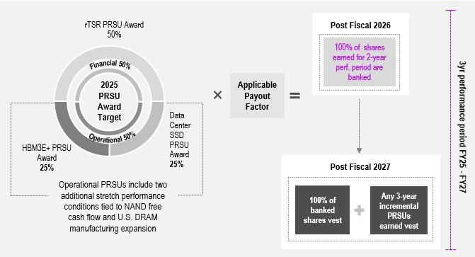

53

Table of Contents

Overall Combined Cap on PRSU Earning and Vesting

The maximum number of PRSUs that a Named Executive Officer may earn under all 2025 PRSU Awards is limited to 200% of the aggregate target number of PRSUs awarded to that executive. The maximum number of PRSUs that can be earned under the 2025 rTSR PRSU Award is 150% of the target number of rTSR PRSUs granted. The maximum number of PRSUs that can be earned under the 2025 Operational PRSU Awards generally is 200% of the target number of Operational PRSUs granted. However, the Compensation Committee has approved two additional stretch performance conditions under the 2025 Operational PRSU Awards, and achievement of each can increase the earning opportunity by an additional 33% of the 2025 Operational PRSU Awards target (or 66% of the 2025 Operational PRSU Awards target if both are achieved). The additional stretch performance conditions are selected because they are important strategic targets whose accomplishment is highly uncertain as the targets represent a stretch from an operational and execution perspective, and the Compensation Committee believes that their attainment would position the Company very well from a competitive standpoint in the future.

Based on the design of the LTI plan, it is not possible to achieve the maximum of 200% of the aggregate target for the 2025 PRSU Awards without the achievement of both of the additional stretch performance conditions.

2025 Operational PRSU Awards

Performance for the 2025 HBM3E+ PRSU Award, weighted 25% in the overall PRSU formula, refers to performance with respect to HBM3E+ products. HBM3E+ goal achievement is based on the higher of revenue-based market share or bit shipment achievement as measured each year. Performance for the 2025 Data Center SSD PRSU Award, also weighted 25% in the overall PRSU formula, refers to performance with respect to data center SSD products. Data center SSD achievement is based on the higher of revenue-based market share or bit shipment achievement as measured each year. In each case, payouts can range from 0% (for achievement below a specified threshold) to a maximum of 200% of the target number of PRSUs granted.

In addition, as noted above, the 2025 Operational PRSU Awards include two additional stretch performance conditions. The 2025 Operational PRSU additional stretch performance condition targets relate to NAND free cash flow and our U.S. DRAM manufacturing expansion. The Compensation Committee believes that attaining these additional stretch performance conditions, which would require a meaningful level of execution and effort, would enhance long-term shareholder value. Delivering on either of these additional stretch performance conditions will allow recipients to earn an additional 33% of the 2025 Operational PRSU Awards target (for a total of 66% of the 2025 Operational PRSU Awards target if both are achieved), subject to the overall maximum payout of 200% of target for the 2025 PRSU Awards.

Operational PRSU Goals Require Strong Performance

When setting the target goals for the 2025 Operational PRSU Awards, the Compensation Committee believed that achievement would require stretch performance, a challenging level of execution and effort on the part of our Named Executive Officers, and that achievement of even
the threshold goals was uncertain. To achieve the established market share or bit shipment targets for the HBM3E+ PRSU Award and the Data Center SSD PRSU Award requires continued exceptional execution of our HBM and data center SSD product road maps.

Determination of Payout

Achievement levels with respect to the 2025 Operational PRSU Awards will be measured within 60 days after the end of each of year 2 and year 3 in the Performance Period (each, a “Certification Date”). On each Certification Date, the Compensation Committee will determine and certify the Payout Factors for the applicable fiscal year. In response to shareholder feedback, our 2025 Operational PRSU Awards are subject to full 3-year cliff vesting, such that no shares will vest and be settled before the end of the 3-year Performance Period. Any 2025 Operational PRSU Awards earned in year 2 of the Performance Period will be banked on the Certification Date that immediately follows year 2 of the Performance Period (Fiscal 2026). Shares that are banked under the 2025 Operational PRSUs from year 2, and any incremental shares under the 2025 Operational PRSUs earned in year 3 will vest and be settled upon the Certification Date that immediately follows year 3 of the Performance Period (the fiscal year ending September 2, 2027, or “Fiscal 2027”).

54 | 2025 Proxy Statement

Table of Contents

2025 rTSR PRSU Award

The 2025 rTSR PRSU Award ties 50% of each Named Executive Officer’s target 2025 PRSU Award to the Company’s TSR compound annual growth rate over the three-year Performance Period, as compared to the TSR compound annual growth rate of the companies in the SOX index, which is composed of companies primarily involved in the design, distribution, manufacture, and sale of semiconductors. The TSR component will be measured every day in year 2 and year 3 of the Performance Period, as described below. Similar to the 2025 Operational PRSU Awards, shares under the 2025 rTSR PRSU Award may be banked in year 2, but no shares will vest and be settled until the end of year 3 of the Performance Period. For the 2025 rTSR PRSU Award, the target level of performance is set at the 55th percentile of the SOX index. Additionally, the Payout Factor is capped and cannot exceed 100% if the Company’s absolute TSR is negative, even if relative performance achievement is above target.

Payout Factor

The Payout Factor for the 2025 rTSR PRSU Award is based on the average of the Company’s three-year rTSR for each of the 60 days trailing the applicable measurement date (and including the measurement date), expressed as a compounded annual growth rate (the “TSR CAGR”), relative to the 55th percentile TSR CAGR (“rTSR CAGR”) of the companies in the SOX index. For this purpose, the SOX index is defined as the SOX constituents at each measurement date, excluding any company that has not been public for at least three years. The rTSR CAGR is calculated by subtracting the TSR CAGR at the 55th percentile of the SOX index from the Company’s TSR CAGR for that measurement date.

The following table sets forth the Payout Factors under the 2025 rTSR PRSU Award for various levels of rTSR CAGR. If the rTSR CAGR achieved is between two of the specific levels shown below, the Payout Factor will be determined using straight line interpolation.
 | Payout Factor for the rTSR
rTSR CAGR Achieved on a Measurement Date | CAGR
Less than -50 percentage points (“ppts”) | 0 %
-50 ppts (“rTSR Threshold”) | 50 %
0 ppts (“rTSR Target”) | 100 %
+50 ppts or greater (“rTSR Maximum”) | 150 %

Additional Cap on rTSR PRSUs

The Payout Factor for the 2025 rTSR PRSU Award will be capped at the rTSR Target in the event that the Company’s absolute TSR is negative, notwithstanding the level of relative performance achieved.

Determination of Payout

Beginning on the first day of Fiscal 2026 (the first measurement date in the Performance Period), the number of 2025 rTSR PRSUs that will be banked, if any, for a Named Executive Officer will equal the product of the Payout Factor and the target number of 2025 rTSR PRSUs granted to that executive. Thereafter, additional PRSUs can be earned and banked only if the Company attains a higher rTSR CAGR level on a later measurement date. The number of such additional banked PRSUs, if any, will be equal to the excess of the number of PRSUs that would be banked based on the new, higher Payout Factor minus the number of PRSUs that have already been banked. After the end of each of year 2 and year 3 of the Performance Period, the Compensation Committee will certify the number of PRSUs earned for such year.

PRSU Vesting

After the end of year 2 of the Performance Period (Fiscal 2026), any of the 2025 rTSR and 2025 Operational PRSUs deemed earned, will be banked. Any earned and banked shares from year 2, along with any earned and banked shares from year 3 will vest on the Certification Date following year 3 of the Performance Period.

55

Table of Contents

If a Named Executive Officer terminates employment with the Company for any reason other than a termination by the Company for cause, any banked shares will continue to vest on the vesting schedule described above. No PRSUs will vest if a Named Executive Officer is terminated for cause. For this purpose, “cause” is as defined in the employment agreement between a Named Executive Officer and the Company, or if not so defined, as defined in the equity incentive plan under which the award was granted.

Fiscal 2025 PRSUs Achievement

The measurement periods for the 2025 PRSU Awards do not begin until Fiscal 2026. No shares can be earned, banked, or vested during Fiscal 2025 under these awards.

Time-Based Restricted Stock Awards

Time-based RSAs support retention and are linked to shareholder value and ownership. RSAs granted in Fiscal 2025 will vest ratably over three years from the date of grant, subject to continued employment. In Fiscal 2025, RSAs made up 35% of the target value of the LTI awards granted to the Chief Executive Officer, and 50% of the target value of the LTI awards granted to the other Named Executive Officers.

Previously Granted Fiscal 2024 Performance-Based RSUs

Half of the earned 2024 PRSU Awards vested on the first Certification Date that immediately followed the end of Fiscal 2025. The remaining half of PRSUs earned as of that Certification Date are banked and will vest on the second Certification Date that immediately follows the end of Fiscal 2026, together with any incremental PRSUs that are earned during Fiscal 2026, as illustrated below.
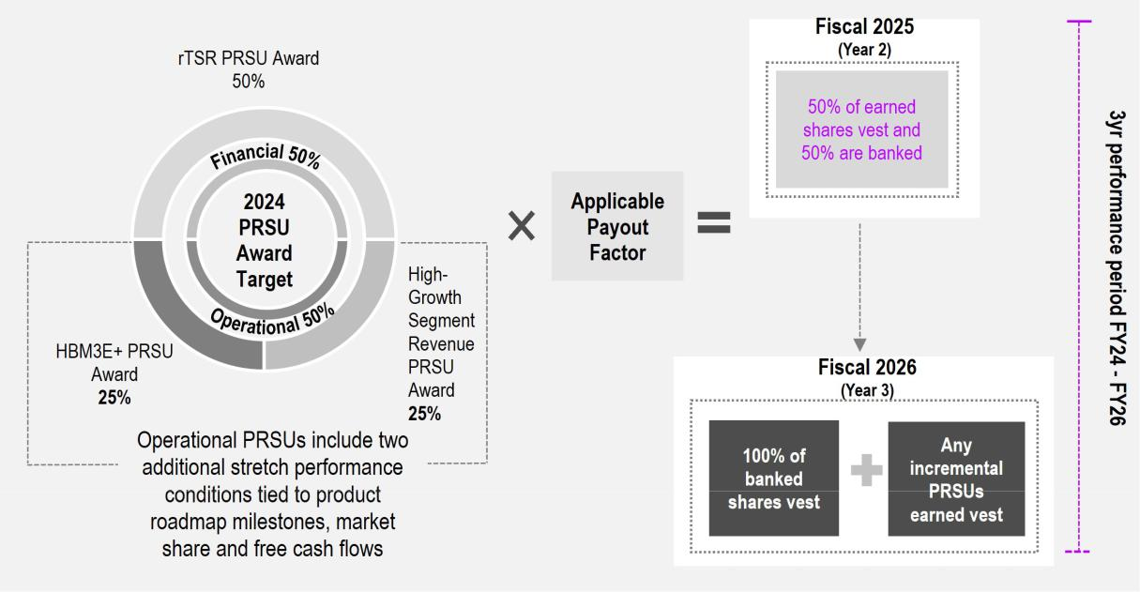

If a Named Executive Officer terminates employment with the Company, that executive’s 2024 PRSUs will vest or be forfeited in the manner described above for the 2025 PRSUs.

56 | 2025 Proxy Statement

Table of Contents

Fiscal 2024 PRSUs Achievement

In October 2025, the Compensation Committee reviewed the Company’s performance relative to the performance goals for the 2024 PRSU Awards for Fiscal 2025—year 2 of the Performance Period—and confirmed the following results:

Fiscal 2024 PRSU Award Payout Factors

 |  |  | Operational - 50% Weight |  |  |  |  |  |  | Financial - 50% Weight
 |  |  |  |  |  |  | Additional
 |  |  |  | High-Growth |  |  | Performance
 | HBM3E+ |  |  | Segment Revenue |  |  | Conditions |  |  | rTSR CAGR
Fiscal | Actual | Payout |  | Actual | Payout |  | Actual | Payout |  | Actual | Payout
Year | Result | Factor |  | Result | Factor |  | Result | Factor |  | Result | Factor
 |  |  |  |  |  |  | Achieved
 | Above |  |  | Above |  |  | SSD market
2025 | Above | 200% |  | Above | 200% |  | share and | 33% |  | +11.4ppts | 111%
2025 | maximum | 200% |  | maximum | 200% |  | positive | 33% |  | +11.4ppts | 111%

NAND free
cashflow

Performance will also be measured after the end of Fiscal 2026—year 3 of the Performance Period—and additional shares may or may not be earned. Following the completion of Fiscal 2026, the Company intends to provide additional information regarding goal achievement, and whether additional shares were earned.

The Compensation Committee certified that the following shares had been earned by our Named Executive Officers under the 2024 PRSU Awards:

 |  |  |  |  |  | Fiscal 2024
 |  | Fiscal 2024 |  |  | High-Growth Segment Revenue |  |  |  |  | Fiscal 2024
 | HBM3E+Shares |  |  |  |  | Shares |  |  |  | rTSR Shares
 | Earned for |  |  |  | Earned for |  |  |  | Earned for
Executive | FY25 | Vested | Banked |  | FY25 | Vested | Banked |  | FY25 | Vested | Banked
Sanjay Mehrotra | 128,924 | 64,462 | 64,462 |  | 128,924 | 64,462 | 64,462 |  | 110,049 | 55,024 | 55,025
Mark Murphy | 35,493 | 17,746 | 17,747 |  | 35,493 | 17,746 | 17,747 |  | 30,296 | 15,148 | 15,148
Manish Bhatia | 37,581 | 18,790 | 18,791 |  | 37,581 | 18,790 | 18,791 |  | 32,079 | 16,039 | 16,040
Scott DeBoer | 30,274 | 15,137 | 15,137 |  | 30,274 | 15,137 | 15,137 |  | 25,841 | 12,920 | 12,921
Sumit Sadana | 37,581 | 18,790 | 18,791 |  | 37,581 | 18,790 | 18,791 |  | 32,079 | 16,039 | 16,040

57

Table of Contents

Previously Granted Fiscal 2023 Performance-Based PRSUs

In October 2025, the Compensation Committee reviewed the Company’s performance relative to the performance goals for the 2023 PRSU Awards for Fiscal 2025—year 3 of the Performance Period—and confirmed the following results:

Fiscal 2023 PRSU Award Payout Factors

 |  |  | Operational - 50% Weight |  |  |  |  |  |  | Financial - 50%
 |  |  |  |  |  |  |  |  |  | Weight
 |  |  |  |  |  |  | Additional
 |  |  |  |  |  |  | Performance
 | NAND |  |  | DRAM |  |  | Conditions |  |  | rTSR CAGR
Fiscal | Actual | Payout |  | Actual | Payout |  | Actual | Payout |  | Actual | Payout
Year | Result | Factor |  | Result | Factor |  | Result | Factor |  | Result | Factor
 |  |  |  |  |  |  | Achieved
2025 | Above |  |  | Above |  |  | cumulative
2025 | Above | 200% |  | Above | 200% |  | HBM | 33% |  | +14ppts | 128%
2025 | maximum | 200% |  | maximum | 200% |  | HBM | 33% |  | +14ppts | 128%
 | maximum |  |  | maximum |  |  | revenue
goal

The Compensation Committee certified that the following additional shares had been earned by our Named Executive Officers under the 2023

PRSU Awards:

 | Fiscal 2023 |  |  | Fiscal 2023 |  |  | Fiscal 2023
 | DRAM Shares |  |  | NAND Shares |  |  | rTSR Shares
 | Incremental |  |  | Incremental |  |  | Incremental
 | Shares Earned | Total Shares |  | Shares Earned | Total Shares |  | Shares Earned | Total Shares
 | & Vested for | Earned & |  | & Vested for | Earned & |  | & Vested for | Earned &
Executive | FY25 | Vested(1) |  | FY25 | Vested(1) |  | FY25 | Vested(1)
Sanjay Mehrotra | 99,052 | 131,132 |  | 18,572 | 131,132 |  | 17,753 | 113,619
Mark Murphy | 32,322 | 42,790 |  | 6,060 | 42,790 |  | 5,793 | 37,075
Manish Bhatia | 34,408 | 45,552 |  | 6,452 | 45,552 |  | 6,167 | 39,468
Scott DeBoer | 27,109 | 35,889 |  | 5,083 | 35,889 |  | 4,858 | 31,096
Sumit Sadana | 35,450 | 46,931 |  | 6,647 | 46,931 |  | 6,353 | 40,664

- Includes shares earned and vested or banked on the first Certification Date (which followed Fiscal 2024). Any shares that were banked on the first Certification Date vested on the second Certification Date (which followed Fiscal 2025).

CONSIDERATION OF TAX CONSEQUENCES WHEN MAKING COMPENSATION DECISIONS

Code Section 162(m) generally disallows a tax deduction to public companies such as Micron for annual compensation over $1,000,000 per person paid to our Named Executive Officers and certain other current or former executive officers. Although the Compensation Committee considers the deductibility of compensation under Section 162(m), it reserves the right to grant or approve compensation or awards that may be non-deductible when it believes such compensation or awards are in the best interests of Micron and its shareholders.

58 | 2025 Proxy Statement

Table of Contents

OTHER COMPENSATION POLICIES

EXECUTIVE OFFICER STOCK OWNERSHIP GUIDELINES

We have established stock ownership guidelines for our executive officers. The Compensation Committee believes that our executive officers will more effectively manage the Company in the best interests of the shareholders if they are also shareholders. The minimum ownership guideline for our Chief Executive Officer is to hold shares with a value equal to six times his base salary. Our other executive officers are required to hold shares with a value equal to three times their base salary. Executive officers are given five years to meet the ownership guidelines. The Governance and Sustainability Committee reviews the stock ownership guidelines periodically and monitors each covered executive’s progress toward, and continued compliance with, the guidelines. Stock sales restrictions may be imposed upon executive officers if the stock ownership guidelines are not met. All our executive officers are currently in compliance with the guidelines.


Compliance is based on ownership (either directly in their name or jointly or separately by a spouse, children or trusts) of fully vested shares obtained through previous equity awards, unvested time-based equity awards and shares purchased on the open market. Unexercised options and unearned performance-based equity awards do not count towards ownership. As of Fiscal 2025 year-end, all Named Executive Officers were in compliance with the guidelines.

Please see page 34 for information on stock ownership guidelines for our directors.

COMPENSATION RECOUPMENT (CLAWBACK) POLICY

We maintain a compensation recoupment (clawback) policy, which we amended and restated effective in September 2023 for compliance with the listing standards of Nasdaq and Section 10D of the Exchange Act. In the event that the Company is required to prepare an accounting restatement due to its material noncompliance with any financial reporting requirement under U.S. securities law, the policy provides that the Company will recoup compensation from each current or former executive officer who, during the three-year period preceding the date on which a restatement is required, received compensation from incentive awards based on the erroneous financial data that exceeds the amount of incentive-based compensation the executive would have received based on the restatement. The Compensation Committee has sole discretion to determine how to seek recovery under the policy and may forgo recovery if it determines that recovery would be impracticable and either the cost of recovery would exceed the amount sought to be recovered, or that recovery would violate a home-country law that was adopted prior to November 28, 2022 or would cause an otherwise tax-qualified retirement plan broadly available to our employees to fail to meet applicable tax qualification requirements.

INSIDER TRADING, ANTI-HEDGING AND PLEDGING POLICIES

We have adopted an Insider Trading Policy containing policies and procedures governing the purchase, sale and/or other dispositions of our securities by Insiders (including officers and directors as well as certain other employees identified pursuant to the Insider Trading Policy), or by us. Such policies and procedures are reasonably designed to promote compliance with insider trading laws, rules and regulations, and any listing standards applicable to us. Our Insider Trading Policy has been filed as required by the rules and regulations of the SEC.

59

Table of Contents

We prohibit Insiders from engaging in speculative transactions involving the Company's securities, including short sales, puts, calls or other options on our Common Stock, that hedge or offset, or are designed to hedge or offset, any decrease in the market value of the Company’s equity securities. Additionally, Insiders may not pledge Company securities as collateral for any loan or as part of any other pledging transaction.

EQUITY AWARD GRANT PRACTICES

We have not granted stock options or other similar types of awards as part of our equity compensation programs since 2018. RSAs, RSUs, or other types of equity awards that we grant to directors, officers and employees do not include an exercise price.

Historically, long-term incentive awards for all executive officers have been made in the first quarter of the fiscal year, with the exact grant date occurring on or after the date of the Compensation Committee’s approval.

The Compensation Committee does not factor any material non-public information into the timing of grants of equity awards. Further, the Company does not time the disclosure of material non-public information for purposes of affecting the value of executive compensation.

OTHER FISCAL 2025 EMPLOYEE BENEFITS

We provide a competitive level of time-off, health, life, disability, and retirement benefits to substantially all employees. The Named Executive Officers are eligible to participate in the same such plans as our other employees. In addition, our executive officers are able to participate in our executive health benefit program, providing for various annual health screening options, while our Chief Executive Officer also participates in a health benefit program providing for certain concierge-type health care benefits. These supplemental executive health benefits were approved by the Compensation Committee.

Additionally, we pay for personal security arrangements for Mr. Mehrotra. We do not consider personal security measures to be a personal benefit to Mr. Mehrotra, but instead appropriate expenses for the benefit of the Company that arise out of his employment responsibilities, which are necessary for his job performance and to ensure the safety of Mr. Mehrotra and his family. In determining to authorize these security arrangements, the Compensation Committee evaluated the need to respond to specific incidents and threats, and reviewed recommendations from a leading independent security firm. In addition, the Compensation Committee has established a policy to review personal security costs quarterly. The Security Committee also has an annual process for oversight of the nature of security measures and will discontinue, adjust, or enhance security as appropriate.

In the interests of safety, security, and efficiency, the Compensation Committee has authorized Mr. Mehrotra to use the Company's aircraft for personal travel. The Compensation Committee also has established a policy to review costs for use of Company aircraft for personal travel on a quarterly basis.

See footnote 4 to the Summary Compensation Table for additional information.

SEVERANCE AND CHANGE IN CONTROL ARRANGEMENTS

Severance Agreements

Chairman, President and Chief Executive Officer

At the time of his hire, we entered into an executive agreement with Mr. Mehrotra (the “Executive Agreement”) providing for severance benefits in certain circumstances. The Executive Agreement provides that if Mr. Mehrotra’s employment is terminated (i) as result of his death or “disability,” (ii) by us without “cause” or (iii) as a result of Mr. Mehrotra’s resignation for “good reason,” then in addition to receiving his accrued base salary, accrued vacation pay, and other earned and vested employee benefits, Mr. Mehrotra will receive the following severance benefits:

60 | 2025 Proxy Statement

Table of Contents

- salary continuation equal to two times Mr. Mehrotra’s salary in effect upon the date of termination paid in installments during the one-year period following termination (or paid in a lump sum if Mr. Mehrotra’s termination of employment occurs on, or within 12 months after, a “Change in Control”);

- a pro-rated annual bonus under the STI plan for the year of termination, subject to achievement of applicable performance criteria, paid in accordance with the terms of the STI plan;

- an additional bonus of two times Mr. Mehrotra’s target annual bonus under the STI plan for the year of termination paid on the one-year anniversary of Mr. Mehrotra’s termination;

- continued vesting (and exercisability) of any options, restricted stock or other time-based awards, and, subject to achievement of applicable performance criteria, performance-based equity awards for the one-year period following Mr. Mehrotra’s termination of employment; and

- a cash payment equal to the additional cost to Mr. Mehrotra for continuation of coverage in the Company’s non-cash benefits Mr. Mehrotra would have incurred and the employer qualified plan matching contributions Mr. Mehrotra would have received had Mr. Mehrotra remained a participant for an additional two years, paid in a lump sum following termination.

If Mr. Mehrotra’s severance benefits become payable on account of his “good reason” resignation prior to a “Change in Control” and Mr. Mehrotra becomes employed within one year of his termination of employment, the unpaid portion of his salary continuation benefit will be forfeited. The Executive Agreement also includes a “cut-back” provision, which provides that Mr. Mehrotra’s benefits under the Executive Agreement will be reduced so that no excise tax will apply under Section 280G of the Code, if such reduction will result in a higher net after-tax benefit to Mr. Mehrotra. The Executive Agreement does not provide a tax gross-up for any such tax. Mr. Mehrotra’s entitlement to the severance benefits provided under the Executive Agreement is conditioned on Mr. Mehrotra signing a release of claims in favor of Micron and on Mr. Mehrotra’s compliance with terms of our non-competition, non-solicitation, and non-disclosure agreement.

Other Named Executive Officers

Each of our other Named Executive Officers has a severance agreement (together, the “Named Executive Officer Severance Agreements”). The Named Executive Officer Severance Agreements provide for severance benefits upon certain terminations of employment. These benefits begin upon a “separation of service” as defined in Section 409A of the Code, regardless of when a termination of employment or loss of officer status occurs, and ends after one year (or 18 months, other than for Dr. DeBoer, if termination occurs on or within 12 months following a Change in Control). We believe severance agreements for certain of our officers are in the best interests of us and our shareholders, in that they help us attract and retain qualified executive talent, promote candid discussion among our officers, help provide for a smooth transition when there is a change in management, provide the officer with benefits in consideration of a promise not to compete with us after termination of employment, and a general release of the Company, and our officers, directors, employees, and agents from claims.

Provided a Named Executive Officer complies with the post-employment obligations and restrictions described below and all other terms of the Named Executive Officer Severance Agreement, the Named Executive Officer is entitled to receive compensation during the 12- or 18-month period following termination of employment equivalent to the compensation and benefits customarily provided to such Named Executive Officer while employed including, but not limited to, salary, and in certain cases, continued vesting of outstanding stock options and restricted equity awards (that is, restricted stock and restricted stock units), along with amounts with respect to 401(k) plan matching contributions and COBRA premiums. In addition, the Named Executive Officer Severance Agreements for Messrs. Murphy, Bhatia and

Sadana provide for payment of an annual bonus with respect to the year of termination, based on actual performance, or, in the event of a qualifying termination in connection with a Change in Control, at target levels. With respect to cash and equity awards that are performance-
based, the Named Executive Officer is entitled to receive such awards only if the goals are achieved before or during the 12- or 18-month period following termination of employment. Terminated Named Executive Officers are not entitled to receive any new awards under our equity plans or the STI plan (although Dr. DeBoer would be eligible to receive a bonus equal to the STI plan bonus he would have earned for the 12-month period following a qualifying termination) or to the payment of any compensation that would be deferred past the 12- or 18-month period following termination of employment due to payment criteria of an incentive program, as those criteria exist as of the date of termination.

61

Table of Contents

The Named Executive Officer Severance Agreements provide that upon certain terminations of employment on or within 12 months following a Change in Control, all of the Named Executive Officer’s outstanding stock options and restricted equity awards will be treated as vested and earned. Mr. Murphy’s Named Executive Officer Severance Agreement also provides that, in connection with certain terminations of employment, any unvested shares granted as part of his new hire equity award will continue to vest at the same time and in the same amounts as if he had remained an employee through the applicable vesting date. The Named Executive Officer Severance Agreement for Dr. DeBoer, which was amended and restated in November 2023, is described further below.

Terminated Named Executive Officers are subject to the following post-termination obligations and restrictions:

- a one-year non-competition obligation;

- confidentiality obligations related to our proprietary and confidential information that last indefinitely;

- a non-disparagement and confidentiality obligation surrounding the reasons for, and circumstances of, the Named Executive Officer’s termination of employment or change in officer status that lasts indefinitely. However, we may disclose such information if we determine, in our sole discretion, it is either required by law to be disclosed or necessary to be disclosed to serve a valid business purpose; and

- non-solicitation and non-interference provisions relating to our employees and business partners that last at least one year.

Upon receipt of all benefits under the Named Executive Officer Severance Agreement for Messrs. Murphy, Bhatia and Sadana, we and the Named Executive Officer are considered to have settled, waived, and voluntarily released any and all claims each has or may have against the other, inclusive of any of our affiliates, officers, directors, employees or agents, both individually and in their official capacities, which claims are accruing prior to the end of the 12- or 18-month period following termination of employment. Dr. DeBoer’s entitlement to the severance benefits provided under his Named Executive Officer Severance Agreement are conditioned on Dr. DeBoer signing a release of claims in favor of Micron.

We entered into an amended and restated Severance Agreement with Dr. DeBoer after the close of Fiscal 2023. This amended and restated Severance Agreement provides for the following differences from the benefits described with respect to the Named Executive Officer
Severance Agreements above:

- it provides for an annual bonus under the STI plan for the year of termination, subject to achievement of applicable performance criteria, paid in accordance with the terms of the STI plan, along with an annual bonus that would have been payable under the STI plan based on actual attainment of performance goals for the 12-month period following termination;

- it provides for a cash payment equal to the additional cost to Dr. DeBoer for continuation of coverage in the Company’s non-cash benefits Dr. DeBoer would have incurred and the employer qualified plan matching contributions Dr. DeBoer would have received had Dr. DeBoer remained a participant for an additional two years, paid in a lump sum following termination;

- it caps at Fiscal 2023 levels (prior to reduction) the salary and target bonus used to determine the compensation payable to Dr. DeBoer for the 12-month period following termination of employment in the event of a qualifying termination in the absence of a “Change in Control”;

- it provides that, in the event of Dr. DeBoer’s retirement, any such severance payments will be pursuant to a consulting agreement that will terminate upon Dr. DeBoer’s return from retirement;

- it provides that, in the event of Dr. DeBoer’s qualifying termination upon or within 12 months following a “Change in Control”, Dr. DeBoer will vest in full in his outstanding unvested options and restricted equity awards, with any unresolved performance conditions deemed to be met at target levels.

Estimated Severance Payments

See “Potential Payments Upon Termination or Change in Control” on page 74 for a description of the estimated severance amounts as of the end of Fiscal 2025 for the Named Executive Officers. Any cash severance amounts

62 | 2025 Proxy Statement

Table of Contents

that would be payable to our executive officers are subject to the Executive Officer Cash Severance Policy described below.

Executive Officer Cash Severance Policy

In October 2023, we adopted an Executive Officer Cash Severance Policy that provides that the Company will not enter into any new employment agreement, severance agreement or separation agreement with any executive officer—or establish any new severance plan or policy covering any executive officer— in either case that provides for cash severance benefits exceeding 2.99 times the sum of the executive officer’s base salary plus target annual bonus opportunity, unless shareholders approve such arrangement. In addition, the Executive Officer Cash Severance Policy provides that any cash payments that may be owed under any existing agreement, plan or policy with an executive officer that was in place prior to adoption of the policy will be reduced as necessary to not exceed the 2.99 times limit unless shareholder approval is obtained. The Executive Officer Cash Severance Policy is administered by the Compensation Committee, which has full authority to interpret and enforce such policy.

Change in Control Arrangements

We do not have separate Change in Control agreements for our Named Executive Officers and directors. The Executive Agreement and the Named Executive Officer Severance Agreements referenced above provide for transitional benefits in the event of termination of employment, including following a Change in Control. In addition, under the terms of our STI plan and our equity compensation plans, awards may be substituted, assumed, or accelerated upon a Change in Control, depending upon the circumstances. Our equity plans provide for “double-trigger” vesting provisions in the event of a Change in Control. As a result, if awards are assumed by a successor in connection with a Change in Control, such awards will not automatically vest and pay out solely as a result of the Change in Control. Instead, vesting for such awards will accelerate if within one year after the effective date of the Change in Control, the participant’s employment is terminated without cause or, in the case of certain participants including our Named Executive Officers, if the participant resigns for good reason. The compensation that Named Executive Officers could receive if a Change in Control occurs is intended to enable them to objectively evaluate whether a potential Change in Control is in the best interest of us and our shareholders. The estimated value that the Named Executive Officers could receive from our Change in Control provisions can be found in “Potential Payments Upon Termination or Change in Control” on page 74.

63

Table of Contents

COMPENSATION COMMITTEE REPORT

The material in this report is not “soliciting material,” is not deemed “filed” with the SEC, and is not to be incorporated by reference into any filing by Micron under the Securities Act of 1933 or the Exchange Act.

The Compensation Committee has reviewed and discussed with management the disclosures contained in the Compensation Discussion and Analysis section of this Proxy Statement. Based upon this review and our discussions, the Compensation Committee has recommended to our Board that the Compensation Discussion and Analysis be included in this Proxy Statement.

The Compensation Committee
Richard M. Beyer (Chair)
Lynn A. Dugle

MaryAnn Wright

COMPENSATION COMMITTEE INTERLOCKS AND INSIDER PARTICIPATION

No member of the Compensation Committee is or has been one of our officers or employees or an officer or employee of any of our subsidiaries during Fiscal 2025. During Fiscal 2025, none of our executive officers served on the compensation committee (or equivalent) or the board of directors of another entity whose executive officer(s) served on our Compensation Committee or Board.

64 | 2025 Proxy Statement

Table of Contents

COMPENSATION TABLES

FISCAL 2025 SUMMARY COMPENSATION TABLE

The following table details the total compensation earned by our Named Executive Officers in Fiscal 2025, 2024, and 2023.

 |  |  |  |  |  | Stock |  | Non-Equity |  | All Other
Name and Principal Position | Year |  | Salary(1) |  | Bonus | Stock |  | Incentive Plan |  | All Other |  | Total
Name and Principal Position | Year |  | Salary(1) |  | Bonus | Awards(2) |  | Compensation(3) |  | Compensation(4) |  | Total
Sanjay Mehrotra | 2025 | $ | 1,446,185 | $ | — $ | 25,360,029 | $ | 3,894,990 | $ | 238,942 | $ | 30,940,146
Chairman, President and Chief | 2024 |  | 1,416,909 |  | — | 23,749,623 |  | 4,847,433 |  | 46,161 |  | 30,060,126
Executive Officer | 2023 |  | 1,255,476 |  | — | 23,750,005 |  | — |  | 271,472 |  | 25,276,953
Mark Murphy | 2025 |  | 815,956 |  | — | 9,000,040 |  | 1,185,425 |  | 115,284 |  | 11,116,705
Executive Vice President and | 2024 |  | 765,654 |  | — | 8,499,848 |  | 1,540,313 |  | 26,188 |  | 10,832,003
Chief Financial Officer | 2023 |  | 639,827 |  | — | 7,749,991 |  | — |  | 14,284 |  | 8,404,102
Manish Bhatia | 2025 |  | 842,277 |  | — | 9,499,906 |  | 1,397,801 |  | 21,932 |  | 11,761,916
Executive Vice President, | 2024 |  | 791,203 |  | — | 8,999,852 |  | 1,590,000 |  | 17,250 |  | 11,398,305
Global Operations | 2023 |  | 667,020 |  | — | 8,250,009 |  | — |  | 17,118 |  | 8,934,147
Scott DeBoer | 2025 |  | 749,323 |  | — | 8,249,981 |  | 1,199,999 |  | 25,312 |  | 10,224,615
Executive Vice President, | 2024 |  | 690,668 |  | — | 7,249,849 |  | 1,335,600 |  | 18,450 |  | 9,294,567
Chief Technology and Products | 2023 |  | 571,046 |  | — | 6,500,022 |  | — |  | 18,352 |  | 7,089,420
Officer | 2023 |  | 571,046 |  | — | 6,500,022 |  | — |  | 18,352 |  | 7,089,420
Sumit Sadana | 2025 |  | 861,332 |  | — | 9,499,906 |  | 1,427,883 |  | 25,101 |  | 11,814,222
Executive Vice President | 2024 |  | 819,452 |  | — | 8,999,852 |  | 1,803,656 |  | 17,250 |  | 11,640,210
and Chief Business Officer | 2023 |  | 715,007 |  | — | 8,500,024 |  | — |  | 16,500 |  | 9,231,531

- Our fiscal year is the 52-week period ending on the Thursday closest to August 31. Fiscal 2025, 2024, and 2023 each contained 52 weeks.

- The grant date fair values for the stock awards are based on the closing price on the last market trading day prior to the date of grant. The grant date fair value of the performance-based awards granted in Fiscal 2025, 2024, and 2023 was computed by multiplying (i) the target number of restricted shares or units awarded to each Named Executive Officer, which was the assumed probable outcome as of the grant date, by (ii) either (a) the closing price of our Common Stock on the last market trading day prior to the date of grant; or (b) the fair value per share as calculated by the use of a Monte Carlo simulation, which represents the most likely value, if the award had a market condition performance goal. The following table includes the assumptions used in the Monte Carlo simulation to calculate the grant date fair value of the rTSR PRSU awards for Fiscal 2025, 2024 and 2023.
 |  | Fair Value ($) | Historical | Compounded | Dividend Yield | Remaining Performance Period
 |  | Fair Value ($) | Volatility | Risk-free Rate | Dividend Yield | on the Grant Date (years)
10/13/24 rTSR PRSU | $ | 123.89 | 44.55 % | 3.79 % | — % | 2.89
10/13/23 rTSR PRSU |  | 77.85 | 41.86 % | 4.74 % | — % | 2.90
10/13/22 rTSR PRSU |  | 66.89 | 49.08 % | 4.22 % | — % | 2.88

Although the assumed probable outcome as of the grant date was achievement at the target level, the terms of the awards for performance-based restricted stock unit awards granted in Fiscal 2025, 2024, and 2023 also provide for achievement of up to 200% of the target amount (“maximum”).

65

Table of Contents

The table below presents the aggregate grant date fair value of stock awards for the periods presented assuming achievement at the maximum level for such performance-based awards. Grant date fair values for both the target and maximum levels are consistent with the amounts used to determine compensation cost under Accounting Standards Codification 718.

 |  | 2025 |  |  | 2024 |  |  | 2023
 |  | Performance- |  |  | Performance- |  |  | Performance-
 |  | based Stock |  |  | based Stock |  |  | based Stock
 | Time-based | Award at | Total Stock | Time-based | Award at | Total Stock | Time-based | Award at | Total Stock
Executive Officer | Time-based | Maximum | Total Stock | Time-based | Maximum | Total Stock | Time-based | Maximum | Total Stock
Executive Officer | Stock Award | Level | Awards | Stock Award | Level | Awards | Stock Award | Level | Awards
Sanjay Mehrotra | $ 8,875,964 | $ 30,165,843 | $ 39,041,807 | $ 8,312,526 | $ 28,250,328 | $ 36,562,854 | $ 11,874,975 | $ 21,731,347 | $ 33,606,322
Mark Murphy | 4,500,049 | 8,235,031 | 12,735,080 | 4,250,007 | 7,777,347 | 12,027,354 | 3,875,015 | 7,091,239 | 10,966,254
Manish Bhatia | 4,750,028 | 8,692,224 | 13,442,252 | 4,499,991 | 8,234,853 | 12,734,844 | 4,124,997 | 7,548,803 | 11,673,800
Scott DeBoer | 4,124,974 | 7,548,736 | 11,673,710 | 3,624,977 | 6,633,661 | 10,258,638 | 3,249,980 | 5,947,570 | 9,197,550
Sumit Sadana | 4,750,028 | 8,692,224 | 13,442,252 | 4,499,991 | 8,234,853 | 12,734,844 | 4,250,015 | 7,777,478 | 12,027,493

- The Fiscal 2023 STI plan for all Named Executive Officers was suspended in February 2023 and no amounts were paid.

- Includes matching contributions paid by us pursuant to our 401(k) plan. For Fiscal 2025, $17,500 was contributed for each Named Executive Officer. For Fiscal 2025, includes executive health benefits paid by us for Messrs. Mehrotra, Murphy, Bhatia, DeBoer, and Sadana in the amounts of $6,795, $6,704, $4,358, $4,896 and $6,003, respectively. Includes matching contributions paid by us for health savings accounts in Fiscal 2025 for Messrs. Murphy, and DeBoer and de minimis non-cash benefits and related tax gross-ups paid by us for each Named Executive Officer.

All Other Compensation also includes the following for the Named Executive Officers mentioned below:

  - Amount for Mr. Mehrotra’s Fiscal 2025 compensation includes $86,576 for the use of Company aircraft for personal travel, $64,865 for Hart-Scott-Rodino Act filing fees (including $34,865 tax gross-up), $24,000 for medical healthcare membership, and $35,636 for personal security arrangements paid by us. While we do not consider personal security measures to be a personal benefit, but instead appropriate expenses for the benefit of the Company that arise out of our executive’s employment responsibilities, which are necessary for his or her job performance and to ensure the safety of our executives and their families, SEC regulations require the costs of certain personal security arrangements to be reported as personal benefits. In determining to authorize these security arrangements, the Compensation Committee evaluated the need to respond to specific incidents and threats, and reviewed recommendations from a leading security firm. In addition, the Compensation Committee has established a policy to review personal security costs quarterly. The Security Committee also has an annual process for oversight of the nature of security measures and will discontinue, adjust, or enhance security as appropriate.

  - Amount for Mr. Murphy’s Fiscal 2025 compensation includes $20,000 relocation bonus, $39,515 for relocation expenses, and

$30,214 for a reimbursement of federal, state and other income taxes resulting from imputed income on such relocation expenses.

66 | 2025 Proxy Statement

Table of Contents

GRANTS OF PLAN-BASED AWARDS IN FISCAL 2025

The table below sets forth the plan-based award grants to our Named Executive Officers in Fiscal 2025.

 |  |  |  |  |  |  |  | All Other Stock
 |  | Estimated Future Payouts |  |  |  |  |  | Awards:
 |  |  |  |  |  |  |  | Number of |  | Grant Date
 |  | under Non-Equity Incentive |  |  | Estimated Future Payouts under |  |  | Number of |  | Grant Date
 |  |  |  |  |  |  |  | Shares of |  | Fair Value
 |  | Plan Awards(1) |  |  | Equity Incentive Plan Awards(2) |  |  | Shares of |  | Fair Value
 |  |  |  |  |  |  |  | Stock or |  | of Stock (or
Name | Grant Date | Threshold | Target | Max | Threshold | Target | Max | Stock or |  | of Stock (or
 |  |  |  |  |  |  |  | Units(3) |  | Units)(4)
Sanjay Mehrotra |  | $ 1,595,000 | $ 3,190,000 | $ 6,380,000
 | 10/13/24 |  |  |  | 33,264 | 143,613 | 287,226 |  | $ | 16,484,065
 | 10/13/24 |  |  |  |  |  |  | 83,015 |  | 8,875,964
Mark Murphy |  | 533,975 | 1,067,950 | 2,135,900
 | 10/13/24 |  |  |  | 9,081 | 39,205 | 78,410 |  |  | 4,499,991
 | 10/13/24 |  |  |  |  |  |  | 42,088 |  | 4,500,049
Manish Bhatia |  | 572,400 | 1,144,800 | 2,289,600
 | 10/13/24 |  |  |  | 9,585 | 41,382 | 82,764 |  |  | 4,749,878
 | 10/13/24 |  |  |  |  |  |  | 44,426 |  | 4,750,028
Scott DeBoer |  | 491,400 | 982,800 | 1,965,600
 | 10/13/24 |  |  |  | 8,324 | 35,938 | 71,876 |  |  | 4,125,008
 | 10/13/24 |  |  |  |  |  |  | 38,580 |  | 4,124,974
Sumit Sadana |  | 584,719 | 1,169,438 | 2,338,875
 | 10/13/24 |  |  |  | 9,585 | 41,382 | 82,764 |  |  | 4,749,878
 | 10/13/24 |  |  |  |  |  |  | 44,426 |  | 4,750,028

- Represent estimated possible payouts for Fiscal 2025 under the STI plan. Payment of bonuses under the STI plan is dependent upon meeting specified performance goals. A description of the performance milestones associated with such bonuses is included in the “Compensation Discussion and Analysis.” Actual payouts received by the Named Executive Officers for Fiscal 2025 under the STI plan are reported in the Summary Compensation Table under the column titled “Non-Equity Incentive Plan Compensation.”

- Represents restricted stock units awarded in Fiscal 2025 under the 2007 Plan with performance-based and market-based vesting conditions. The threshold amounts shown relate solely to the 2025 rTSR PRSU Award. For the 2025 HBM3E+ PRSU Award and the 2025 Data Center SSD PRSU Award, achievement at the relevant threshold level results in no payout. For all PRSU awards, achievement between the threshold level and the maximum level is paid out based on interpolation between performance levels. Information related to the performance-based and market-based conditions associated with these awards is contained in “Compensation Discussion and Analysis.” All of the PRSUs include the potential to receive dividends at the same rate as other holders of Common Stock. Any such dividends initially will be unvested and will accumulate and pay out in cash only if and when the underlying PRSUs vest.

- Represents restricted stock awarded in Fiscal 2025 under the 2007 Plan with time-based restrictions. Time-based restrictions on these awards lapse in three equal installments over a three-year period from the date of the award. The restricted stock includes the potential to receive dividends at the same rate as other holders of Common Stock. Any such dividends initially will be unvested and will accumulate and pay out in cash only if and when the underlying shares of restricted stock vest.

- The value shown is based on the fair value as of the date of grant and was computed by multiplying (i) the target number of restricted shares or units awarded to each Named Executive Officer by (ii) either (a) the closing price of our Common Stock on the last market-trading day prior to the date of grant; or (b) the fair value per share as calculated by the use of a Monte-Carlo simulation, which represents the most likely value if the award had a market condition performance goal.

67

Table of Contents

PLAN INFORMATION

The securities granted to our Named Executive Officers in Fiscal 2025 were granted pursuant to our 2007 Plan. The purpose of the 2007 Plan is to promote our success by linking the personal interests of our employees and officers to those of our shareholders, and by providing participants with an incentive for outstanding performance. Permissible awards under the 2007 Plan include: options, restricted stock, restricted stock units, stock appreciation rights, deferred stock units, and dividend equivalent rights. We have issued restricted stock, restricted stock units, deferred stock units and dividend equivalent rights under the 2007 Plan. Shares issued under an award granted under the 2007 Plan reduced the number of shares available under the 2007 Plan on a two-for-one basis while such plan remained in effect. At our Fiscal 2024 Annual Meeting of Shareholders, our shareholders approved our 2025 Plan, pursuant to which the Company has granted equity awards upon and following such plan’s effectiveness. The 2007 Plan was terminated in connection with the effectiveness of the 2025 Plan and no equity awards will be granted under the 2007 Plan following such termination, provided that the 2007 Plan will continue to govern the terms of any equity awards granted under it.

LAPSING OF RESTRICTIONS ASSOCIATED WITH EQUITY AND CASH AWARDS

The restrictions associated with the restricted stock and restricted stock units granted to the Named Executive Officers include both time-based restrictions and performance-based vesting conditions. Restrictions on time-based equity awards lapse in three equal installments over a three-year period. The performance conditions associated with performance-based equity and cash awards are described below.

ISSUANCE AND VESTING OF PERFORMANCE-BASED EQUITY AWARDS

Performance-Based Restricted Stock Units

Our executive officers received awards related to three performance goals: a HBM3E+ bits shipped or revenue-based market share metric, a data center SSD bits shipped or revenue-based market share metric, and a rTSR metric. Please see “Components of our Executive Compensation Program—Long-Term Equity Incentives” section of the “Compensation Discussion and Analysis.” The number of shares that will be received at the end of the three years generally varies between 0% and 200% of the targeted share amount and is dependent upon the level of achievement. All threshold, target, and maximum amounts require significant execution and effort with no assurance of achievement. Unless the threshold targets are achieved or exceeded, the vesting conditions will not be met and the awards will be forfeited.

Performance-Based Cash Awards

Bonuses were paid to the Named Executive Officers for Fiscal 2025 as a result of achievement of certain goals. Please see the “Components of our Executive Compensation Program—Short-Term Incentives” section of the “Compensation Discussion and Analysis.”

68 | 2025 Proxy Statement

Table of Contents

OUTSTANDING EQUITY AWARDS AT FISCAL 2025 YEAR-END

The following table provides information with respect to outstanding restricted stock and restricted stock units held as of August 28, 2025, by our Named Executive Officers. None of the Named Executive Officers held any stock options as of such date.
Stock Awards

 | Shares or Units of Stock That Have Not Vested
Name | Number | Market Value($)(1)
Name | (#) | Market Value($)(1)

 | Equity Incentive Plan
Equity Incentive Plan Awards: Number of | Awards: Market or Payout
Equity Incentive Plan Awards: Number of | Value of Unearned Shares,
Unearned Shares, Units or Other Rights That | Units or Other Rights That
Have Not Vested(#) | Have Not Vested($)(1)

Sanjay Mehrotra | 18,760 | (2) | $ | 2,288,720 | 74,852 | (3) | $ | 9,131,944
 | 79,451 | (4) |  | 9,693,022 | 115,092 | (5) |  | 14,041,224
 | 83,015 | (6) |  | 10,127,830 | 65,686 | (7) |  | 8,013,692
 |  |  |  |  | 128,924 | (8) |  | 15,728,728
 |  |  |  |  | 128,924 | (9) |  | 15,728,728
 |  |  |  |  | 110,049 | (10) |  | 13,425,978
 |  |  |  |  | 38,543 | (11) |  | 4,702,246
 |  |  |  |  | 38,543 | (12) |  | 4,702,246
 |  |  |  |  | 66,527 | (13) |  | 8,116,294
Mark Murphy | 6,122 | (2) |  | 746,884 | 24,425 | (3) |  | 2,979,850
 | 40,621 | (4) |  | 4,955,762 | 37,556 | (5) |  | 4,581,832
 | 42,088 | (6) |  | 5,134,736 | 21,434 | (7) |  | 2,614,948
 |  |  |  |  | 35,493 | (8) |  | 4,330,146
 |  |  |  |  | 35,493 | (9) |  | 4,330,146
 |  |  |  |  | 30,296 | (10) |  | 3,696,112
 |  |  |  |  | 10,522 | (11) |  | 1,283,684
 |  |  |  |  | 10,522 | (12) |  | 1,283,684
 |  |  |  |  | 18,161 | (13) |  | 2,215,642
Manish Bhatia | 6,517 | (2) |  | 795,074 | 26,002 | (3) |  | 3,172,244
 | 43,011 | (4) |  | 5,247,342 | 39,980 | (5) |  | 4,877,560
 | 44,426 | (6) |  | 5,419,972 | 22,818 | (7) |  | 2,783,796
 |  |  |  |  | 37,581 | (8) |  | 4,584,882
 |  |  |  |  | 37,581 | (9) |  | 4,584,882
 |  |  |  |  | 32,079 | (10) |  | 3,913,638
 |  |  |  |  | 11,106 | (11) |  | 1,354,932
 |  |  |  |  | 11,106 | (12) |  | 1,354,932
 |  |  |  |  | 19,170 | (13) |  | 2,338,740

69

 |  |  |  |  |  |  |  | Table of Contents
 |  |  |  |  | Stock Awards
 |  |  |  |  |  |  | Equity Incentive Plan
 |  | Shares or Units of Stock That Have Not Vested |  |  |  |  | Awards: Market or Payout
 |  |  |  |  | Equity Incentive Plan Awards: Number of |  | Value of Unearned Shares,
 |  | Number
Name |  | Number |  | Market Value($)(1) | Unearned Shares, Units or Other Rights That |  | Units or Other Rights That
Name |  | (#) |  | Market Value($)(1) | Have Not Vested(#) |  | Have Not Vested($)(1)
Scott DeBoer | 5,135 |  | (2) | 626,470 | 20,486 | (3) | 2,499,292
 | 34,647 |  | (4) | 4,226,934 | 31,499 | (5) | 3,842,878
 | 38,580 |  | (6) | 4,706,760 | 17,977 | (7) | 2,193,194
 |  |  |  |  | 30,274 | (8) | 3,693,428
 |  |  |  |  | 30,274 | (9) | 3,693,428
 |  |  |  |  | 25,841 | (10) | 3,152,602
 |  |  |  |  | 9,645 | (11) | 1,176,690
 |  |  |  |  | 9,645 | (12) | 1,176,690
 |  |  |  |  | 16,648 | (13) | 2,031,056
Sumit Sadana | 6,715 |  | (2) | 819,230 | 26,789 | (3) | 3,268,258
 |  | 43,011 | (4) | 5,247,342 | 41,191 | (5) | 5,025,302
 |  | 44,426 | (6) | 5,419,972 | 23,509 | (7) | 2,868,098
 |  |  |  |  | 37,581 | (8) | 4,584,882
 |  |  |  |  | 37,581 | (9) | 4,584,882
 |  |  |  |  | 32,079 | (10) | 3,913,638
 |  |  |  |  | 11,106 | (11) | 1,354,932
 |  |  |  |  | 11,106 | (12) | 1,354,932
 |  |  |  |  | 19,170 | (13) | 2,338,740

- Calculated by multiplying the number of shares of restricted stock or restricted stock units by $122.00, the closing price of our Common Stock on August 28, 2025.

- Time-based restricted stock awards vested on October 15, 2025.

- Represents the banked number of shares under the 2023 NAND PRSU Award. Performance-based restricted stock units vested in October 2025 based on the achievement of a NAND market segment goal through Fiscal 2025.

- Time-based restricted stock awards vested or will vest, as applicable, in equal installments on October 13, 2025, and October 13, 2026.

- Represents the banked number of shares under the 2023 DRAM PRSU Award. Performance-based restricted stock units vested in October 2025 based on the achievement of a DRAM market segment goal through Fiscal 2025.

- Time-based restricted stock awards vested or will vest, as applicable, in equal installments on October 13, 2025, October 13, 2026, and October 13, 2027.

- Represents the banked number of shares under the 2023 rTSR PRSU Award. Performance-based restricted stock units vested in October 2025 based on the achievement of a rTSR goal through Fiscal 2025.

- Represents the banked number of shares under the 2024 HBM3E+ PRSU Award. Performance-based restricted stock units vested or will vest, as applicable, in October 2025 and October 2026 based on the achievement of a HBM3E+ shipments goal through Fiscal 2025 and 2026.

- Represents the banked number of shares under the 2024 High-Growth Segment Revenue PRSU Award. Performance-based restricted stock units vested or will vest, as applicable, in October 2025 and October 2026 based on the achievement of a high-growth and more stable market segment goal through Fiscal 2025 and 2026.

70 | 2025 Proxy Statement

Table of Contents

- Represents the banked number of shares under the 2024 rTSR PRSU Award. Performance-based restricted stock units vested or will vest, as applicable, in October 2025 and October 2026 based on the achievement of a rTSR goal through Fiscal 2025 and 2026.

- Represents the target number of shares under the 2025 HBM3E+ PRSU Award. Performance-based restricted stock units will become banked in October 2026 and October 2027 depending on the achievement of a HBM3E+ shipments goal through Fiscal 2026 and 2027, but will vest and be settled in October 2027 upon certification of performance following Fiscal 2027.

- Represents the target number of shares under the 2025 Data Center SSD PRSU Award. Performance-based restricted stock units will become banked in October 2026 and October 2027 depending on the achievement of a data center SSD shipments goal through Fiscal 2026 and 2027, but will vest and be settled in October 2027 upon certification of performance following Fiscal 2027.

- Represents the target number of shares under the 2025 rTSR PRSU Award. Performance-based restricted stock units will become banked in October 2026 and October 2027 depending on the achievement of a rTSR goal through Fiscal 2026 and 2027, but will vest and be settled in October 2027 upon certification of performance following Fiscal 2027.

71

Table of Contents

STOCK VESTED IN FISCAL 2025

The following table sets forth information related to the number of restricted awards held by each of the Named Executive Officers that vested in Fiscal 2025 and the value realized. None of the Named Executive Officers held any stock options in Fiscal 2025.

 | Stock Awards
 | Number of
 | Shares | Value Realized on
Name | Acquired on
Name | Vesting(1) |  | Vesting(2)
Sanjay Mehrotra | 613,046 | $ | 97,767,677
Mark Murphy | 208,873 |  | 31,001,555
Manish Bhatia | 209,974 |  | 32,875,481
Scott DeBoer | 166,630 |  | 26,100,486
Sumit Sadana | 214,078 |  | 33,508,687

- Includes performance-based restricted units vested in October 2025 based on performance completed by the end of Fiscal 2025 and performance-based restricted units for which time-based restrictions lapsed in Fiscal 2025 but for which the performance condition had been met in prior years. Excludes performance-based restricted units vested in October 2024 based on performance completed by the end of Fiscal 2024 and performance-based restricted units with time-based restrictions that had met the performance-based condition but for which the time-based restriction had not lapsed by the end of Fiscal 2025.

- Value calculated by multiplying number of shares by the market value per share on the vesting date.

72 | 2025 Proxy Statement

Table of Contents

2025 NONQUALIFIED DEFERRED COMPENSATION

Mr. Mehrotra is the only Named Executive Officer who has participated in the Micron Technology, Inc. Deferred Compensation Plan (the “Deferred Compensation Plan”) through the end of Fiscal 2025.
 |  | Executive |  | Registrant | Aggregate |  |  | Aggregate Balance
 |  | Executive |  | Registrant | Earnings |  | Aggregate
Name |  | Contributions in | Contributions in (Losses) in Last |  |  |  | Aggregate | at Last Fiscal Year-
Name |  | Last Fiscal Year | Last Fiscal Year |  | Fiscal Year | Withdrawals/Distributions |  |  | End
Sanjay Mehrotra | $ | 3,403,151 (1) | $ | — $ | 1,231,657 | $ | (2,914,051) | $ | 8,256,487 (2)

- Consists of $655,375 included in the Summary Compensation table in the “Salary” column for Fiscal 2025, $324,060 of dividend equivalents on vested stock units (paid at the same rate as for all shares of Common Stock), and $2,423,716 included in the “Non-Equity Incentive Plan Compensation” column for Fiscal 2024.

- Balance as of the beginning of Fiscal 2025 was $6,535,730.

SUMMARY OF MATERIAL TERMS OF DEFERRED COMPENSATION PLAN

The Deferred Compensation Plan is a nonqualified deferred compensation plan under which designated eligible participants may elect to defer compensation. Eligible participants include a select group of management and other employees of the Company that meet certain
compensation requirements, including each of the Company’s Named Executive Officers. Pursuant to the Deferred Compensation Plan and subject to applicable tax laws, participants may elect to defer up to 75% of their base salary and up to 100% of their bonus compensation. The Company may, in its sole discretion, provide matching and/or discretionary contributions to the Deferred Compensation Plan. Participants will be 100% vested at all times in their deferral accounts; provided, however, that matching and/or discretionary contributions by the Company, if any, may be subject to a vesting schedule as provided by the Company. Participants may elect to receive payment of their account balances upon a fixed date, or their separation from service with the Company, or the earlier of a fixed date or their separation from service. Participants may elect to receive payment of their account balances in a single sum cash payment or in substantially equal annual cash installments over not less than two years and not more than ten years. Account balances will become payable immediately in a single sum cash payment upon a participant’s death or disability, or upon a Change in Control. Account balances under the Deferred Compensation Plan earn or lose value based on the investment performance of one or more of the various investment funds offered under the Deferred

Compensation Plan and selected by the participants. Incentive compensation that is subject to our Recoupment Policy remains subject to that policy when deferred under the Deferred Compensation Plan. Compensation deferred under the Deferred Compensation Plan represents an
unsecured obligation of the Company. Amounts deferred under the Deferred Compensation Plan are held in a separate rabbi trust established to pay Plan benefits.

CHIEF EXECUTIVE OFFICER PAY RATIO

In accordance with Item 402(u) of Regulation S-K, we are providing the ratio of the annual total compensation of our Chief Executive Officer to the annual total compensation of our median compensated employee.

- The annual total compensation of our median compensated employee for Fiscal 2025 was $58,461.

- The annual total compensation of our Chief Executive Officer for Fiscal 2025 was $30,940,146.

- The ratio of the annual total compensation of our Chief Executive Officer to that of our median employee for Fiscal 2025 was estimated to be 529 to 1.

The median compensated employee generally is the employee whose annual total compensation is at the midpoint of our employees (excluding our Chief Executive Officer), ranked in order of their compensation amounts. As permitted by the SEC rules, we used base salary, bonuses, and grant date fair value of equity awards granted to employees in Fiscal 2025, as reported in our payroll data, to identify our median employee. When calculating our median compensation for Fiscal 2025, we utilized our global employee population and exchange rates as of August 28, 2025, which was the last day of our Fiscal 2025. As of August 28, 2025, our employee population was

73

Table of Contents

approximately 53,000. This includes all regular, part-time, and temporary employees. No exclusions were made for countries, employee types, or acquisitions.

The median compensated employee for Fiscal 2025 was a Manufacturing Engineer in Taiwan. We determined actual annual total compensation in accordance with Item 402(c)(2)(x) of Regulation S-K and in the same manner as our Chief Executive Officer in the Summary Compensation Table using the daily average Taiwan dollar exchange rates for compensation paid to the median compensated employee during Fiscal 2025. We compared this value to the annual total compensation of our Chief Executive Officer for purposes of the ratio set forth above. We did not make any cost-of-living adjustments.

The SEC rules for identifying the median compensated employee and calculating the pay ratio based on that employee’s annual total compensation allow companies to adopt a variety of methodologies, to apply certain exclusions, and to make reasonable estimates and assumptions that reflect their compensation practices. As such, the pay ratio reported by other companies may not be comparable to the pay ratio reported above, as other companies may have different employment and compensation practices and may utilize different methodologies, exclusions, estimates, and assumptions in calculating their own pay ratios. Based on the above, the ratio shown of the annual total compensation of our Chief Executive Officer to the annual total compensation of the median compensated employee for Fiscal 2025 is a reasonable estimate calculated in a manner consistent with Item 402(u) of Regulation S-K.

POTENTIAL PAYMENTS UPON TERMINATION OR CHANGE IN CONTROL

The following tables quantify the estimated payments and benefits for each of our Named Executive Officers pursuant to the Executive Agreement and Named Executive Officer Severance Agreements and in the event of a Change in Control as described in “Compensation Discussion and Analysis—Other Compensation Practices—Severance and Change in Control Arrangements.” The amounts listed for the continuing Named Executive Officers are estimated amounts that were calculated as if a Change in Control occurred on August 28, 2025, or the Named Executive Officers separated from service on August 28, 2025, the last day of Fiscal 2025.

POTENTIAL PAYMENTS UPON TERMINATION WITHOUT CHANGE IN CONTROL

All the Named Executive Officers have severance agreements. Payments and benefits upon termination for Messrs. Mehrotra, Murphy, Bhatia, DeBoer and Sadana are payable only if their employment with the Company terminates as a result of death or disability (for Messrs. Mehrotra, Murphy, Bhatia and Sadana), the Company terminates their employment without cause, or they resign for good reason.

The “Salary” portion of severance payments is paid on our regular bi-weekly payroll schedule during the officer’s one-year Transition Period subject to the possibility of a six-month delay that may be required by Section 409A of the Code (“Section 409A”). If Section 409A imposes a six-month delay, payments subject to the delay would be accumulated and paid to the officer on the first day of the seventh month following the Named Executive Officer’s separation from service. The remaining payments would then be paid according to our regular payroll schedule.

The “Bonus” portion of the severance payments includes a component that is paid only if the applicable performance goals are achieved before or during the applicable Transition Period. Such payments are made at the same time that the other officers participating in the applicable bonus plan receive their payments, if any, and typically would occur during our first fiscal quarter. Mr. Mehrotra would receive a separate bonus severance payment equal to two times his target annual bonus under the STI plan for the year of termination paid on the anniversary of his termination.

The “Cash In Lieu of Benefits” portion of the severance payments is calculated based on the difference between the amount of premiums the Named Executive Officer paid each month for benefits coverage as our employee and the estimated premiums the Named Executive Officer would need to pay each month for the same or similar coverage as a former employee. This monthly amount is multiplied by the number of months in the Named Executive Officer’s Transition Period and, with the exception of Mr. Mehrotra, who would receive two times this amount. These “Cash in Lieu of Benefits” payments will be made in a lump sum within 60 days after the Named Executive Officer’s separation

74 | 2025 Proxy Statement

Table of Contents

from service for Dr. DeBoer or Mr. Mehrotra, and in roughly equal installments over the Transition Period for our other Named Executive Officers, subject to the possibility of a six-month delay that may be required by Section 409A. To the extent that Section 409A imposes a six-month delay, these payments would commence on the first day of the seventh month following the officer’s separation from service.
 |  |  |  |  |  |  |  | Value of |  | Value of
 |  |  |  |  | Cash in Lieu of |  |  | Value of |  | Unearned
 |  |  |  |  |  |  |  | Extended |  | Performance -
Name |  | Salary(1)(3) |  | Bonus(2)(3) |  | Benefits | Restricted Stock |  |  | Based Stock |  | Total
Name |  | Salary(1)(3) |  | Bonus(2)(3) |  | Payment(4) |  | Vesting(5) |  | Awards(6) |  | Total
Sanjay Mehrotra | $ | 2,900,000 | $ | 10,274,990 | $ | 555,972 | $ | 10,511,276 | $ | 93,591,080 | $ | 117,833,318
Mark Murphy |  | 821,500 |  | 1,185,425 |  | 68,576 |  | 4,936,242 |  | 27,316,044 |  | 34,327,787
Manish Bhatia |  | 848,000 |  | 1,397,801 |  | 68,256 |  | 5,225,504 |  | 28,965,606 |  | 36,505,167
Scott DeBoer |  | 624,750 |  | 1,318,223 |  | 84,531 |  | 4,308,796 |  | 23,459,258 |  | 29,795,558
Sumit Sadana |  | 866,250 |  | 1,427,883 |  | 59,440 |  | 5,249,660 |  | 29,293,664 |  | 36,896,897

- Represents one year of the Named Executive Officer’s salary as of August 28, 2025, except the figure for Mr. Mehrotra, which represents two years of salary as of August 28, 2025, and the figure for Dr. DeBoer, which represents one year of his Fiscal 2023 salary prior to reduction.

- Represents for Mr. Mehrotra, a bonus severance payment equal to two times his target annual bonus and for Dr. DeBoer, the bonus severance payment equals the actual bonus he would earn for Fiscal 2025 and target bonus for Fiscal 2026, but calculated based on his Fiscal 2023 salary and bonus opportunity percentage prior to reduction. Additionally, this column includes the actual STI bonus paid for Fiscal 2025 for each of Messrs. Mehrotra, Murphy, Bhatia and Sadana.

- Cash severance benefits payable to Mr. Mehrotra (subject to certain exceptions) would be reduced to the extent necessary not to exceed 2.99 times the sum of his base salary plus target bonus opportunity under our Executive Officer Cash Severance Policy.

- For Mr. Mehrotra, represents a cash payment of twice the amount estimated to allow Mr. Mehrotra to purchase, during the Transition Period, benefits similar to those received while an employee. For Dr. DeBoer, represents a cash payment in an amount estimated to allow Dr. DeBoer to purchase, during the Transition Period, benefits similar to those received while an employee. For Messrs. Murphy, Bhatia and Sadana, represents matching contributions under our 401(k) Plan and the cost of COBRA premiums at the benefit level in effect at the time of termination, reduced by the employee portion for that benefit level, in each case for the Transition Period.

- Represents the value resulting from the additional vesting of restricted shares during the Named Executive Officer’s Transition Period. The amount shown is calculated as the number of additional shares that would vest during the Transition Period multiplied by $122.00, our closing stock price on August 28, 2025.

- Represents the value resulting from the vesting of performance-based restricted awards during the Named Executive Officer’s Transition Period, the banking of performance-based restricted awards in connection with the Named Executive Officer’s termination, and the vesting of banked performance-based awards in connection with the Named Executive Officer’s termination. The amount shown is calculated as the number of additional shares that would vest during the Transition Period based on actual attainment of performance goals through the end of such Transition Period (assuming, for purposes of this disclosure, that this attainment will be at target levels), multiplied by $122.00, our closing stock price on August 28, 2025.

POTENTIAL PAYMENT UPON TERMINATION WITH CHANGE IN CONTROL

For purposes of the Executive Agreement and the Named Executive Officers’ Severance Agreements, a Change in Control is generally defined as a change in the majority of the members of the Board within a specified time period, the acquisition of 35% or more of our outstanding Common Stock, or a reorganization or sale of assets after which the holders of the Company stock before the transaction do not hold a majority of the stock of the surviving entity.

Our equity plans, grant agreements, and STI plan have Change in Control provisions, including “double-trigger” vesting provisions in the event of a Change in Control. As a result, if awards are assumed by a successor in connection with a Change in Control, such awards will not automatically vest and pay out solely as a result of the

75

Table of Contents

Change in Control. Instead, such awards will only vest if within one year after the effective date of the Change in Control, the participant’s employment is terminated without cause or, in the case of certain participants including our Named Executive Officers, if the participant resigns for good reason. For equity awards, the impact of a Change in Control differs for outstanding time-based and performance-based awards. Outstanding time-based awards would automatically become fully vested or the applicable restrictions would lapse upon occurrence of the double-trigger event. For our Named Executive Officers, upon the occurrence of a double-trigger event, outstanding performance-based awards are treated as if all required performance goals were satisfied at the target level, and the awards vested, on the date of the double-trigger event, except that if applicable performance goals have been exceeded, or the applicable performance period has been completed at the time of a double-trigger event, performance-based awards will be treated as if relevant performance goals were satisfied at the actual level instead of the target level, subject to any applicable caps.

Under the STI plan, a Change in Control results in an early payout of awards, to the extent earned. Upon a Change in Control, performance achievement is measured as of the last day of the month preceding the Change in Control.

We do not have separate Change in Control agreements for our Named Executive Officers. The severance agreements for Messrs. Mehrotra, Murphy, Bhatia, DeBoer and Sadana provide for transitional benefits for Change in Control separation. Change in Control separation means a qualifying separation from service that occurs on or within 12 months following a Change in Control. In the event of a Change in Control separation, the payments for “Salary,” “Bonus,” and “Cash in Lieu of Benefit” for these Named Executive Officers on a Change in Control separation are paid in a lump sum within 60 days from the date of separation, other than salary severance payable to Dr. DeBoer, which will be payable bi-weekly during the Transition Period, in each case subject to the possibility of a six-month delay that may be required by Section 409A. All outstanding time-based and performance-based awards would become fully vested.

The compensation that executive officers could receive if a Change in Control occurs is intended to enable them to objectively evaluate whether a potential Change in Control is in the best interest of us and our shareholders.

The following table sets forth the estimated benefits payable to the Named Executive Officers pursuant to Change in Control agreements or provisions, assuming a Change in Control separation occurred on August 28, 2025.

 |  |  |  |  | Cash in Lieu of |  | Value of Stock
Name |  | Salary(1) |  | Bonus(2) |  | Benefits | Value of Stock |  | Total
Name |  | Salary(1) |  | Bonus(2) |  | Payment(3) | Awards(4) |  | Total
Sanjay Mehrotra | $ | 2,900,000 | $ | 10,274,990 | $ | 555,972 | $ 115,700,652 | $ | 129,431,614
Mark Murphy |  | 1,232,250 |  | 1,067,950 |  | 102,864 | 38,153,426 |  | 40,556,490
Manish Bhatia |  | 1,272,000 |  | 1,144,800 |  | 102,384 | 40,427,994 |  | 42,947,178
Scott DeBoer |  | 756,000 |  | 2,241,767 |  | 84,531 | 33,019,422 |  | 36,101,720
Sumit Sadana |  | 1,299,375 |  | 1,169,438 |  | 89,160 | 40,780,208 |  | 43,338,181

- Represents one-and-a-half years of the Named Executive Officer’s salary as of August 28, 2025, except the figure for Mr. Mehrotra, which represents two years of his salary as of August 28, 2025, and the figure for Dr. DeBoer, which represents one year of his salary as of August 28, 2025.

- Represents the target STI bonus opportunity for Fiscal 2025, except the figure for Mr. Mehrotra, which also includes two times his target annual bonus, subject to the maximum award limit imposed by the STI plan, and the figure for Dr. DeBoer, which includes his actual STI bonus paid for Fiscal 2025 together with a bonus severance payment equal to the actual bonus Dr. DeBoer would earn for Fiscal 2026 (assuming, for purposes of this disclosure, that attainment of the Fiscal 2026 bonus would be at target levels).

- For Mr. Mehrotra and Dr. DeBoer, represents a cash payment in an amount estimated to allow the Named Executive Officer to purchase 12 months of benefits similar to those received while an employee, except the figure for Mr. Mehrotra, which represents 24 months of such benefits. For Messrs. Murphy, Bhatia and Sadana, represents matching contributions under our 401(k) Plan and the cost of COBRA premiums at the benefit level in effect at the time of termination, reduced by the employee portion for that benefit level, in each case for the 18-month Transition Period.

- Represents the value of all outstanding time-based and performance-based restricted stock awards vesting in full at target or actual achievement level on August 28, 2025. The amount shown is calculated as the number of

76 | 2025 Proxy Statement

Table of Contents

shares upon which restrictions would lapse, multiplied by $122.00, the closing price of our Common Stock on August 28, 2025.

77

Table of Contents

EQUITY COMPENSATION PLAN INFORMATION

The following table provides information as of August 28, 2025 regarding shares of Common Stock that may be issued pursuant to our equity compensation plans:
 | (a) Number of |  | (b) Weighted | (c) Number of Securities
 | Securities to be |  | (b) Weighted | Remaining Available for
 | Issued Upon Exercise |  | Average Exercise | Future Issuance Under Equity
 | of Outstanding | Price of Outstanding |  | Compensation Plans
 | Options, Warrants and |  | Options, Warrants | (Excluding Securities
 | Rights |  | and Rights(1) | Reflected in Column (a))
Equity Compensation Plans Approved by Shareholders(2) | 26,192,235 | $ | 45.81 | 54,525,877 (3)
Equity Compensation Plans Not Approved by Shareholders(4) | 40,675 |  | 43.99 | —
Totals(5) | 26,232,910 |  | 44.22 | 54,525,877

- Excludes restricted stock that is issued for no consideration and upon vesting, all restrictions lapse without payment of consideration, and excludes ESPP shares for which the exercise price will not be fixed until the purchase date.

- Includes shares issuable or available pursuant to our 2004 Equity Incentive Plan (the “2004 Plan”), 2007 Plan, 2025 Plan and Employee Stock Purchase Plan (the “ESPP”). The 2004 Plan and the 2007 Plan provide for a maximum term for options and Stock Appreciation Rights (“SARs”) of eight years. The 2025 Plan provides for a maximum term for options and SARs of ten years. The 2004 Plan, 2007 Plan and 2025 Plan are our only plans that permit granting of awards other than stock options. The 2004 Plan and the 2007 Plan provide that awards other than stock options or SARs reduce the number of available shares under the plan by two shares for each one share covered by the award. In addition, none of our equity plans contain provisions that are commonly known as “liberal share counting provisions” or permit the grant of discounted options or SARs.

- The 2025 Plan permits granting options and full-value awards. The 2007 Plan was terminated in January 2025 in connection with the approval of the 2025 Plan by shareholders. The 2004 Plan expired in January 2023.

- Options granted under our Nonstatutory Stock Option Plan (the “NSOP”). Options granted under the NSOP have terms ranging from six to ten years. The exercise price and the vesting schedule of the options granted under this plan are determined by the administrators of the plan or our Board. The NSOP was terminated in January 2025 in connection with the approval of the 2025 Plan by shareholders.
Executive officers and directors did not participate in the NSOP.

- The following table contains further information as to awards outstanding and available for issuance under each of our equity plans as of August 28, 2025:

 | (a) |  | (b)
 | Number of Securities to be |  | Number of Securities Available
 | Issued upon Exercise of |  | for Issuance (Excluding
Equity Plan | Outstanding Options, |  | Securities Reflected in Column
Equity Plan | Warrants and Rights |  | (a))
Plans Approved by Shareholders
2004 Plan | 329,298 | (1) | — | (3)
2007 Plan | 22,851,684 | (2) | — | (4)
2025 Plan | 1,018,974 | (5) | 47,557,072
ESPP | 1,992,279 |  | 6,968,805
Approved Plan Total | 26,192,235 |  | 54,525,877
Plans Not Approved by Shareholders
NSOP | 40,675 |  | — | (6)
Not Approved Plan Total | 40,675 |  | —
Grand Total | 26,232,910 |  | 54,525,877

- Includes 325,577 restricted stock units.

- Includes 22,849,403 restricted stock units and excludes 791,400 shares of restricted stock.

78 | 2025 Proxy Statement

- 2004 Plan expired in January 2023.

- The 2007 Plan was terminated in January 2025.

- Includes 1,018,974 restricted stock units and excluded 2,666 shares of restricted stock.

- The NSOP was terminated in January 2025.

Table of Contents

79

 |  |  |  |  |  |  |  |  |  |  |  |  |  |  | Table of Contents
PAY VERSUS PERFORMANCE
 |  |  |  |  |  |  |  |  |  | Value of Initial Fixed $100 |  |  |  |  |  |  | Company
 |  |  |  |  |  |  |  |  |  | Investment Based on:(4)
 |  |  |  |  |  |  |  |  |  |  |  |  |  |  |  |  | Selected
 |  |  |  |  |  |  |  |  |  | Company
 |  |  |  |  | Average Summary |  |  | Average |  | Company |  |  |  |  |  | Measure: Non-
 |  | Summary |  | Compensation |  |  |  | Average |  | Total |  |  |  | Net Income |  |  | GAAP Net
Fiscal |  | Summary |  | Compensation |  | Compensation |  | Compensation | Shareholder |  | Peer Group |  |  |  |  | Income (Loss)
Fiscal |  | Compensation |  | Actually Paid to |  | Table Total for |  | Actually Paid to |  | Return |  |  |  | (Loss)(6) |  |  | (7)
Year | Table for PEO(1) |  |  | PEO(2) | Non-PEO NEOs(3) |  | Non-PEO NEOs(2) |  |  | (“TSR”) |  | TSR(5) |  | (in millions) |  |  | (in millions)
2025 | $ | 30,940,146 | $ | 86,570,533 | $ | 11,229,365 | $ | 28,542,495 | $ | 269.61 | $ | 261.97 | $ | 8,539 |  | $ | 9,470
2024 |  | 30,060,126 |  | 72,800,970 |  | 10,791,271 |  | 25,984,963 |  | 210.22 |  | 225.10 |  | 778 |  |  | 1,472

2023 | 25,276,953 | 42,535,802 | 8,414,800 | 13,652,768 | 153.10 | 164.30 | (5,833) | (4,862)
2022 | 28,840,809 | 13,451,732 | 10,446,440 | 4,217,817 | 124.42 | 117.53 | 8,687 | 9,475
2021 | 25,316,709 | 68,023,777 | 7,697,877 | 19,558,088 | 159.70 | 152.68 | 5,861 | 6,976

- Our Principal Executive Officer (“PEO”) for each of the fiscal years shown in the table is Sanjay Mehrotra. Amounts reflect the compensation reported in the “Total” column of the Summary Compensation Table for our PEO for the corresponding fiscal year.

- Amounts reflect the Compensation Actually Paid (“CAP”) of our PEO, or the average of the CAP of our Non-PEO Named Executive Officers (“Non-PEO NEOs”), for each fiscal year. CAP does not necessarily reflect amounts of compensation actually earned, realized, or received in each fiscal year. Rather, CAP is calculated starting with the amount of compensation reported in the “Total” column of the Summary Compensation Table for our PEO or Non-PEO NEOs, as applicable, for each fiscal year (and averaged for our Non-PEO NEOs), as adjusted in accordance with the requirements of Item 402(v) of Regulation S-K. The following adjustments were made to the amount of compensation reported in the “Total” column of the Summary Compensation Table for our PEO and the average of the amounts of compensation reported in the “Total” column of the Summary Compensation Table for our Non-PEO NEOs:

 |  |  |  |  |  | PEO
 |  | Fiscal 2025 |  | Fiscal 2024 |  | Fiscal 2023 |  | Fiscal 2022 |  |  | Fiscal 2021
Summary Compensation Table Total |  | $ 30,940,146 |  | $ 30,060,126 |  | $ 25,276,953 |  | $ 28,840,809 |  | $ | 25,316,709
- grant date fair value of awards granted in fiscal year |  | (25,360,029) |  | (23,749,623) |  | (23,750,005) |  | (23,499,965) |  |  | (18,499,995)
+ fair value of outstanding and unvested awards at |  | 29,861,929 |  | 32,900,545 |  | 30,945,387 |  | 19,866,074 |  |  | 26,043,233
fiscal year end that were granted in fiscal year |  | 29,861,929 |  | 32,900,545 |  | 30,945,387 |  | 19,866,074 |  |  | 26,043,233
+/- change, from prior fiscal year end, in fair value of
awards granted in any prior fiscal year outstanding and |  | 44,943,028 |  | 34,000,647 |  | 8,473,475 |  | (9,033,074) |  |  | 26,370,283
unvested |  | 44,943,028 |  | 34,000,647 |  | 8,473,475 |  | (9,033,074) |  |  | 26,370,283
+ fair value as of vesting date of equity awards granted |  | — |  | — |  | — |  | — |  |  | —
and vested in the year |  |  |  |  |  |  |  |  |  |  | —
+/- change, from prior fiscal year end, in fair value at
vesting date of any awards granted in any prior fiscal
year for which all applicable vesting conditions were |  | 5,537,339 |  | (761,787) |  | 1,168,408 |  | (3,060,411) |  |  | 8,793,547
satisfied at end of or during fiscal year |  | 5,537,339 |  | (761,787) |  | 1,168,408 |  | (3,060,411) |  |  | 8,793,547
- fair value at end of prior fiscal year of any awards
granted in any prior fiscal year that failed to meet |  | — |  | — |  | — |  | — |  |  | —
applicable vesting conditions during fiscal year |  |  |  |  |  |  |  |  |  |  | —
+ value of dividends or other earnings paid on stock or
option awards not otherwise reflected in fair value or |  | 648,120 |  | 351,062 |  | 421,584 |  | 338,299 |  |  | —
total compensation |  | 648,120 |  | 351,062 |  | 421,584 |  | 338,299 |  |  | —
Total Equity Award Adjustments |  | 55,630,387 |  | 42,740,844 |  | 17,258,849 |  | (15,389,077) |  |  | 42,707,068
Compensation Actually Paid |  | $ 86,570,533 |  | $ 72,800,970 |  | $ 42,535,802 |  | $ 13,451,732 |  | $ | 68,023,777

80 | 2025 Proxy Statement

 |  |  |  |  |  |  |  |  |  |  |  |  |  | Table of Contents
 |  |  |  | Average Non-PEO NEOs
 |  | Fiscal 2025 |  | Fiscal 2024 |  |  | Fiscal 2023 |  |  | Fiscal 2022 |  |  | Fiscal 2021
Summary Compensation Table Total |  | $ 11,229,365 |  | $ 10,791,271 |  | $ | 8,414,800 |  | $ | 10,446,440 |  | $ | 7,697,877
- grant date fair value of awards granted in fiscal year |  | (9,062,458) |  | (8,437,350) |  |  | (7,750,012) |  |  | (7,771,995) |  |  | (5,624,972)
+ fair value of outstanding and unvested awards at |  | 10,594,929 |  | 11,658,872 |  |  | 10,097,981 |  |  | 5,492,754 |  |  | 7,918,513
fiscal year end that were granted in fiscal year |  | 10,594,929 |  | 11,658,872 |  |  | 10,097,981 |  |  | 5,492,754
+/- change, from prior fiscal year end, in fair value of
awards granted in any prior fiscal year outstanding and |  | 13,802,433 |  | 11,856,045 |  |  | 2,455,380 |  |  | (2,077,206) |  |  | 8,310,020
unvested |  | 13,802,433 |  | 11,856,045 |  |  | 2,455,380 |  |  | (2,077,206)
+ fair value as of vesting date of equity awards granted |  | — |  | — |  |  | — |  |  | — |  |  |  | —
and vested in the year
+/- change, from prior fiscal year end, in fair value at
vesting date of any awards granted in any prior fiscal
year for which all applicable vesting conditions were |  | 1,752,176 |  | 15,055 |  |  | 309,198 |  |  | (761,113) |  |  | 1,256,650
satisfied at end of or during fiscal year |  | 1,752,176 |  | 15,055 |  |  | 309,198 |  |  | (761,113)
- fair value at end of prior fiscal year of any awards
granted in any prior fiscal year that failed to meet |  | — |  | — |  |  | — |  |  | (1,170,912) |  |  |  | —
applicable vesting conditions during fiscal year |  |  |  |  |  |  |  |  |  | (1,170,912)
+ value of dividends or other earnings paid on stock or
option awards not otherwise reflected in fair value or |  | 226,050 |  | 101,070 |  |  | 125,421 |  |  | 59,849 |  |  |  | —
total compensation |  | 226,050 |  | 101,070 |  |  | 125,421 |  |  | 59,849 |  |  |  | —
Total Equity Award Adjustments |  | 17,313,130 |  | 15,193,692 |  |  | 5,237,968 |  |  | (6,228,623) |  |  | 11,860,211
Compensation Actually Paid |  | $ 28,542,495 |  | $ 25,984,963 |  | $ | 13,652,768 |  | $ | 4,217,817 |  | $ | 19,558,088

- Amounts reflect the average of the amounts of compensation reported in the “Total” column of the Summary Compensation Table for our Non-PEO NEOs for the corresponding fiscal year. Our Non-PEO NEOs for each of the fiscal years shown in the Pay Versus Performance

2025: M. Murphy, M. Bhatia, S. DeBoer, and S. Sadana

2024: M. Murphy, M. Bhatia, S. DeBoer, and S. Sadana

2023: M. Murphy, M. Bhatia, S. DeBoer, and S. Sadana

2022: M. Murphy, M. Bhatia, M. Bokan, S. DeBoer, S. Sadana, and D. Zinsner (former Chief Financial Officer)

_{Table are:}2021: M. Bhatia, S. DeBoer, S. Sadana, and D. Zinsner

- The total shareholder return, or TSR, of each of the Company and the Peer Group is calculated by assuming that an investment of $100 is made in our common stock and in the Peer Group, respectively, starting from the market close on September 3, 2020, which is the last trading day before the earliest fiscal year shown. Total shareholder return includes reinvestment of dividends into shares of common stock of the applicable company. Historical stock performance is not necessarily indicative of future stock performance. Disclosure of the TSRs is required by Item 402(v) of Regulation S-K and is not intended to forecast or be indicative of possible future performance of our common stock or the Peer Group.

- The Peer Group is based on the Philadelphia Semiconductor Index, one of the indices identified in the Stock Price Performance Graph included in our Annual Report on Form 10-K for Fiscal 2025.

- Amounts reflect the Company’s net income as reflected in the audited financial statements for each covered fiscal year.

- Amounts reflect the Company’s non-GAAP net income (loss) which is the audited net income (loss) plus adjustments for stock-based compensation, restructure and asset impairments, goodwill impairment, gains and losses from settlements and patent license charges, gains and losses on debt repurchases and conversions, initial impact of inventory accounting policy change to FIFO and change in inventory cost absorption, and estimated tax effects of the above and other tax adjustments.

81

Table of Contents

RELATIONSHIP BETWEEN CAP VS. CUMULATIVE TSR OF COMPANY AND THE PEER GROUP

The following chart illustrates the relationship between CAP for our PEO and the average CAP for our Non-PEO NEOs against our TSR, as well as the relationship between our TSR and the TSR of our Peer Group:
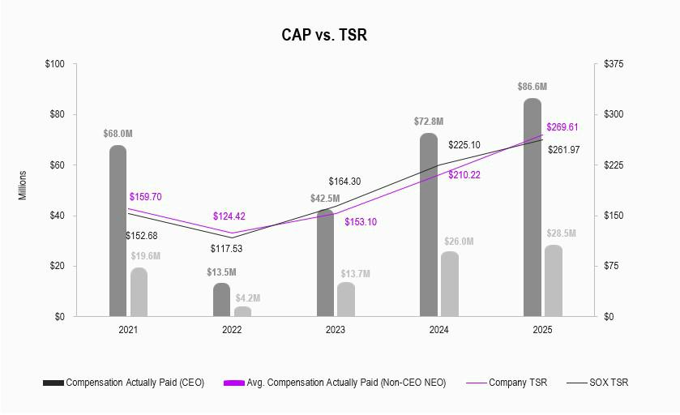

82 | 2025 Proxy Statement

Table of Contents

RELATIONSHIP BETWEEN CAP VS. NET INCOME (LOSS) & NON-GAAP NET INCOME (LOSS)

The following charts illustrate the CAP for our PEO and the average CAP for our Non-PEO NEOs against our net income (loss) and non-

GAAP net income (loss):
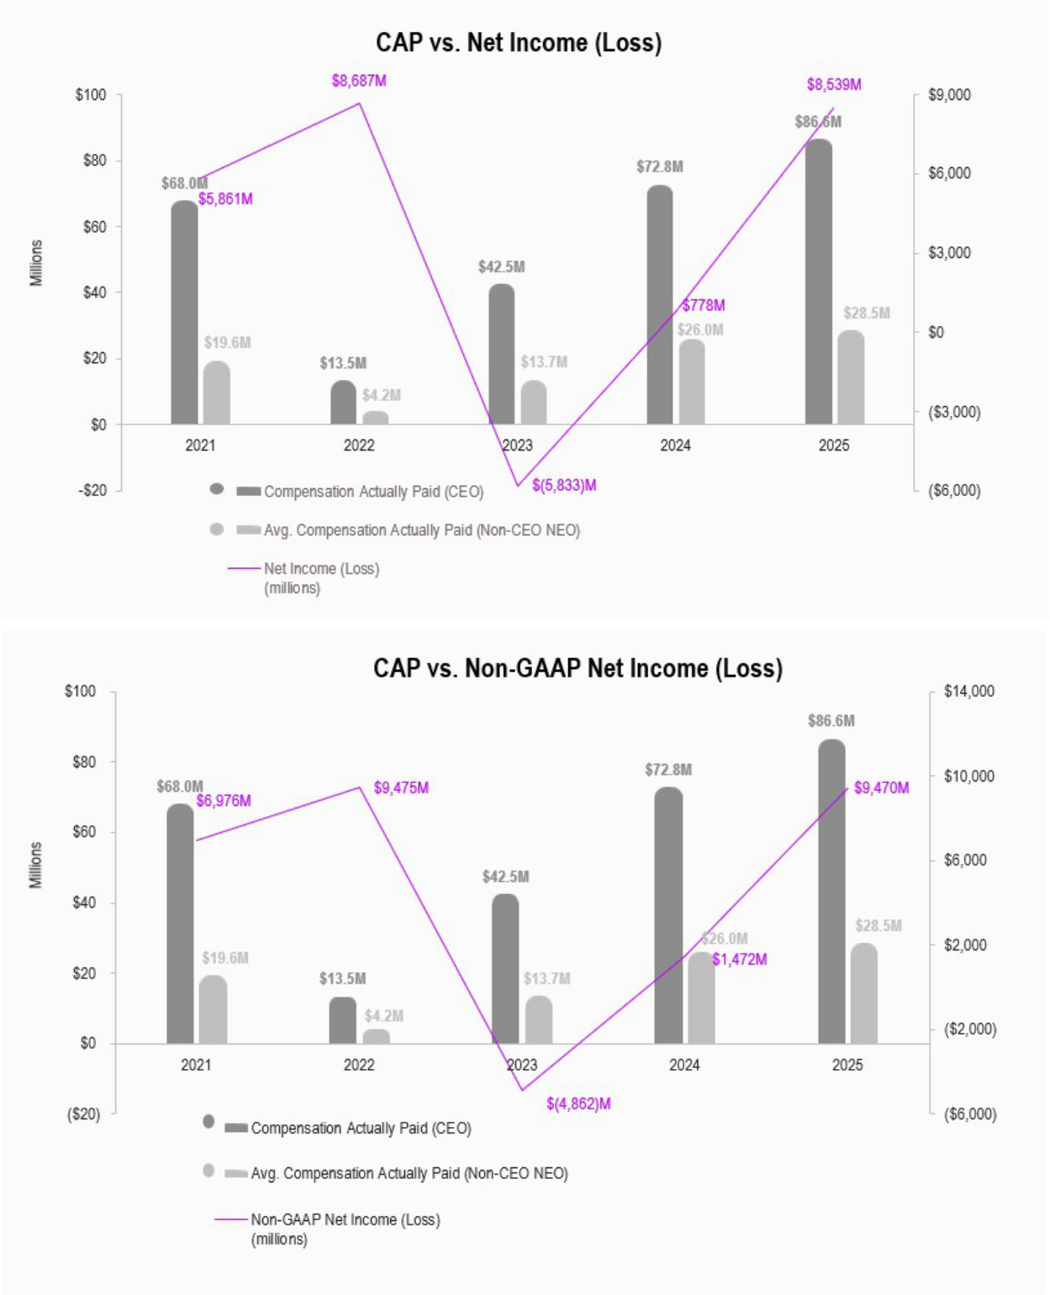

83

Table of Contents

MOST IMPORTANT PERFORMANCE MEASURES

The following is an unranked list of the performance measures we consider most important in linking Company performance and compensation actually paid to our Named Executive Officers for the most recently completed fiscal year:

- Non-GAAP net income (loss)

- Non-GAAP operating margin

- Relative TSR growth of the Company’s stock price versus the SOX index

- Data center SSD market share or bit shipments

- HBM3E+ market share or bit shipments

84 | 2025 Proxy Statement

Table of Contents

PROPOSAL 3 – AMENDMENT OF CERTIFICATE OF INCORPORATION

PROPOSAL DETAILS

General

The State of Delaware, our state of incorporation, recently enacted legislation that enables Delaware corporations to limit the liability of certain of their officers in limited circumstances. Specifically, Section 102(b)(7) of the Delaware General Corporate Law (“DGCL”) was amended to authorize corporations to adopt a provision in their certificate of incorporation to eliminate or limit monetary liability of certain corporate officers, or exculpation, for direct claims brought by shareholders for breach of the fiduciary duty of care. Previously, the DGCL allowed only exculpation of directors for breach of the fiduciary duty of care. As amended, Section 102(b)(7) of the DGCL authorizes corporations to provide for exculpation of the following officers: (i) the corporation’s president, chief executive officer, chief operating officer, chief financial officer, chief legal officer, controller, treasurer or chief accounting officer; (ii) “named executive officers” identified in the corporation’s SEC filings; and (iii) other individuals who have agreed to be identified as officers of the corporation for the purposes of accepting service of process.

Section 102(b)(7) of the DGCL, as amended, only permits, and this Proposal 3 would only permit, the exculpation of certain officers in connection with direct claims brought by shareholders, including class actions, but would not eliminate officers’ monetary liability for breach of fiduciary duty claims brought by Micron itself or for derivative claims brought by stockholders in the name of Micron. In addition, this Proposal 3 would not limit the liability of officers for any breach of the duty of loyalty to Micron or its shareholders, any acts or omissions not in good faith or which involve intentional misconduct or a knowing violation of the law, or any transaction from which the officer derived an improper personal benefit. Our existing Restated Certificate of Incorporation (the “Existing Charter”) currently provides for the exculpation of directors, but it does not include a provision that allows for the exculpation of officers.

Rationale for the Amendment and Factors to Consider

Our Board of Directors believes that it is important to provide protection from certain liabilities and expenses in order to attract and retain officers. As with directors, officers frequently must make decisions in response to time-sensitive opportunities and challenges, which can create substantial risk of investigations, claims, actions, suits or proceedings seeking to impose liability on the basis of hindsight. In the absence of the proposed amendment to the Existing Charter, candidates might be deterred from serving as officers due to exposure to personal liability in an environment with increasing litigation and the risk that substantial expense will be incurred in defending lawsuits, regardless of merit. A number of our peers have adopted, and we expect that others will adopt, similar exculpation clauses that limit the personal liability of officers in their respective certificates of incorporation. Failing to adopt this Proposal 3 could impact our recruitment and retention of officer candidates.

Our Board also took into account the narrow class and type of claims from which such officers would be exculpated from liability pursuant to DGCL Section 102(b)(7), the limited number of our officers that would be impacted and the benefits our Board believes would accrue to Micron by providing exculpation in accordance with DGCL Section 102(b)(7), including the ability to further enable our officers to best exercise their business judgment in furtherance of the best interests of shareholders without the potential for distraction posed by the risk of personal liability. After weighing these considerations, our Board approved and declared it advisable to adopt, subject to shareholder approval, the proposed amendment to provide for exculpation of certain officers of Micron as permitted by recent amendments to Delaware law.

This Proposal 3 would also amend the Existing Charter to provide that no subsequent amendment to the exculpation provision will reduce or negatively impact the rights or protections of directors or officers under the provision with respect to any situations, actions or failures to act prior to such amendment, or any cause of action or claim that would have accrued or arisen prior to such amendment. This Proposal 3 would additionally amend the Existing Charter to provide that if the DGCL is later amended to authorize further elimination or reduction of the

85

Table of Contents

personal liability of directors or officers, then the liability of a director or officer of Micron will be eliminated or reduced to the fullest extent permitted by the DGCL as so amended.

The description of the proposed amendment and the applicable provisions of the DGCL contained herein are summaries and are qualified in their entirety by the text of the amendment to the Existing Charter, attached hereto as Annex A, and the full text of the applicable provisions of the DGCL.

Effect of Approval

Approval of this Proposal 3 will constitute approval of the corresponding amendment to Section 9 of the Existing Charter, attached hereto as Annex A. If this Proposal 3 is approved, we intend to file the amendment to the Existing Charter with the Secretary of State of the State of Delaware, and this Proposal 3 will become effective at the time of that filing.

BOARD RECOMMENDATION

The Board recommends voting “FOR” this Proposal 3 to approve the amendment of the Existing Charter to provide exculpatory protection for certain company officers.

VOTE REQUIRED FOR APPROVAL

The “FOR” vote of the holders of a majority of the outstanding voting power of the shares of our Common Stock entitled to vote thereon is required to approve Proposal 3. Abstention and broker non-votes, if any, will have the same effect as a vote “against” this proposal.

86 | 2025 Proxy Statement

Table of Contents

AUDIT COMMITTEE MATTERS

PROPOSAL 4 - RATIFICATION OF APPOINTMENT OF PRICEWATERHOUSECOOPERS LLP

The Audit Committee of the Board evaluates the independent auditor selection each year and has retained PricewaterhouseCoopers LLP (“PwC”) as our independent registered public accounting firm to audit our consolidated financial statements for Fiscal 2026. PwC has been our independent registered public accounting firm since 1984. Although ratification is not required, the Board is submitting a proposal to ratify PwC’s appointment to our shareholders because we value our shareholders’ views and as a matter of good corporate practice. If PwC’s appointment is not ratified by our shareholders, the Audit Committee may reconsider its decision to appoint PwC as our independent registered public accounting firm. Even if the appointment is ratified, the Audit Committee may in its discretion select a different independent registered public accounting firm at any time during the fiscal year if it determines that such a change would be in the best interests of the Company and our shareholders. Representatives of PwC are expected to be present at the Annual Meeting, will have the opportunity to make a statement if they so desire, and are expected to be available following the Annual Meeting to respond to appropriate questions submitted before or during the Annual Meeting. The Audit Committee considered a number of factors in re-engaging PwC, including the independence controls in place and PwC’s objectivity, track record, global footprint, and deep semiconductor industry knowledge, experience, and expertise. The Audit Committee concluded that many factors contribute to the continued support of PwC’s independence, such as oversight by the Public Company Accounting Oversight Board (“PCAOB”) through the establishment of audit, quality, ethics, and independence standards in addition to conducting audit inspections; the mandating of reports on internal control over financial reporting; PCAOB requirements for audit partner rotation; and limitations imposed by regulation and by the Audit Committee on non-audit services provided by PwC.

BOARD RECOMMENDATION

The Board recommends voting “FOR” the ratification of the appointment of PwC.

VOTE REQUIRED FOR APPROVAL

The “FOR” vote of the holders of a majority of the voting power of the shares of our Common Stock present in person (virtually) or represented by proxy at the Annual Meeting is required to ratify the appointment of PwC as our independent registered public accounting firm for Fiscal 2026.

FEES PAID

Fees charged for services performed by PwC for Fiscal 2025 and Fiscal 2024 were as follows:
 |  | 2025 |  | 2024
 |  | (amounts in millions)
 | Audit fees(1) | $ | 10.3 | $ | 9.2
 | Audit-related fees(2) |  | 0.4 |  | 0.1
 | Tax fees(3) |  | 1.0 |  | 1.4
 | All other fees (4) |  | — |  | —
 |  | $ | 11.7 | $ | 10.7

- Includes fees related to the audit of our financial statements, fees for services provided in connection with statutory and regulatory filings, and fees for attestation services related to our securities offerings and internal control over financial reporting as required by the Sarbanes-Oxley Act of 2002.

87

Table of Contents

- Fees not included in audit fees that are billed by the auditor for assurance and related services that are reasonably related to the performance of the audit of the financial statements.

- Primarily reflects fees for services in connection with tax planning, tax consulting, tax compliance, and tax audit defense.

- All other fees include any fees billed that are not audit fees, audit-related fees or tax fees. There were no such fees incurred in Fiscal 2025 or Fiscal 2024.

PRE-APPROVAL POLICY

The Audit Committee Charter provides that the Audit Committee will pre-approve all audit and non-audit services provided to us by the independent auditors, except for such de minimis non-audit services for which the pre-approval requirements are waived in accordance with the pre-approval policy and/or rules and regulations of the SEC. The Audit Committee may delegate to one or more of its members the authority to grant such pre-approvals, provided that any pre-approval must be presented to the full Audit Committee at its next scheduled meeting. In Fiscal 2025 and Fiscal 2024, all audit, non-audit, tax services, and all other fees for services provided by PwC were approved by the Audit Committee in advance of services being provided.

REPORT OF THE AUDIT COMMITTEE OF THE BOARD OF DIRECTORS

This report has been prepared by members of the Audit Committee of the Board. The Board determined that each of Mses. McCarthy and Simons and Messrs. Gomo and Swan qualified as an “audit committee financial expert” for purposes of the rules and regulations of the SEC. The Board also determined that during their period of service on the Audit Committee, each member satisfied the independence requirements of applicable federal laws and the Listing Rules of Nasdaq.

The purpose of the Audit Committee is to assist the Board in overseeing and monitoring (i) the integrity of our financial statements, (ii) the adequacy of our internal controls and procedures, (iii) the performance of our internal audit function, (iv) the qualifications, performance, and independence of our independent registered public accounting firm, (v) related party transactions and (vi) our compliance with legal and regulatory requirements. In fulfilling its oversight responsibility, the Audit Committee carefully reviews the criteria for the engagement of the independent registered public accounting firm, including the scope of the audit, audit fees, auditor independence matters, performance of the independent auditors, and the extent to which the independent registered public accounting firm may be retained to perform non-audit services. In conjunction with the rotation of the independent registered public accounting firm’s lead engagement partner, which occurs at least every five years, the Audit Committee is also involved in the selection of PwC’s lead engagement partner.

The Audit Committee has reviewed and discussed our audited financial statements with our management, which has primary responsibility for such financial statements. PwC, our Independent Registered Public Accounting Firm for Fiscal 2025, has expressed in our Annual Report on Form 10-K for Fiscal 2025 its opinion as to the conformity of our consolidated financial statements with accounting principles generally accepted in the United States. The Audit Committee has discussed with PwC the matters that are required to be discussed by the applicable requirements of the PCAOB and the SEC. PwC has provided to the Audit Committee the written disclosures and the letter required by the applicable requirements of the PCAOB. The Audit Committee and PwC also discussed PwC’s independence, including the non-audit services PwC provided to us as described above, and concluded that PwC was independent for Fiscal 2025.

On the basis of the reviews and discussions referred to above, the Audit Committee recommended to the Board that they include our audited consolidated financial statements in our Annual Report on Form 10-K for Fiscal 2025, appointed PwC as our independent registered public accounting firm for Fiscal 2026, and approved and authorized PwC to carry out and perform certain specified non-audit services for us in Fiscal 2026.

88 | 2025 Proxy Statement

Table of Contents

While the Audit Committee has performed the above functions, management, and not the Audit Committee, has the primary responsibility for

- preparing our consolidated financial statements and for the reporting process in general and (ii) establishing and maintaining internal

controls. Similarly, it is the responsibility of the independent registered public accounting firm, and not the Audit Committee, to conduct the audit of our consolidated financial statements and express an opinion as to the conformity of the financial statements with accounting principles generally accepted in the United States.

The Audit Committee

Mary Pat McCarthy (Chair)
Steven J. Gomo
Linnie M. Haynesworth
A. Christine Simons
Robert H. Swan

89

Table of Contents

PROPOSAL 5 - SHAREHOLDER PROPOSAL - REQUESTING AMENDMENT TO SHAREHOLDER SPECIAL MEETING RIGHT

PROPOSAL DETAILS

The following shareholder proposal has been submitted to us for action at the Annual Meeting by John Chevedden, 2215 Nelson Avenue, No. 205, Redondo Beach, CA 90278. Mr. Chevedden has submitted documentation indicating that he is the beneficial owner of at least 50 shares of our Common Stock and he intends to continue to hold the requisite amount of shares through the date of the Annual Meeting. In accordance with proxy regulations, the following is the complete text of the proposal, which is reproduced as submitted to us other than minor formatting changes. All statements contained in the shareholder proposal and supporting statement are the sole responsibility of the proponent.

Proposal 5 - Special Shareholder Meeting Improvement


Shareholders ask the Board of Directors to take the steps necessary to amend the governing documents to give the owners of a combined 10% of our outstanding common stock the power to call a special shareholder meeting.

A more reasonable shareholder right to call for a special shareholder meeting, as called for in this proposal, can help make shareholder engagement more meaningful. A shareholder right to call for a special shareholder meeting will help ensure that the Micron Technology Board and management engages with shareholders in good faith because shareholders will have a viable Plan B of calling for a special shareholder meeting.

Companies like to claim that shareholders have multiple means to communicate with management but in most cases these means are as effective as mailing a letter to the Chief Executive Officer.

To guard against the Micron Technology Board of Directors becoming complacent shareholders need a more reasonable ability to call a special shareholder meeting to help the Board adopt new strategies when the need arises.

Micron seems to be in somewhat of a slump. After Micron's impressive stock price performance from 2016 to 2024 the stock price has been flat in the year leading up to the submittal of this proposal in spite of a robust stock market.

There is no concern that allowing 10% of shares to call for a special shareholder meeting, as called for in this proposal, is too easy. It is almost unheard of for any special shareholder meeting, called for by shareholders, to ever occur at any company even though a significant number of companies allow 10% of shareholders to call for a special shareholder meeting.

The reason to have this right is that with this right in place companies are more likely to engage productively with their shareholders because shareholders have an alternative ability to call for a special shareholder meeting.

On the other hand with the widespread use of online shareholder meetings it is much easier for a company to conduct a special shareholder meeting for important business matters and Micron bylaws need to be updated accordingly.

Please vote yes:

Special Shareholder Meeting Improvement - Proposal 5

90 | 2025 Proxy Statement

Table of Contents

STATEMENT OF OPPOSITION

THE BOARD OF DIRECTORS RECOMMENDS A VOTE AGAINST THE SHAREHOLDER PROPOSAL

We regularly engage with our shareholders on a variety of topics, including those raised in shareholder proposals. We met with the proponent to better understand their perspective. The Board has carefully considered the proposal and the feedback received from the proponent and believes that it is not in the best interests of our shareholders. The Board UNANIMOUSLY recommends a vote AGAINST this proposal for the following reasons:


- Existing Meaningful Shareholder Meeting Right. Our bylaws already permit shareholders holding 20% of our outstanding capital stock to call special meetings of shareholders without a minimum holding requirement.

- Existing Ownership Threshold is Good Practice. Our 20% special meeting ownership threshold is consistent with market practice.

- Strong Corporate Governance. We have strong corporate governance policies and procedures, which include the ability for shareholders to act by written consent, a market-standard proxy access right, annual election of directors and continuous Board refreshment, a robust shareholder outreach program that empowers shareholders to provide ongoing feedback to the Board and management.

Our 20% special meeting ownership threshold with shareholder-friendly terms allows for legitimate proposals while providing a procedural safeguard against abuse, corporate waste and shareholders with minority ownership interests and short-term goals.

Micron’s shareholders already have a meaningful right to call special meetings of shareholders outside of the annual meeting cycle. Micron’s Board has long recognized the importance of giving shareholders a meaningful right to call special meetings in appropriate circumstances, and so for over 20 years, Micron’s shareholders holding an aggregate 20% of our capital stock have had the right to call a special meeting. Further, our special meeting right does not and has not contained any minimum holding requirement for over 20 years. While some companies do impose a minimum holding requirement on their special meeting right that requires shareholders to own their shares for a minimum period in order to call for a special meeting, our Board determined not to impose such a requirement on our shareholders. Micron’s Board continues to believe this strikes the appropriate balance between ensuring that our shareholders have the ability to call a special meeting to act on extraordinary and urgent matters, while at the same time protecting against a misuse of this right by a small minority of shareholders to raise generally unsupported proposals that can waste significant corporate resources on matters that do not reflect the interests of Micron and its broader shareholder base.

Our special meeting right in our bylaws serves as a protective mechanism against shareholders with minority ownership interests and short-term goals. As of August 28, 2025, our two largest shareholders together hold more than 10% of our outstanding shares. Given this ownership composition, reducing the ownership threshold to 10% could enable just a small minority of shareholders to use this right and would result in outsized attention and resources being devoted to the special interests of a minority, at the expense of our smaller shareholders. The 20% threshold in our bylaws ensures that a special meeting of shareholders may only be called by a shareholder or group of shareholders with a more substantial stake in Micron and who share an interest in a common topic. This appropriately safeguards shareholder interests and prevents corporate waste, while at the same time ensuring that shareholders have the ability to call special meetings when appropriate.

Special meetings of shareholders can be disruptive to business operations, incur substantial expenses and harm long-term shareholder interests. The Board, management and employees must devote a significant amount of time and attention preparing for such meetings, which distracts them from their primary focus of maximizing long-term financial returns for shareholders and operating our business in the best interests of shareholders. In addition, with each special meeting of shareholders, we must incur significant expenses in order to prepare the disclosures required for such meetings, print and distribute materials, solicit proxies and tabulate votes. As a result, special meetings of shareholders should be limited to circumstances where a substantial number of shareholders believe a matter is sufficiently urgent or extraordinary to justify calling a special meeting.

91

Table of Contents

The special meeting ownership threshold in our bylaws is consistent with overwhelming market practice.

The 20% special meeting ownership threshold included in our bylaws is in line with market practice and notably, it is lower than the most common special meeting ownership threshold of 25%. As of August 2025, within the S&P 500, 363 U.S. incorporated companies afford shareholders the right to call a special meeting of shareholders. Of those companies, over 60% have adopted an ownership threshold of 20% or higher for allowing shareholders to call a special meeting, with the most common ownership threshold being 25%, while only about 35% have adopted a special meeting ownership threshold of 15% or less.¹ Our Board believes that the 20% ownership threshold is appropriate for our Company and in line with market practice.

Our existing governance policies provide shareholders with meaningful opportunities to engage in Company affairs.

The Board maintains its demonstrated commitment to corporate governance policies that are in the best interests of the Company and its shareholders by regularly reviewing the Company’s governance structure, policies, and practices, including considering input from shareholders and others. Consistent with its commitment to strong corporate governance, our existing governance policies provide shareholders with numerous avenues to address and discuss our business and governance policies with the Board, and demonstrate our responsiveness and willingness to engage with shareholders and provide them with a meaningful voice. These include:


Action by Written Consent

Our bylaws provide our shareholders with the right to act by written consent, without an ownership threshold requirement.


Market Standard Proxy Access

Our bylaws provide a proxy access right permitting certain of our shareholders who have beneficially owned 3% or more of
our common stock continuously for at least three years to submit director nominations via our proxy materials for up to 20% of the directors then serving.

Shareholder Engagement

We regularly engage with key shareholders to discuss, among other items, compensation, sustainability and governance issues to

ensure that management and the Board understand and address issues that are important to the Company’s shareholders. In 2025, we reached out to approximately 58% of our shares outstanding for

engagement and met with approximately 40% of our shares outstanding. Further, our Lead Independent Director was involved in meetings with holders of 39% of our outstanding shares. For more

information about our extensive shareholder outreach program, see “Shareholder Outreach” on page 29.


Provisions Providing for Board Accountability

Our bylaws provide for the annual election of directors. In addition, we engage in regular board refreshment. Since 2021, we have
appointed four new independent directors, each with deep experience in technology and the semiconductor industry, directly aligned with our business needs and strategy. Ninety percent of our

Board is independent, and all of our standing committees are fully independent as well. In 2025, in connection with the retirement of our independent Chairman, we appointed Lynn A. Dugle as our

Lead Independent Director, providing strong independent leadership to our Board. For more information about our Board and its leadership, see “Corporate Governance” on page 6.

These corporate governance policies provide our shareholders with numerous opportunities to be heard and to engage directly with the Board and demonstrate that the Board is not reluctant to make changes in its governance practices when it determines that a change is in the best interests of the Company and its shareholders. In light of our existing strong corporate governance policies and robust shareholder outreach program, the Board believes our current special meeting right at the 20% ownership threshold without a minimum holding requirement is reasonable and appropriate and the lower special meeting threshold as requested by the proposal would not make a meaningful difference in our shareholders’ ability to engage with the Board or influence our business or governance policies.

For these reasons, the Board UNANIMOUSLY urges shareholders to vote AGAINST the proposal to adopt a shareholder right to call a special meeting at a 10% ownership threshold.

- Source: DealPoint, August 1, 2025.

92 | 2025 Proxy Statement

Table of Contents

The “FOR” vote of the holders of a majority of the voting power of the shares of our Common Stock present in person (virtually) or represented by proxy at the Annual Meeting is required to approve the shareholder proposal.

THE BOARD OF DIRECTORS RECOMMENDS A VOTE AGAINST THE SHAREHOLDER PROPOSAL.

93

Table of Contents

PRINCIPAL SHAREHOLDERS

Security Ownership of Certain Beneficial Owners and Management

The following table sets forth security beneficial ownership information of our Common Stock as of October 31, 2025, calculated in accordance with the rules of the SEC based on the most current information provided to us by the beneficial owners, available to us from our own records or provided in SEC filings made by the beneficial owners, for (i) persons known by us to own beneficially more than 5% of our Common Stock, (ii) each director, (iii) each Named Executive Officer listed in the “Fiscal 2025 Summary Compensation Table” set forth herein, and (iv) all directors and executive officers as a group. We have based our calculation of the percentage of beneficial ownership on 1,124,128,357 shares of our Common Stock outstanding as of October 31, 2025. Unless otherwise indicated, the address of each beneficial owner listed in the table below is c/o Micron Technology, Inc., 8000 South Federal Way, Boise, Idaho, 83716-9632.
 | Number of | Right to | Total | Percent of
Name of Beneficial Owner | Shares | Right to | Beneficial | Percent of
Name of Beneficial Owner | Owned(1) | Acquire(2) | Ownership | Class(3)
The Vanguard Group, Inc.(4) | 94,984,500 | — | 94,984,500 | 8.4 %
BlackRock, Inc.(5) | 85,904,256 | — | 85,904,256 | 7.6 %
Capital World Investors (6) | 71,003,502 | — | 71,003,502 | 6.3 %
Richard M. Beyer | 97,408 | — | 97,408 | *
Manish Bhatia | 350,109 | — | 350,109 | *
Scott J. DeBoer | 154,145 | — | 154,145 | *
Lynn A. Dugle | 19,028 | 2,338 | 21,366 | *
Steven J. Gomo | 24,139 | — | 24,139 | *
Linnie M. Haynesworth | 13,632 | 3,715 | 17,347 | *
T. Mark Liu | 2,710 | 220 | 2,930 | *
Mary Pat McCarthy | 21,523 | — | 21,523 | *
Sanjay Mehrotra(7) | 1,084,078 | — | 1,084,078 | *
Mark J. Murphy | 219,693 | — | 219,693 | *
Sumit Sadana | 277,521 | — | 277,521 | *
A. Christine Simons | 3,833 | — | 3,833 | *
Robert H. Swan | 4,444 | 794 | 5,238 | *
MaryAnn Wright | 23,333 | 3,715 | 27,048 | *
All directors and executive officers as a group (18 persons) | 2,675,270 | 10,782 | 2,686,052 | *

* Represents less than 1% of shares outstanding

(1) Includes unvested shares of restricted stock.

- Represents shares that an individual has a right to acquire within 60 days from October 31, 2025. Includes shares underlying deferred restricted stock units that become deliverable upon termination of service.

- For purposes of calculating the Percent of Class, shares that the person or entity had a Right to Acquire are deemed to be outstanding when calculating the Percent of Class of such person or entity.

- Based upon information contained in the Schedule 13G/A filed by The Vanguard Group, Inc. (“Vanguard”) on February 13, 2024, as of December 29, 2023, Vanguard had sole dispositive power as to 90,364,219 shares, shared voting power as to 1,362,947 shares, and shared dispositive power as to 4,620,281 shares. Vanguard’s business address is 100 Vanguard Blvd., Malvern, PA 19355.

94 | 2025 Proxy Statement

Table of Contents

- Based upon information contained in the Schedule 13G/A filed by BlackRock, Inc. (“BlackRock”) on February 13, 2024, as of December 31, 2023, BlackRock had sole voting power as to 78,806,024 shares and sole dispositive power as to 85,904,256 shares. BlackRock’s business address is 50 Hudson Yards, New York, NY 10001.

- Based upon information contained in the Schedule 13G filed by Capital World Investors (“Capital”) on August 13, 2025, as of June 30, 2025, Capital had sole voting power as to 70,975,601 shares and sole dispositive power as to 71,003,502 shares. Capital is a division of Capital Research and Management Company ("CRMC"), as well as its investment management subsidiaries and affiliates Capital Bank and Trust Company, Capital International, Inc., Capital International Limited, Capital International Sarl, Capital International K.K., Capital Group Private Client Services, Inc., and Capital Group Investment Management Private Limited (together with CRMC, the "investment management entities"). Capital’s divisions of each of the investment management entities collectively provide investment management services under the name "Capital World Investors." Capital’s business address is 333 South Hope Street, 55th Floor, Los Angeles, California 90071.

- Includes 500,000 shares held by The Sangeeta Mehrotra 2025 Grantor Retained Annuity Trust I and 175,000 shares held by The Sangeeta Mehrotra 2025 Grantor Retained Annuity Trust VI.

95

Table of Contents

INFORMATION CONCERNING SOLICITATION AND VOTING

This Proxy Statement is furnished in connection with the solicitation of proxies on behalf of the Board of Micron Technology, Inc., for use at the Annual Meeting to be held on January 15, 2026, at 10:00 a.m., Mountain Standard Time, or at any adjournment or postponement thereof. The purpose of the Annual Meeting is set forth herein and in the accompanying Notice.

The information provided in the “question and answer” format below is for your convenience only and is merely a summary of the information contained in this Proxy Statement. You should read this entire Proxy Statement carefully.

HOW DO I ATTEND AND PARTICIPATE IN THE ANNUAL MEETING?

The Annual Meeting will be held via a live webcast, and there will not be a physical meeting location.

You will be able to attend the Annual Meeting online and to vote your shares electronically on the virtual meeting platform by visiting www.virtualshareholdermeeting.com/MU2025 and entering the 16-digit control number included in the Notice, on your proxy card, or in the instructions that accompanied your proxy materials. Even if you have already submitted your vote, you can still vote at the meeting by using the virtual meeting platform. Any previous votes submitted via Internet, telephone, or mail will be superseded by the vote cast at the virtual meeting.

Shareholders will be able to submit questions before the Annual Meeting through www.proxyvote.com or during the Annual Meeting using the virtual meeting platform. Relevant questions submitted before or during the Annual Meeting may be addressed at the Annual Meeting or after the Annual Meeting in the Investor Relations section of our website at www.micron.com.

We encourage you to access the Annual Meeting before it begins. Online check-in will start approximately 15 minutes before the Annual Meeting. If you have difficulty accessing the meeting or other technical or logistical issues, please call the technical support number that will be posted on the virtual Annual Meeting login page. We will have technicians available to assist you.

WHAT MATTERS AM I VOTING ON?

- To elect eight (8) directors to our Board to serve for the ensuing year and until their successors are elected and qualified;

2 To approve, on a non-binding basis, the compensation of our named executive officers;


- To approve an amendment to the Company’s Restated Certificate of Incorporation adding a provision regarding exculpation of officers in accordance with Delaware law;

- To ratify the appointment of PricewaterhouseCoopers LLP as our independent registered public accounting firm for the fiscal year ending September 3, 2026;

- To vote on a shareholder proposal included in this Proxy Statement, if properly presented at the meeting; and

6 To transact such other business as may properly come before the meeting or any adjournment thereof.

96 | 2025 Proxy Statement

Table of Contents

HOW DOES THE BOARD RECOMMEND I VOTE?

- FOR each of the director nominees named herein, or their respective substitutes as may be appointed by the Board;

- FOR a non-binding resolution to approve the compensation of our named executive officers;

FOR the approval of an amendment to the Company’s Restated Certificate of Incorporation adding a provision regarding exculpation of officers in
- accordance with Delaware law;

- FOR ratification of the appointment of PricewaterhouseCoopers LLP as our independent registered public accounting firm for the fiscal year ending September 3, 2026; and

- AGAINST the shareholder proposal.


WHO IS ENTITLED TO VOTE AT THE MEETING?

Shareholders of record at the close of business on November 17, 2025 (the “Record Date”) are entitled to receive notice of and to vote at the Annual Meeting.

HOW DO I VOTE?


Vote through the internet at www.proxyvote.com, using the instructions included in the notice regarding the internet availability of proxy materials, the proxy card, or voting instruction card.

Vote by telephone (1-800-690-6903) using the instructions on the proxy card or voting instruction
card if you received a paper copy of the proxy materials. Have your proxy card in hand when you call and then follow the instructions.

Complete and return a written proxy or voting instruction card.

Attend the meeting electronically on the virtual meeting platform.

Internet and telephone voting are available 24 hours a day, and if you use one of those methods, you do not need to return a
paper proxy or voting instruction card. Unless you are planning to vote at the Annual Meeting, your vote must be received by
11:59 p.m., Eastern Standard Time, on January 14, 2026.

WHAT IS THE COMMON STOCK STATUS ON THE RECORD DATE?

We have one class of stock outstanding, Common Stock. As of the Record Date, 1,125,349,754 shares of Common Stock were issued and outstanding and entitled to vote.

WHAT IS A QUORUM?

The required quorum for the transaction of business at the Annual Meeting is a majority of the voting power of shares of our Common Stock issued and outstanding on the Record Date and entitled to vote thereat, present (virtually) in person or represented by proxy. Shares that are voted “FOR,” “AGAINST,” or “ABSTAIN” are treated as being present at the Annual Meeting for the purposes of establishing a quorum. Broker non-votes will also be considered present and entitled to vote for purposes of determining the presence or absence of a quorum for the transaction of business.

97

Table of Contents

HOW ARE VOTES COUNTED?

Under the Delaware General Corporation Law, our Restated Certificate of Incorporation, and our bylaws, each shareholder will be entitled to one vote for each share of Common Stock held at the Record Date for all matters.

HOW MANY VOTES ARE NEEDED FOR APPROVAL OF EACH MATTER AT THE ANNUAL MEETING?

Shares held in a brokerage account or by another nominee are considered held in “street name” by the shareholder or “beneficial owner.” A broker or nominee holding shares for a beneficial owner does not have discretion to vote on non-routine matters unless the broker or nominee receives specific voting instructions from the beneficial owner of the shares. A broker non-vote occurs when the broker or nominee does not receive voting instructions from the beneficial owner and does not have discretion to direct the voting of the shares on a non-routine matter. Proposal 1 relating to the election of directors and Proposals 2, 3 and 5 are non-routine matters and therefore, brokers may not vote on such matters without specific voting instructions from the beneficial holder. Proposal 4 is a routine matter and, as a result, we do not expect broker non-votes on this proposal.

Directors will be elected if he or she receives the affirmative vote of a majority of the votes cast with respect to his or her election (in other words, the number of shares voted “FOR” a director must exceed the number of votes cast “AGAINST” that director), with abstentions and broker-non votes not counted as a vote cast “FOR” or “AGAINST” that director’s election. With respect to Proposal 3, the amendment of our Restated Certificate of Incorporation, the “FOR” vote of the holders of a majority of the voting power of our outstanding shares of Common Stock entitled to vote thereon is required to approve the amendment. Abstentions and broker non-votes will have the same effect as a vote “AGAINST” such proposal. With respect to all other items of business to be considered at the meeting, the “FOR” vote of the holders of a majority of the voting power of the shares of Common Stock present (virtually) in person or represented by proxy and entitled to vote on the subject matter is required in order for such matter to be considered approved by the shareholders. For such other proposals, abstentions will have the same effect as a vote “AGAINST” such items of business, and broker non-votes, if any, will have no effect on the outcome of the proposal.

WHAT IS THE EFFECT OF GIVING MY PROXY?

The shares of Common Stock represented by all properly executed proxies received by 11:59 p.m. Eastern Standard Time, on January 14, 2026, will be voted in accordance with the directions given by the shareholders. If no instructions are given with respect to a properly executed proxy timely received by us, the shares of Common Stock represented thereby will be voted in accordance with the recommendations of our Board as described above. If any matter not described in the Proxy Statement is properly presented at the Annual Meeting, the proxy holders will use their own judgment to determine how to vote your shares. If the Annual Meeting is adjourned, the proxy holders can vote your shares on the new meeting date as well, unless you have properly revoked your proxy, as described below.

HOW CAN I CHANGE MY VOTE?

You may change your vote or revoke your proxy before the Annual Meeting by:

- entering a new vote by Internet or telephone by following the instructions above (subject to the applicable deadlines for each method as set forth above);
completing and returning a later-dated written proxy card or voting instruction card using the instructions on the proxy card or voting instruction
- card;

delivering a written notice of revocation to us at Micron Technology, Inc., Attn.: Corporate Secretary, 8000 South Federal Way, Boise, Idaho 83716
- or corporatesecretary@micron.com; or

- attending and voting at the annual Meeting (although attendance at the Annual Meeting will not, by itself, revoke a proxy).


Street name holders should follow the instructions provided by their broker, bank or other nominee.

98 | 2025 Proxy Statement

Table of Contents

WHY DID I RECEIVE A NOTICE REGARDING THE AVAILABILITY OF PROXY MATERIALS ON THE INTERNET INSTEAD OF A FULL SET OF PROXY MATERIALS?

As permitted by the SEC, we are making our proxy materials available to our shareholders electronically via the Internet. We have mailed many of our shareholders a Notice containing instructions on how to access this Proxy Statement and our Annual Report on Form 10-K for Fiscal 2025 and vote online. If you received a Notice by mail, you will not receive a printed copy of the proxy materials in the mail. Instead, the Notice instructs you on how to access and review all of the important information contained in the Proxy Statement and Annual Report on Form 10-K for Fiscal 2025. The Notice also instructs you on how you may submit your voting instructions over the Internet.

If you received a Notice by mail and would like to receive a printed copy of our proxy materials, you should follow the instructions for requesting such materials included in the Notice. In addition, shareholders may request to receive proxy materials in printed form by mail or electronically by email on an ongoing basis.

HOW ARE PROXIES SOLICITED AT THE ANNUAL MEETING?

The Board of Directors is soliciting proxies for use at the Annual Meeting. We will bear the cost of solicitation. In addition, we may reimburse brokerage firms and other persons representing beneficial owners of shares for their expenses in forwarding solicitation materials to such beneficial owners. Proxies may be solicited by our directors, officers, and employees, without additional compensation, personally or by telephone or Internet. We have engaged the services of D.F. King & Co., a proxy solicitation firm, in connection with the solicitation of proxies. Although the exact cost of the solicitation services is not known at this time, it is anticipated that the fees paid by us for these services will be approximately $15,000, plus reasonable out-of-pocket expenses.

WHERE CAN I FIND THE VOTING RESULTS OF THE ANNUAL MEETING?

We will disclose voting results on a Current Report on Form 8-K to be filed with the SEC within four business days after the Annual Meeting. If final voting results are not available to us in time to include them in such Current Report on Form 8-K, we will file a Current Report on Form 8-K to publish preliminary results and will provide the final results in an amendment to the Current Report on Form 8-K as soon as final results become available.

OTHER MATTERS

Shareholder Nomination and Recommendation of Director Candidates

Advance Notice Procedures

Our bylaws permit shareholders to nominate directors at an annual meeting of shareholders or at a special meeting at which directors are to be elected. A shareholder may nominate a director candidate by delivering a written notice to our Corporate Secretary at our principal executive offices. Such notice must comply with the timing and disclosure requirements set forth in our bylaws. A nomination will not be included in our proxy materials unless submitted in compliance with the proxy access process described below. A copy of our bylaws can be found on the Corporate Governance page of our website at www.micron.com and is available in print without charge upon request to corporatesecretary@micron.com.

Proxy Access

Our bylaws also permit a shareholder or a group of up to 20 shareholders owning continuously for at least three years shares representing in the aggregate at least 3% of the total voting power of the Company’s outstanding Common Stock (collectively, an “eligible shareholder”) to nominate and include shareholder-nominated director candidates in our proxy materials for annual meetings of shareholders. An eligible shareholder meeting the specified eligibility requirements set forth in the bylaws is generally permitted to nominate the greater of (i) two director nominees and (ii) 20% of the number of directors in office. Use of the proxy access process to submit shareholder nominees is subject to additional eligibility, procedural, and disclosure requirements set forth in Article II, Section 11 of our bylaws. A copy of our bylaws can be found on the Corporate Governance page of our website at www.micron.com and is available in print without charge upon request to corporatesecretary@micron.com.

99

Table of Contents

Recommendations

Shareholders may also recommend candidates for consideration by our Governance and Sustainability Committee. Shareholders recommending candidates for consideration by our Governance and Sustainability Committee should submit their written recommendation no later than one hundred twenty (120) calendar days in advance of the date of our proxy statement released in connection with the previous year's annual meeting of shareholders.

The Governance and Sustainability Committee will evaluate director candidates recommended by shareholders for election to our Board in the same manner and using the same criteria as it uses for any other director candidate. If the Governance and Sustainability Committee determines that a shareholder-recommended candidate is suitable for membership on our Board, it will include the candidate in the pool of candidates to be considered for nomination upon the occurrence of the next vacancy on our Board or in connection with the next annual meeting of shareholders.

INCORPORATION BY REFERENCE OF CERTAIN FINANCIAL INFORMATION

We incorporate by reference in this Proxy Statement the “Equity Compensation Plans” note to our Consolidated Financial Statements included in our Annual Report on Form 10-K for Fiscal 2025. The Annual Report on Form 10-K for Fiscal 2025 accompanies this Proxy

Statement. Copies of the Annual Report on Form 10-K for Fiscal 2025 may be obtained without charge by sending a written request to: Micron Technology, Inc., Attn.: Corporate Secretary, 8000 South Federal Way, Boise, Idaho 83716. Our Annual Report on Form 10-K
for Fiscal 2025 also is available in the “Investor Relations” section of our website at www.micron.com. Web links throughout this document are inactive textual references provided for convenience only, and the content on the referenced websites is not incorporated herein by reference and does not constitute a part of this Proxy Statement.

HOUSEHOLDING OF PROXY STATEMENTS AND ANNUAL REPORTS

We are allowed and intend to deliver only one copy of the Notice regarding the Internet availability of proxy materials or one set of printed proxy materials (i.e., our Annual Report on Form 10-K for Fiscal 2025 and Proxy Statement) to multiple registered shareholders sharing an address who have received prior notice of our intent to deliver only one such notice or set of materials, so long as we have not received contrary instructions from such shareholders. This practice is commonly referred to as “householding.” Householding reduces the volume of duplicate information received at your household and our costs of preparing and mailing duplicate materials.

If you share an address with other registered shareholders and your household receives one copy of the Notice or of the proxy materials and you decide you want a separate copy, through the date of the Annual Meeting we will promptly deliver your separate copy if you contact us at Micron Technology, Inc., Attn.: Corporate Secretary, 8000 South Federal Way, Boise, Idaho 83716-9632 or corporatesecretary@micron.com or (208) 368-4000. Additionally, for registered shareholders to resume the mailing of individual copies of future annual reports, proxy statements, proxy statements combined with a prospectus, and information statements to a particular shareholder, you may contact EQ Shareowner Services, Attn.: Householding, P.O. Box 64854, St. Paul, Minnesota 55164-0874 and your request will be effective within 30 days after receipt. After the Annual Meeting, you may request householding of these documents, including notices, by providing EQ Shareowner Services at the address provided directly above with a written request to eliminate multiple mailings. The written request must include names and account numbers of all shareholders consenting to householding for a given address and must be signed by those shareholders.

Additionally, we have been notified that certain banks, brokers, and other nominees will household our annual reports and proxy statements for shareholders who hold in street names and have consented to householding. In this case, you may request an individual copy of the proxy materials by contacting your bank, broker, or other nominee. You may also contact your broker bank or other nominee if you would like to opt out of householding.

100 | 2025 Proxy Statement

Table of Contents

CAUTIONARY NOTE ON FORWARD-LOOKING STATEMENTS

This Proxy Statement contains forward-looking statements that involve a number of risks and uncertainties. Such forward-looking statements may be identified by words such as “anticipate,” “expect,” “intend,” “pledge,” “committed,” “plans,” “opportunities,” “future,” “believe,” “target,”

“on track,” “estimate,” “continue,” “likely,” “may,” “will,” “would,” “should,” “could,” and variations of such words and similar expressions. However, the absence of these words or similar expressions does not mean that a statement is not forward-looking. Specific forward-looking
statements include, but are not limited to, statements such as those made regarding market demand for our products, including AI-driven demand growth; the outlook for our industry and our expected leadership position; investments in research and development and expansion of our global manufacturing network; benefits of AI on our operations and products; our sustainability and compensation plans, expectations and commitments; and expectations regarding shareholder outreach. These forward-looking statements are subject to a number of risks and uncertainties that could cause actual events to differ materially. Please refer to the documents we file with the SEC, including our most recent Annual Report on Form 10-K and our annual report provided as part of the proxy materials. These documents contain and identify important factors that could cause our actual results to differ materially from those contained in the forward-looking statements. Although we believe that the expectations reflected in the forward-looking statements are reasonable, we cannot guarantee future results, levels of activity, performance, or achievements. We are under no duty to update any of the forward-looking statements, except as required by applicable law.

101

Table of Contents

DEADLINE FOR RECEIPT OF SHAREHOLDER PROPOSALS FOR FISCAL 2026 ANNUAL MEETING

Shareholders may present proper proposals for inclusion in our proxy statement and for consideration at the next annual meeting of shareholders by submitting their proposals in writing to our Corporate Secretary in a timely manner. For a shareholder proposal to be considered for inclusion in our proxy statement for our Fiscal 2026 annual meeting of shareholders, our Corporate Secretary must receive the written proposal at our principal executive offices located at 8000 South Federal Way, Boise, Idaho 83716-9632, Attention: Corporate Secretary, no later than July 28, 2026. In addition, such shareholder proposals must comply with the other requirements of Rule 14a-8 regarding the inclusion of shareholder proposals in Company-sponsored proxy materials. Submission of a proposal before the deadline does not guarantee its inclusion in our proxy materials.

Under our bylaws, director nominations and other business may be brought before an annual meeting of shareholders only by or at the direction of the Board or by a shareholder entitled to vote who has submitted a proposal in accordance with the requirements of our bylaws. To nominate a candidate or submit a proposal for consideration at our Fiscal 2026 Annual Meeting pursuant to our advance notice bylaw provisions, shareholders must deliver or mail their nomination submission or other shareholder notice of a proposal so that it is received by our Corporate Secretary, at the address above no earlier than 8:00 a.m., Mountain time, on July 28, 2026 and no later than 5:00 p.m., Mountain time, on August 27, 2026. In addition to the requirements set forth in our bylaws, to comply with Rule 14a-19 under the Exchange Act, shareholders must provide notice of intent to solicit proxies in support of director nominees (other than the Company’s nominees) for the Fiscal 2026 Annual Meeting when providing notice of nomination to the Company no later than the dates set forth above. Please note that the notice requirement under Rule 14a-19 is in addition to the applicable notice requirements in our bylaws.

Shareholders wishing to nominate a director candidate through our proxy access bylaw provisions for inclusion in our proxy statement must comply with the eligibility, procedural, and disclosure requirements set forth in our bylaws. To be timely for our Fiscal 2026 annual meeting of shareholders, our Corporate Secretary must receive a shareholder’s notice of proxy access nomination at our principal executive offices, not earlier than 8:00 a.m. Mountain time, on June 28, 2026 or later than 5:00 p.m., Mountain time, on July 28, 2026.

November 25, 2025

THE BOARD OF DIRECTORS

102 | 2025 Proxy Statement

Table of Contents

ANNEX A

CERTIFICATE OF AMENDMENT OF THE

RESTATED CERTIFICATE OF INCORPORATION OF

MICRON TECHNOLOGY, INC.

The undersigned, Michael Ray, hereby certifies that:

- He is the duly elected and acting Senior Vice President, Chief Legal Officer and Corporate Secretary of Micron Technology, Inc., a Delaware corporation.

- The original Certificate of Incorporation of this corporation was filed on April 6, 1984, and the Restated Certificate of Incorporation of this corporation was originally filed with the Secretary of State of Delaware on April 18, 2001.

- Pursuant to Section 242 of the General Corporation Law of the State of Delaware, this Certificate of Amendment of the Restated Certificate of Incorporation amends Section 9 of this corporation’s Restated Certificate of Incorporation to read in its entirety as follows:

“ 9. Pursuant to, and to the full extent permitted by Section 102(b) and any other relevant provisions of the General Corporation Law of the State of Delaware, as the same exists or as may hereafter be amended from time to time, no director or officer shall be liable to the corporation or its stockholders for monetary damages for breach of fiduciary duty as a director or officer. Without limiting the effect of the preceding sentence, if the General Corporation Law of the State of Delaware is hereafter amended to authorize corporate action further eliminating or limiting the personal liability of directors or officers, then the liability of a director or officer of this corporation shall be eliminated or limited to the fullest extent permitted by the General Corporation Law of the State of Delaware, as so amended. Any amendment, repeal or elimination of the foregoing provisions of this Section 9 by the stockholders of the corporation shall not adversely affect any right or protection of a director or officer of the corporation existing at the time of, or increase the liability of any director or officer of the corporation with respect to any acts or omissions of such director or officer occurring prior to, such amendment, repeal or elimination.”

- The foregoing Certificate of Amendment of the Restated Certificate of Incorporation has been duly adopted by this corporation’s Board of Directors and Stockholders in accordance with the applicable provisions of Section 242 of the General Corporation Law of the State of Delaware.

IN WITNESS WHEREOF, said corporation has caused this Certificate of Amendment to the Restated Certificate of Incorporation to be executed by its Senior Vice President, Chief Legal Officer and Corporate Secretary this _____ day of _____________, 2026.

____________________________

Michael Ray

Senior Vice President, Chief Legal Officer

and Corporate Secretary

103







